30 November 2011
St Paul’s at 300
(Part Two)

Martin Stancliffe

I am aware that I left you with a few cliff-hangers last week, and I hope that we can address at least some of those this week.

Let me begin by talking about the South Transept and indeed of the structure more generally. As I told you last week, the South Transept was handed on to me by my predecessors as a potentially major problem. I found out soon enough that I needed to review the monitoring programmes that were still in place. I felt that they showed that the building was actually extremely stable, but being a world famous monitoring system, I did not wish to set that aside lightly.

I took quite a lot of advice and, eventually, the Dean and Chapter agreed with me that we should appoint a new set of engineers. In appointing Alan Baxter and, in particular, his assistant Robert Bowles, I believe that we made a very safe move. They carried out a complete reappraisal of the structural systems of the Cathedral and produced an important three-volume document which sets out the status quo for the Cathedral as a whole. I have not got time to go into the detail of all of that, but I do want to just tell you what happened in the South Transept.

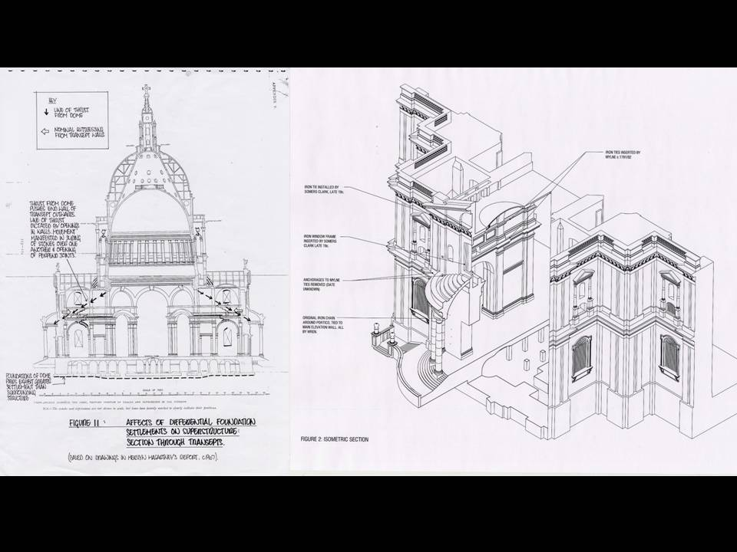

Here is a drawing of the South Transept that formed part of the fat, two-volume report which we put together as a preliminary to our work. I am a great believer in analysing problems before plunging into them, and I found Robert Bowles to be of similar mentality – he too believes in doing his homework first. These two big volumes that we produced, and which are now going into the archive, were very informative and very important. They showed that, instead of being a mighty problem that previous Surveyors had thought would bedevil the Cathedral for some years, the South Transept was not a problem at all.

The right-hand drawing enumerates the various structural schemes put in at various points in the late 18th, 19th and 20th centuries, to try and restrain the so-called outward movement. However, when we came to look at it in detail, we found a few interesting things. There are wonderful tools that one can now use, photogramitry being one of them, which allows you to obtain an absolutely accurate cross-section.

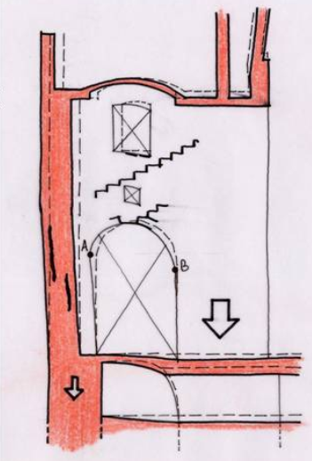

This drawing, by Robert Bowles, shows exactly what he thought had happened. We were able to test this. Notice the letters “A” and “B” at the foot of the springing of the arch and how “B” has slipped down relative to “A”; how the arch has moved out of the true semicircle because of the settlement downwards under the weight of the dome. The main thrust downwards is shown by the arrow. The stone in the middle, marked with a cross, is twisted sideways, and it does not take great understanding to realise that this stone is therefore longer from one corner to the other than it was straight. That is what happened: those stones twisted sideways. The dome could not move sideways because it is too heavy. The only thing that could move was the outer wall, and that moved outwards. By measuring the amounts that the floor and the footings under the dome supports have sunk, you can calculate how far the south wall will be pushed out. Actually, having measured the two and calculated them, we found that they coincided. So, we feel confident that we know what is happening: nothing is happening.

We have taken out some of the ironwork that was put in by Robert Milne in 1782. We have also taken out some of the tie-rods that were put in by Somers Clarke in 1898. I was a little bit nervous when we cut the tie-rods, and half-expected to hear an almighty ‘ping’ – but fortunately, I am still here to tell the tale!

When I started my inspection of the fabric in 1990, I looked up and saw a large chunk of stone coming out of the entablature of the peristyle and wondered what on earth was going on. It was a long way up. We erected emergency scaffolding up and what I saw was not very encouraging. Not only were there bits missing, but there were clearly many more bits about to go missing, given a little more pressure. As a result, we started an exploratory programme, which proved to be an investigative conundrum.

We noticed that some stones had already been pieced in: somebody had been there before. You do not want to open up bits of the fabric that are quite so far up in the air and without support from below, so adopted a very gradual approach. The problem that concerned me was how did this bit of the Cathedral actually work, how was it constructed?

After several months of investigation, we found all sorts of things going on, including a hidden row of arches which were undoubtedly used by Wren to get the blocks in in the first place and level them up all the way round the dome. You must remember that there were four different contractors, each working on a segment of the dome, and they all had to meet one another on a level. The ingenious architect implemented a system whereby they could do that.

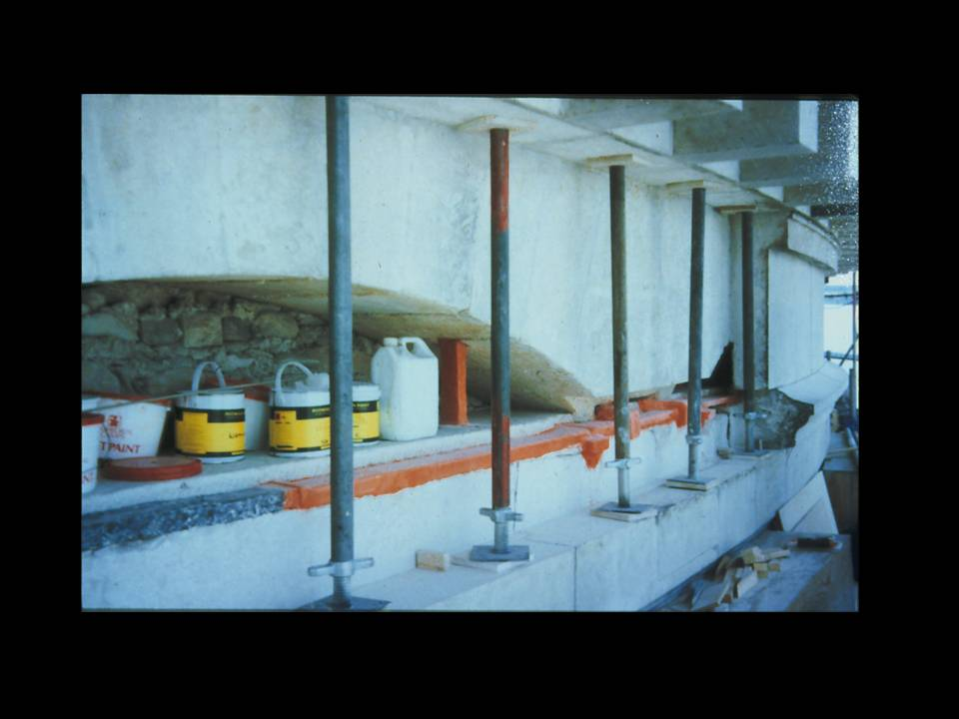

Once we knew how the structure worked, we could act more bravely. In this photograph, you can see the hidden arches. By one of the pots of paint, you can see one of the hangers which allows the lower stones to be adjusted up or down to level it on the completion of the installation. You will also see that there is a great iron chain going right round, and this is what was causing the stones to split away. The slightly lurid orange is because of the fact we used red lead in a lead putty, rather like a glazier’s putty, to clad the ironwork of the chain.

Replacing the stonework around that, where it had been split and fractured, was a very tricky business indeed. I remind you that we are 200 feet up in the air, dealing with blocks of stone that could weigh almost a ton each, and which had to be slotted into place so that the whole thing was structurally stable. None of us felt that it was right to cut the chain, just in case, so we did not do that.

The work took about five or six years. While we were doing it, we took the opportunity to clean the stonework and that, in a way, set a precedent for the major remaining work: the stonework of the entire exterior of the Cathedral. You will remember the blackened photographs that I showed you last week.

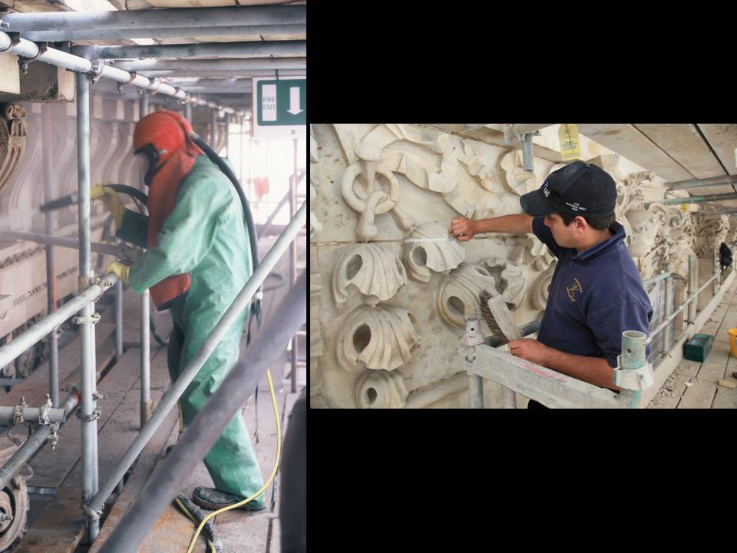

The cleaning process itself looks a bit frightening, with the chap on the left blasting some terrible substance at the stone. In fact, the blast is under 40 psi, so it is a fairly low kind of blast, and there is a very small amount of aggregate in it. What comes out of the end of the tube is essentially a spray of water. Only one or two litres a minute were used, so not very great. It is a very soft and gentle technique, but of course you have to be kitted up to do it.

Of course, the majority of the work has been to try and make the whole external stonework surface as watertight as possible. This has involved a lot of extremely patient pointing, as you can see on the right hand photo.

We were also worried about the effects of continued weathering on surfaces. The major cornices, which had been asphalted by Somers Clarke in the early years of the 20th century, had completely cracked and had pulled away from the leading edges. The leading edges were therefore very thin and indented, so that they were in great danger of actually channelling water down specific routes. So we evolved a little lead strip that runs along the edge that projects out, throws the water off and is then tucked into the asphalt underneath. The asphalt runs backwards to little drainage channels, which run down the internal rainwater pipes. This was dreamed up by Somers Clarke, not me. As a result, we were able to keep all of those leading edges, which are actually wonderful and sound stones, just through using a little black line. This contrasts with what was being done in the 1970s and 1980s, where a huge amount of new stone was being put into those cornices, unnecessarily and detrimentally, because we all love the slightly worn stones that fit in with the rest of the Cathedral.

The end result is of course homogeneity as much as anything else. It has taken from 1994 to 2011 to get round the whole thing. I originally thought that it would take 25 years, so I want to say a big thank you to the donors who actually made this possible by producing the substantial sums of money that it takes to get there - and I say “to get there” because a dishearteningly large amount of that money goes into the scaffolding! But I hope you agree that the exterior has now been transformed. It is not blindingly clean, and it never will be, and, in my view, never should be, but it is homogenous.

The great west steps were replacements from 1875, put in by F.C. Penrose. He used blue Guernsey granite to replace the black Irish marble which Wren had used and which had entirely decayed. When we took them off, we saw that they were balanced on a curious sub-structure, composed largely of a material called trass, which is a very interesting mixture of volcanic ash and lime, to make what Wren believed, and with good reason, to be a good waterproof substance. However, the steps were moving and letting in water at an alarming rate and we felt that this should be addressed.

We took them completely to pieces and put them back together again. This was a task made a little bit more challenging because of the way that they were set out by Penrose. These are not the steps that Wren designed. He had a different great west staircase, which Penrose completely redesigned in the mid-1870s.

Penrose was not the first person to notice entasis on the Parthenon in Athens, the absence of any straight lines within the architectural layout. That had first been observed by another Surveyor of the Fabric of St Paul’s Cathedral, Charles Cockerell, a generation before. However, Penrose was the first person to measure the Parthenon absolutely accurately, to a thousandth of an inch of tolerance (pretty good going, I reckon).

Penrose laid the steps out with an entasis. We had to take all that to pieces, and then put it back the same way again. Fortunately, we had a contractor who was able to do that.

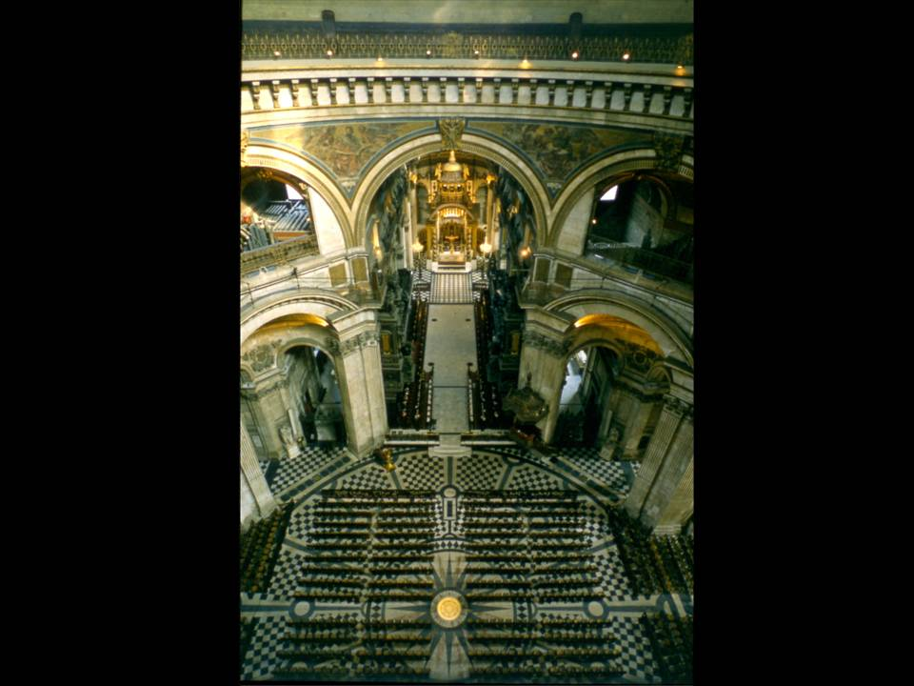

I turn now to the interior. Let me remind you of how the Cathedral was arranged for worship on a normal day-by-day basis. It is like a big parish church, with a kind of nave going up to a chancel screen, with the choir in the choir stalls, and that great high altar up at the end. The choir loved being in there: it is nice and cosy, with velvet cushions, but it does not actually project the sound very well.

On big diocesan occasions, the Dean and Chapter rigged up a sort of camp. They did not know, in those days, that camps were what one did at St Paul’s! They put up rather ramshackle platforms, with old bits of frilly carpet round the edge. When you realise that these platforms were used by the likes of the Bishop of London and the Archbishop of Canterbury, you can understand why I felt that this was something that needed to be changed.

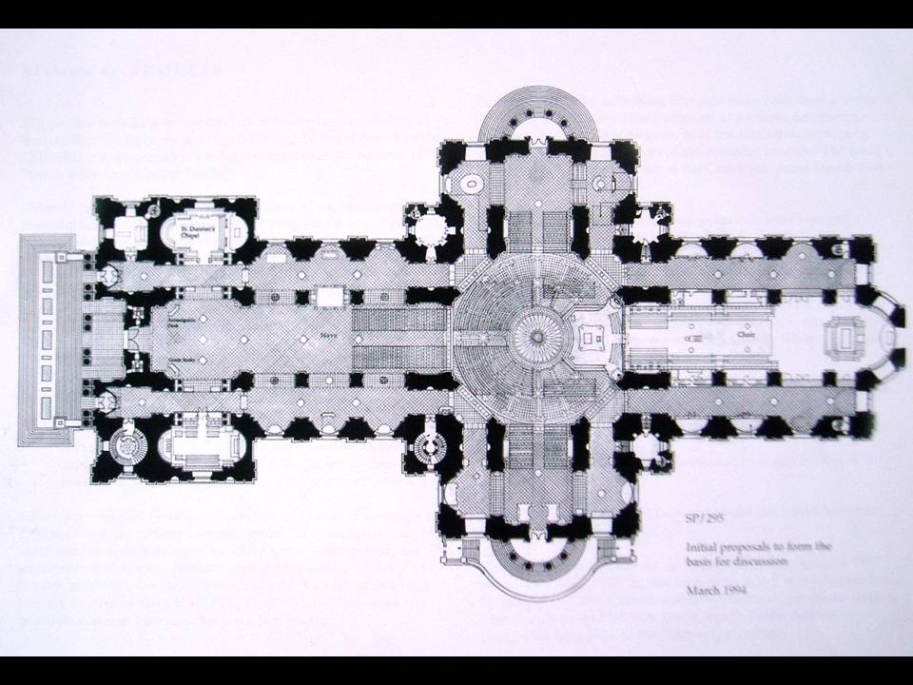

I did a drawing, which replicates very closely the Micklethwaite drawing I showed you last week. I did not know about the Micklethwaite drawing at the time, but we were both on the same track. That is, the position of the altar greatly affects the number of people able to see it. I persuaded the Dean and Chapter that it was worth doing a mock-up. We built it out of MDF and veneer, and put it up for a whole liturgical sequence, from Easter through to Christmas. I think that if I had not reminded them, the Dean and Chapter would not have noticed that it was a mock-up and left it in place forever! Eventually, I persuaded them that it was not worthy enough, and we had the current dais made, out of beautiful materials and as well-crafted as I could manage, because I think that it will be there for a good length of time. It is placed on the floor so that, when liturgical fashions change (and we all know how liturgical fashions change), it can be taken away again and the floor will be left untouched.

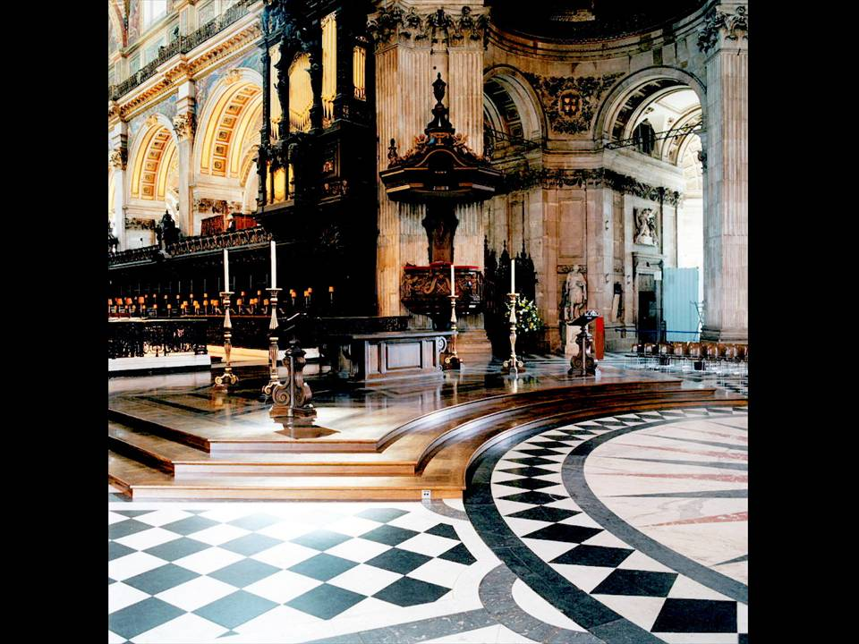

It is designed in such a way that it can come to pieces. It would take two or three days to take to pieces and probably about a fortnight to put back together again, but it is made in sections because that is what the Dean and Chapter requested. Fortunately, I think that they have forgotten that this is the case because it has never needed to be taken to pieces since.

The end result is something which adds a real dignity and sense of community to major services under the dome. We are now working on the furniture for the choir and another mock-up has been in place for a number of months testing that. I rather hope that the Dean and Chapter do not forget that that is a mock-up too and that, one day, it needs to be replaced by a more worthy piece of furniture.

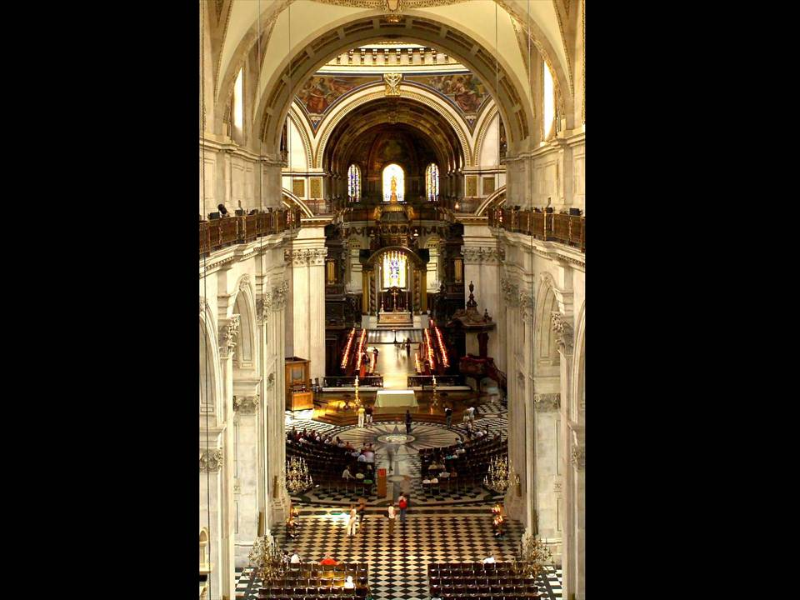

The end result has been that the sense of community around the new central altar under the dome. It has, in the words of Dean John Moses, enabled the building “to speak of faith”. He and I worked together to install a paradigm of the spiritual journey. The people gathered round the altar in the centre of the building become an image of the church on Earth, while the high altar, in the far distance, becomes something of a transcendental image of the life beyond.

Of course, that pilgrimage of faith required a starting point. Wren did not actually provide a font for the Cathedral. It was only provided after his death by Francis Bird, and is a beautiful piece. It has a marble top, weighing a number of tons, and there are no means of taking it off. Therefore it is not altogether surprising that it was not used very often in the first 160 years of its life.

It has since been something of a refugee, hiding in different corners of the Cathedral. I got a clever sculptor to make an exact life-size mock-up of it in polystyrene. We also made another mock-up, at the west end of the nave, to see whether it maintained the right kind of scale there if we took the lid off. We have the lid safely upstairs, where we hope to put it on display soon, but we have decided that it should be on a proper dais, in a proper, permanent way at the west end. In that position, it completes this paradigm of faith as a processional route, from baptism and initiation through to transfiguration at the extreme east end. It is a simple idea, but can only work clearly in a place like St Paul’s.

The space under the dome gets used for all sorts of things. Of course, this area requires some stage managing because the popular night for concerts is a Saturday night, and by early Sunday morning, the Cathedral has to be back to its normal configuration.

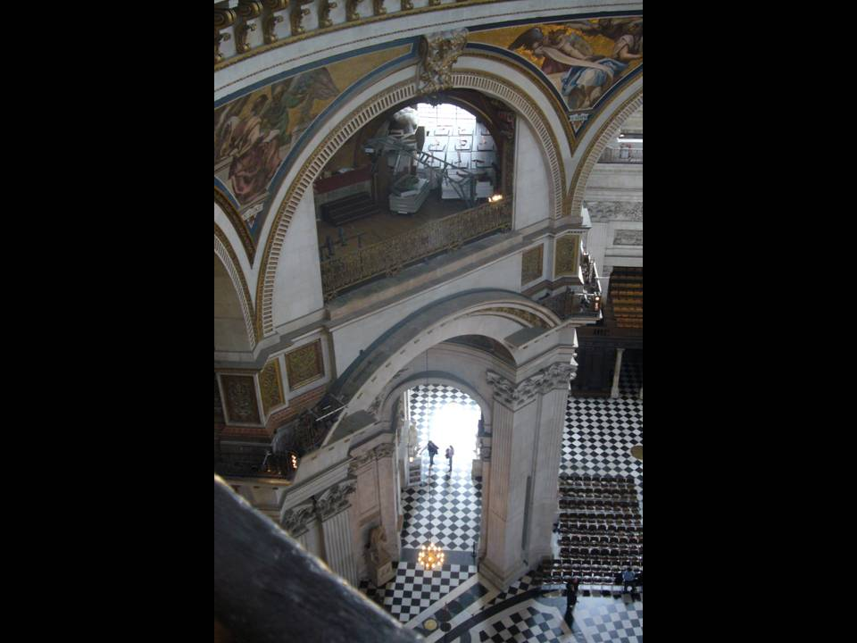

So, I put a crane in there. It is like a derrick for lowering lifeboats from a liner. It swings out to set down the decking for platforms and then lifts it all back into storage afterwards.

St Paul’s is a monumental place and there are not really enough points of focus for quiet prayful reflection. Holman Hunt’s famous picture, The Light of the World, hung in the south nave aisle until Princess Diana’s death, when suddenly it became the centre of an enormous pile of flowers and lots and lots of candles. Visitors were always bumping into them, and we might have burnt the place down, but it demonstrated a particular reflective quality of the painting. As a result, I have re-set it as an altarpiece, as a much more focal position, in the Middlesex Chapel.

We have talked for many years about other points of focus and discussions have been in progress now for several years with the great American video artist, Bill Viola. He is presently making two wonderful new artworks which are going to be positioned at the end of the choir aisles, to be installed probably at the end of next year.

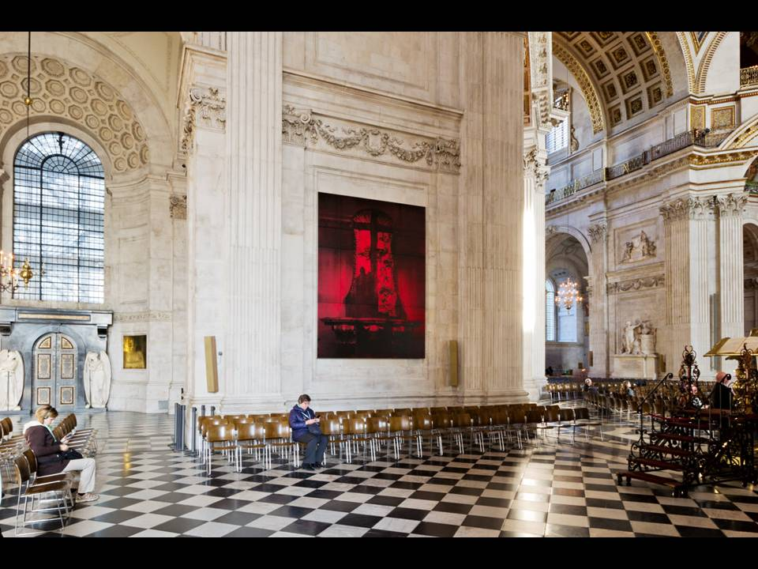

The re-arrangements of the interior layout have allowed the Cathedral to engage much more immediately with the visual arts. These great panels on the walls at the entrance to the dome have become places where, from time to time, artists have been able to show work for a few months, to the great benefit of all.

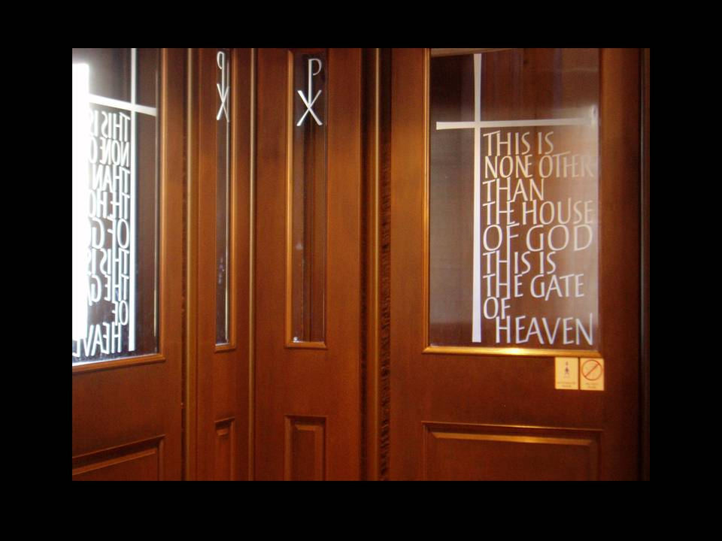

I have also tried to foster the work of the great craftsmen-artists. We installed some great new revolving west doors, with glazed panels etched by Richard Kindersley. They are wonderful inscriptions. He has managed to make Jacob’s Ladder out of the little “H”s that run up to the cross.

But it’s not just the layout of the Cathedral that needed to be addressed back in the early 1990s – it was the whole interior that seemed so dispiriting. I suggested cleaning it for the Millennium, and there seemed to be plenty of time from 1991 to the Millennium, but of course these things take a lot of preparation and research, and there were very many more important things that needed to be done first. The preparation and research took us right up till the year 2000 and we were not able to begin the cleaning work until 2001. We had to do art historical and technical research. We had to find out whether it was affordable or not, whether it was practical in programming terms. Of course, the consents you need for this kind of thing are also alarming in the extreme.

But we did develop a series of tests, to see what cleaned stonework might look like. We covered one whole little bay of the South Transept to see what the effect of cleaning would be on a whole element within the church. On the completion of that, the various advisory committees were able to give their approval for us to do the substantial work involved in undertaking the cleaning of the complete interior of the Cathedral.

To begin with, there was dust - tons of it. The technique we used, which we imported from Belgium, involved applying a latex spray to the stonework. This was carried out by a special team who came over every three weeks from Belgium. They sprayed the material on, which created a latex mask covering the stonework that could very simply be peeled off and bagged for removal. It then only needed a little brush with water to remove the dirt completely and expose the clean stonework of the interior. In doing so, we exposed the wonderful intricacy of the carved work which had before just been a mass of black soot. The end result has been a complete transformation of the interior of the Cathedral. Not only is it full of light but it has that ‘homogenous’ architectural character that Wren intended.

We did leave a panel behind the great west doors in uncleaned stone, just so that people could be reminded of the previous state of the Cathedral. In fact, we have placed a glass inscription over the panel as a real thank you to the extraordinarily generous donation that enabled this project to be carried out.

It was the Thornhill dome, high above, that proved the biggest cleaning challenge. When you are standing on the floor and you have got to specify what the conservator is going to do when he gets up there on his expensive scaffolding, you really do have to think very hard!

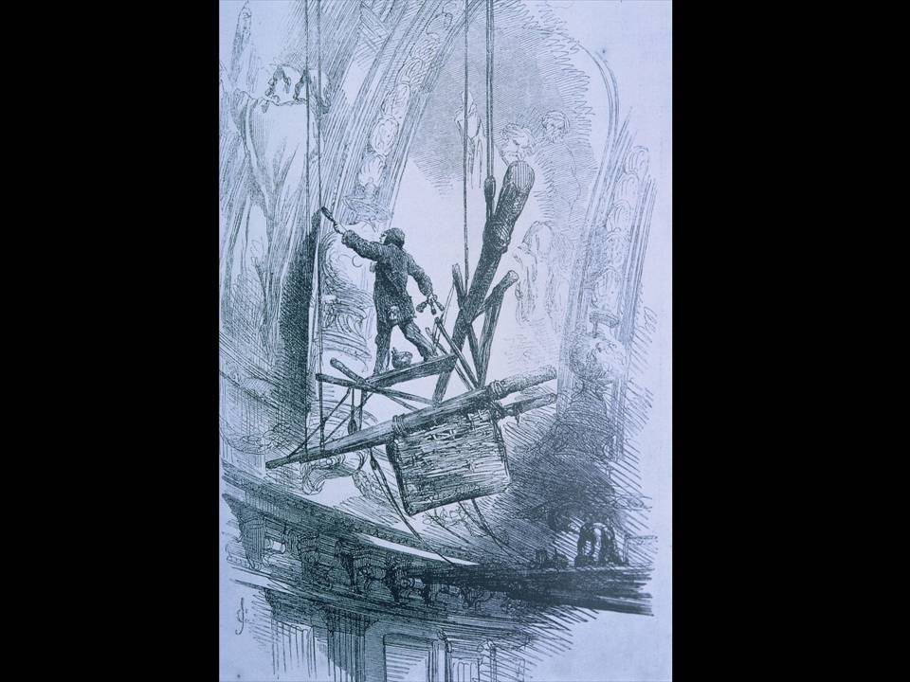

Of course, people had been there before. E.T. Parris did an amazing job between 1853 and 1856. Perhaps this illustration from the Illustrated London News at the time slightly over-glamorises it, but it does make the point that health and safety issues are slightly more rigorous than they once were! He completely repainted, single-handedly, the bottom twenty feet of the entire dome, all the way round.
We needed rather safer scaffolding to get there, but we also needed to keep the dome visible because public access to the Whispering Gallery is an important money-spinner for the Dean and Chapter. We also needed to be able to monitor the appearance as we worked. So, I had this dotty idea, as architects do, of hanging scaffolding from the top of the lantern, by a cable, so that it could rotate. The poor engineers and scaffolding designers had to try and make it work, which, to give them their credit, they did, eventually.

We did not know to what degree of cleanliness we were able to get the painted surface until we got up there. The ability to move the scaffold allowed us to do initial areas, move the scaffold out of the way, and then stand back and actually see how we could marry the cleaned area of the painting above down to the stonework which being cleaned below.
Once up there, we discovered all sorts of interesting things. It was well-known that E.T. Parris had repainted the bottom twenty feet; what had not been known was that he actually scraped all the plaster off, completely back to the brickwork, re-plastered it, and then put the whole thing back on again.

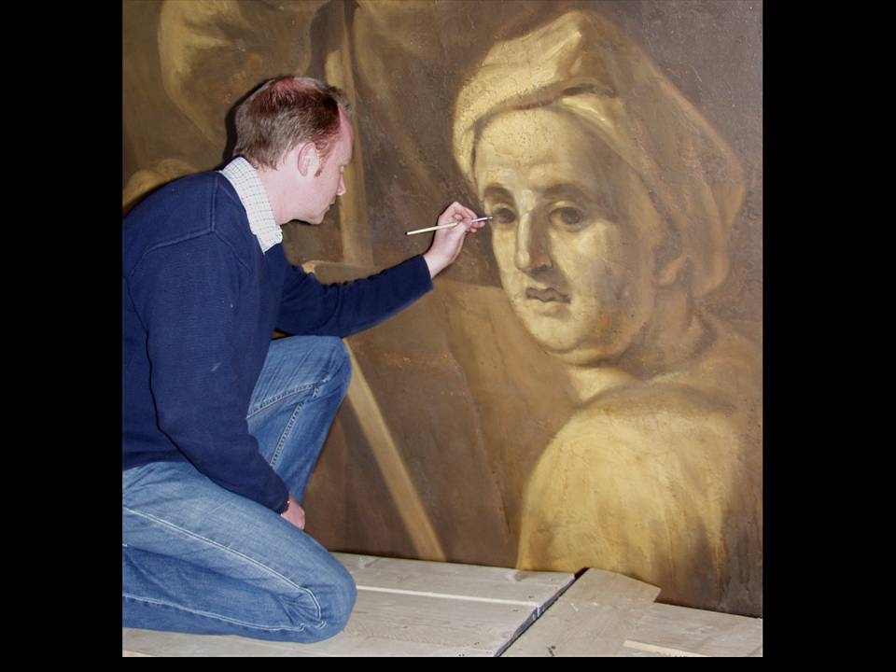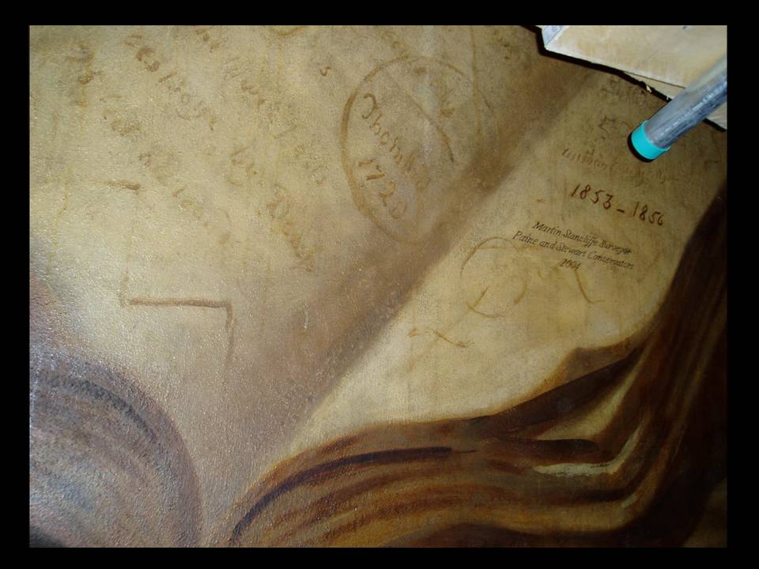

We also discovered this self-portrait of Thornhill. He signed his name in this seal, “Thornhill 1720” and E. T. Parris had also put his name and date there. We thought we would be cheeky and add ours too. So, that is the one place where I appear in the Cathedral, but you need a quite powerful pair of binoculars to be able to see it from below.

What I had not realised was that the area above the Whispering Gallery and below the bottom of the dome had been completely painted out in 1859 in stone-coloured paint; Thornhill’s decorative scheme which had been in that area had been completely forgotten.

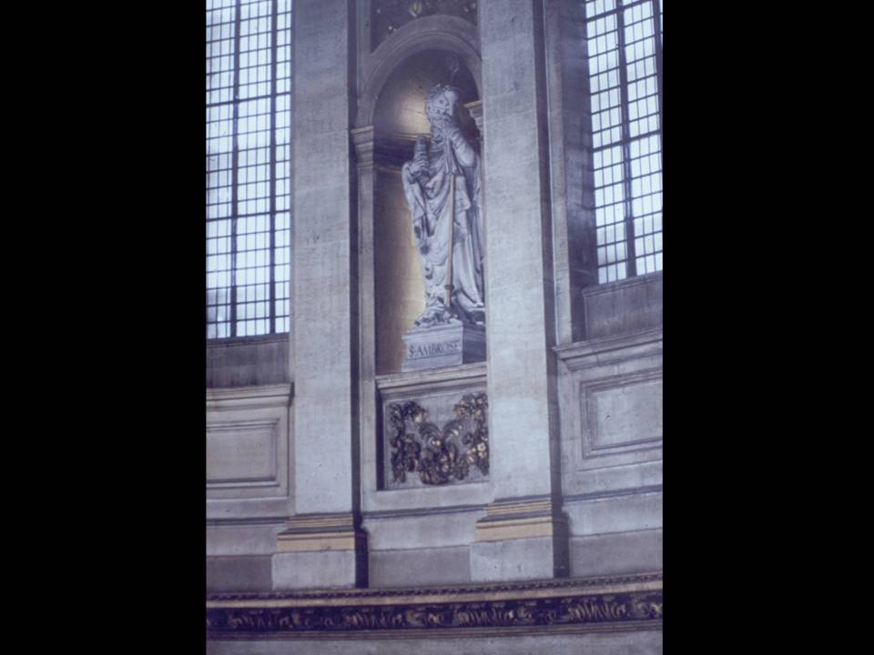

But in this photograph, you can just make out the shadow of the under-painted fluting of the original Thornhill scheme below.

We then carried out an excavation of that. We patiently scraped off the upper layer of paint to reveal the details of that scheme below. To have removed the whole thing, by scalpel, would have taken years and years and cost millions of pounds, and it probably would have been very damaged. In the end, we were given consent to put an archaeological separating layer over this paintwork and we completely reconstructed the whole thing on the top. Charles Hesp, a wonderful painter, repainted the whole thing using the materials of the time. We researched very carefully the exact pigments and the exact techniques that would have been used so that he could replicate them.

We were then able to move the scaffolding out of the way to allow us to see the effect from below and adjust it, depending on how we felt about it. The ultimate result was the unification of the dome.

There are also the great mosaics of the pendentives below the Whispering Gallery. There are eight of them. We did numbers one to seven, quite satisfactorily, moving round one by one. Of course, as luck would have it, number eight proved to be entirely loose – you could push it and it would go in and out. It is just above where the Bishop sits, so we thought we should probably make it a little bit more secure. The whole pendentive of St Mark was taken down, taken away to the workshops and consolidated, and brought back and put back up again.

We always anticipated that transformation of the interior would enable a new lighting system to be developed which would use less power because of the greater reflectivity of the cleaned stonework. I took the bit between my teeth and actually suggested that we hang a great series of chandeliers down the nave. Previously, the lighting system of the 1950s had involved hidden lights all over the place. But these great chandeliers add something very particular to the space as a whole. They are very controllable – they are all on dimmers, so that they can be turned right down and left on, using very little power, even when the building is quite well-lit, adding a wonderful glow to the whole.

Then there was an issue which came along about twelve years ago which we had not anticipated. This was the Equality Act, which says that it is illegal for any building owner not to make adequate provision for equality of access to the church. We had a major report done, which memorably described the west steps as a “formidable obstacle” to anybody who could not easily manage stairs. We thought of all sorts of ways that this might be overcome, all of which were totally disastrous and had to be set aside.

There were some easy things that could be done, like putting in handrails and stone nosings for the poorly-sighted, but the bigger problem was how to get wheelchair users into the Cathedral more effectively.

On the south side, the south-west churchyard had been planted up in the 1970s by a rather enthusiastic Parks & Gardens Department of the Corporation of London. This had developed into a rather outsized herbaceous border of trees, which were very beautiful to look at, but did not allow you to see very much of the Cathedral. In addition, there were no railings round the Cathedral. They had been taken away. We were able to trace them to a yard in Ashford, where they had been languishing. People at the Cathedral had completely forgotten that they existed. I did not know that they existed, and it was only by research that we discovered that they were being lovingly stored, and the contractors were puzzled as to why they were not being asked to put them back again.

We arranged to put them back again, but we also used the opportunity to completely re-landscape the whole area so as to make the door more accessible. Beneath this churchyard lie the remains of the only parts of the pre-Fire Cathedral which visible at ground level. These are the parts of the original Chapter House and its surrounding two-storey cloister, the great work of William Ramsey. The details of the Chapter House layout are now the basis of the re-landscaped system, which actually disguises the fact that it is just a great ramp allowing step-free access!
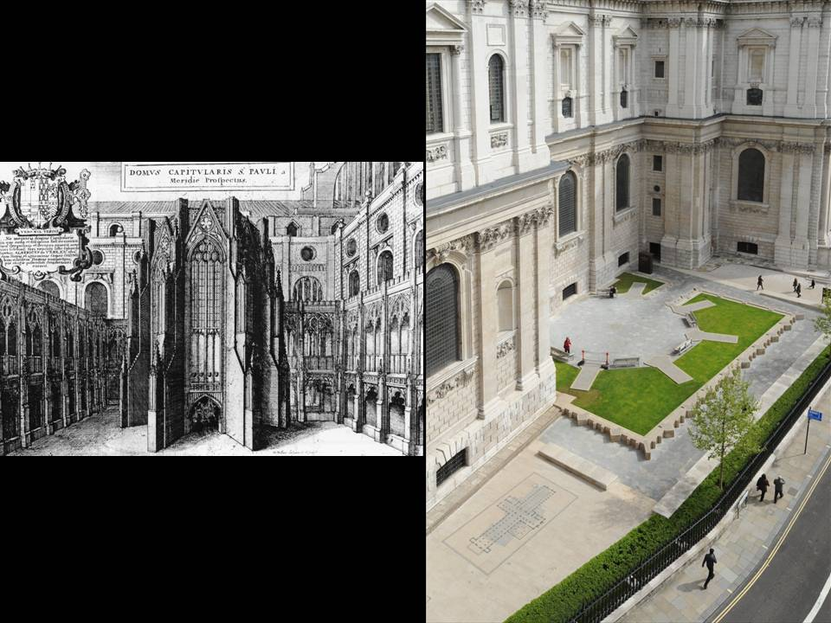

We commissioned Richard Kindersley to make this very beautiful inlay in the pavement, using various different kinds of Purbeck stone, which shows the relationship of Wren’s Cathedral to the much bigger, longer original medieval cathedral which preceded it.

This provided access in one way, but not in others. Another means of access was the installation, in the crypt, of a 270 degree projection system. This is an immersive experience that allows people, with specially made films, to get the experience of going up to the Whispering Gallery and the Golden Gallery above and seeing the views. With that facility in place, we are also able to use it for other things, such as telling, in brief form, the life of the Cathedral and its history.

I have to say that, initially, the Chapter were not persuaded by my ideas to open up the crypt: very few people visited the crypt because you had to pay to go down. However, I pointed out that if you put the WCs in the crypt, it would ensure that nearly every visitor goes down - and so it has proved.

As a result, the transformed centre of the crypt, as well as being a very busy and sociable place, has benefitted the life of the Cathedral in ways which I hardly dared to think possible when I started on the drawings. We have squeezed a great deal of additional space in, which you cannot see when you are in the crypt, by adding mezzanine levels wherever we can. This has enabled us to have not only a shop, a café, a refectory, a conference suite, but also staff restrooms and common rooms, and a completely new Education Department, a completely new set of choir practice rooms and new entrances from the undercroft. That has transformed the life of the crypt, and it has also transformed much of the life of the Cathedral.

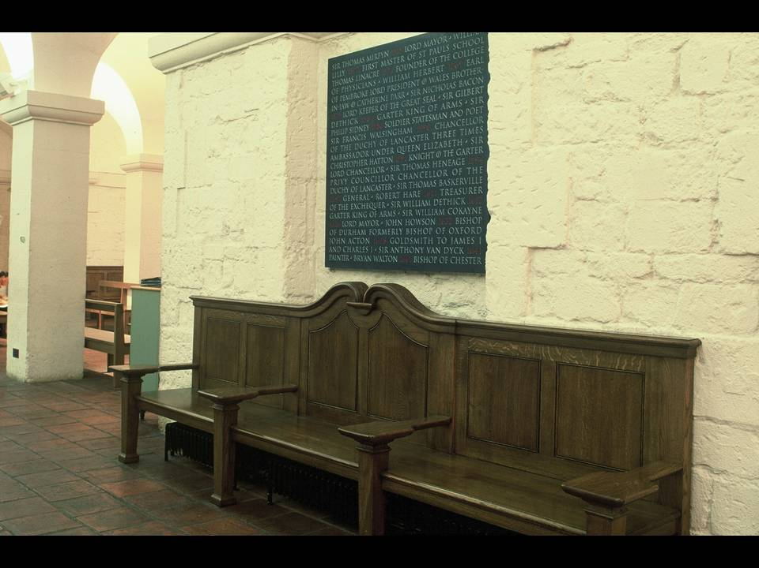

The furniture and other details are important too. I designed these big benches to look as though they might have been there for a while, but you will notice that they have got wonderful flat, wide arms, which are designed to hold trays and cups of tea from the café. Above them, you will see Richard Kindersley’s beautiful inscription recording many of the significant memorials lost in the destruction of the pre-Fire Cathedral, a beautiful piece of late 20th Century lettering.

The division of the crypt into three differently characterised areas has made it, in my view, all the more legible. There was a great deal of pressure for a memorial to Winston Churchill, on the model of the tombs of Nelson and Wellington. Of course, Churchill is not buried in the Cathedral.

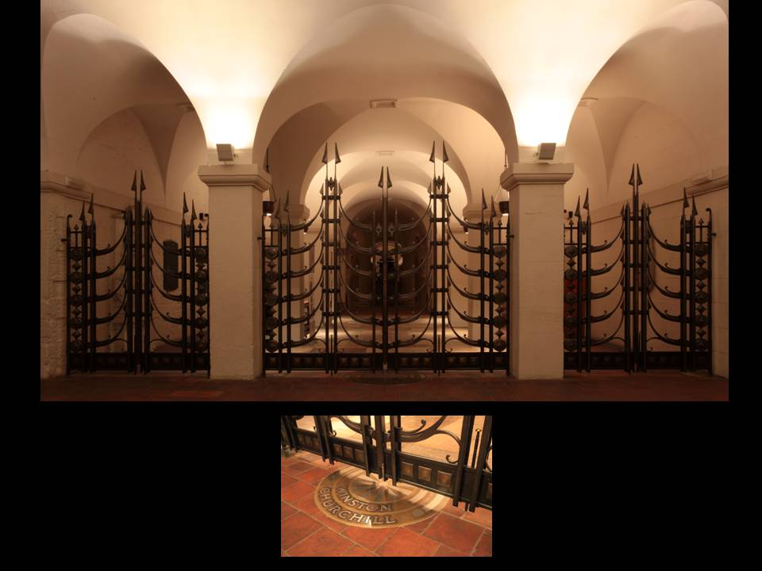

The suggestion was put forward for a great screen dividing the national mausoleum of Wellington and Nelson from what the previous Dean called “the people’s boulevard”, the western part of the crypt. This fine piece of contemporary metalwork was eventually commissioned, and I enjoyed very much working with Jim Horrobin, a most wonderful craftsman in metal, in his forge in Somerset.

We have also lit the crypt completely anew. I often come to blows with the guides there because I want the area around Nelson to be as dim as can possibly be, and I am forever turning down the lights, only for them to be turned up a little bit. We have now agreed on a good compromise, and the atmosphere down there makes people behave much better – they are much more reverential and quiet.

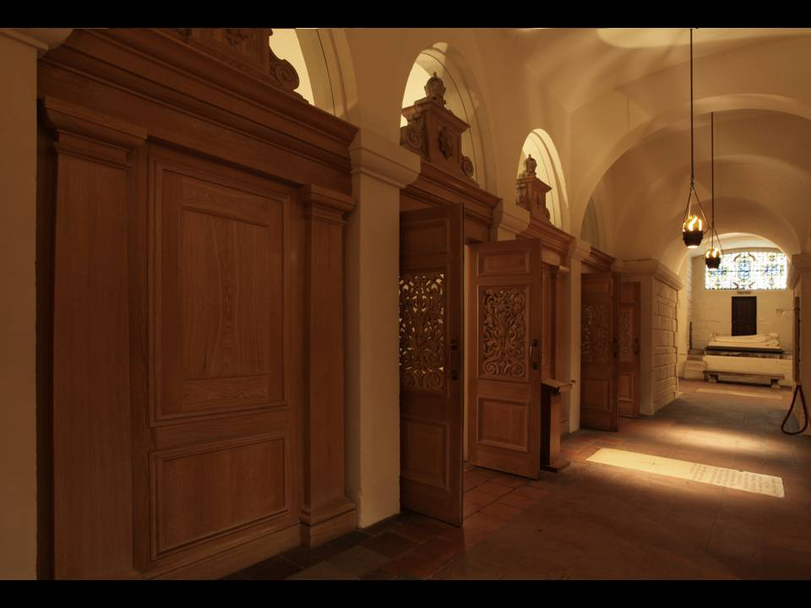

I referred last week to the fact that the OBE Chapel did not really work in the crypt because whenever there was a service, the whole crypt had to be shut because of noise disturbance. So, the first thing that I did was to design a completely new screen, as acoustically protected as possible. Each of those caskets above is split by a piece of acoustic glass. Hopefully you do not notice that there is glass there, but it enables you to shut the door and for the inside and outside to be separated from one another.

The OBE Chapel itself was also completely redecorated and relit, with a rather flamboyant lighting scheme I thought up about sixteen years ago now, but it still seems to be alright.

At the east end in the OBE Chapel, the floor was covered for the floor by curling vinyl Marley tiles in grey and white, which were not very satisfactory. We discovered that the reason they were there is because there is a Victorian mosaic underneath. They clearly did not want to disturb at the time, despite the fact that they had cut through it to make a new step and insert Mandell Creighton’s great ledger stone. So it took a little bit of persuading to enable us to lift the mosaic floor (now up in the triforium ready to be put down for display purposes) and replace it with a completely new marble floor, using the silver grey and the rose colour of the order (silver grey Purbeck stone and the rose coloured rosso di Verona). These pick up the materials in Bishop Mandell Creighton’s wonderful ledger stone, which needed a lot of conservation after years hidden under a carpet.

The business of wear and tear on the floors is an ongoing issue. Many years ago, I started a gradual programme of assessing ledger stones to establish whether they should be allowed to wear out or whether they recalled burials significant enough to merit re-cutting.

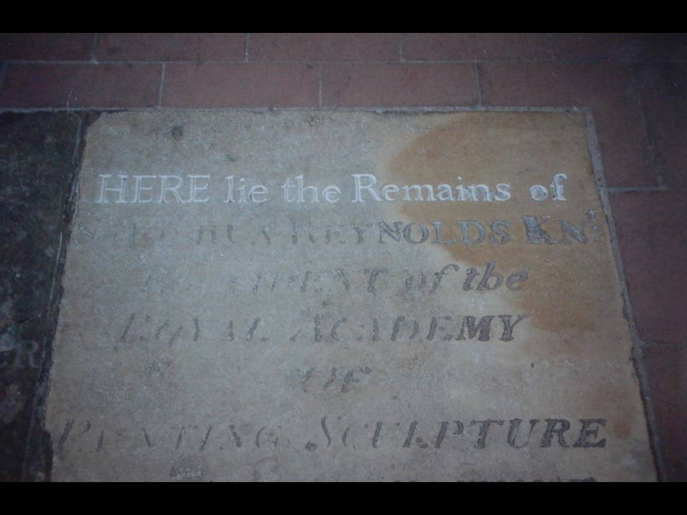

Here is one of the few that we decided we would re-cut. This is Sir Joshua Reynolds, in the process of being done. It was done eleven or twelve years ago now, and I think it is now almost indistinguishable from the others surrounding it. I commend it to my successor to see whether the process of continuing occasional re-cutting should not be followed.

Care of the fabric must also extend to its historical artefacts and archives. I pointed out last week how many wonderful things were scattered around various parts of the Cathedral. I was permitted to put down a floor, over large areas of the triforium, to create a conservation studio and an archive store.

The Cathedral holds an extraordinarily important archive, which I have shamefully added to by an enormous percentage during my time as Surveyor. The creation of a larger archive storage space has, in turn, made it possible to employ archivists and conservators, who, in turn, have been instrumental in bringing in students in order to give them useful hands-on experience. Now, twenty years on, there is a whole Collections Team. There is a Collections Manager, a Librarian, an Archivist, and a Conservator, and they all bring in students to help them.

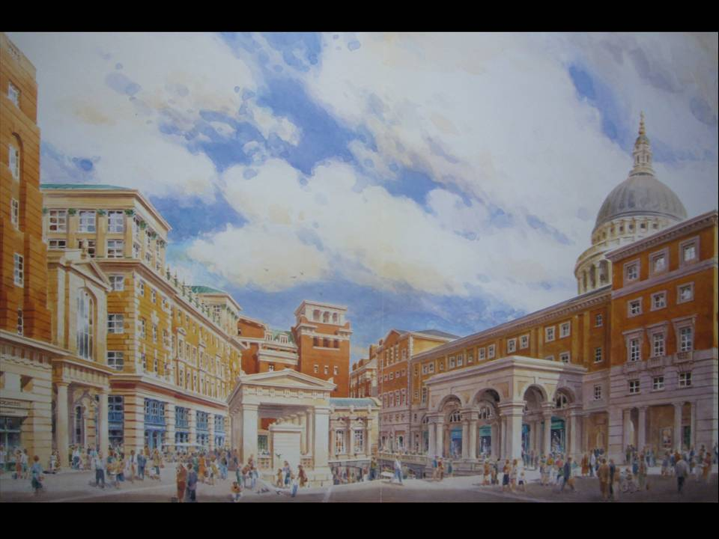

Finally, a brief review of the Cathedral’s setting over the last twenty years. Last week, I talked about the Paternoster scheme of William Holford. A replacement to it was arranged by a competition run in the 1980s, which was won by Arups in 1987. However, for good or bad, it was set aside in favour of John Simpson and Terry Farrell’s, luckily unbuildable, scheme, which would have effectively cut the Cathedral and its Chapter House out of the new Paternoster Square. If I compare that with what has been built there now, you can probably see that this space is actually a nasty trick, because all the people have been made about three-quarters’ full-size to make the space look substantially bigger than it would have actually been. Luckily, the planners cottoned on to that and other aspects of the scheme, which made them feel that perhaps it was not to be followed. Instead, William Whitfield was appointed to act as Master Planner for the Paternoster Scheme, as executed in the late ‘90s and the first part of this century.

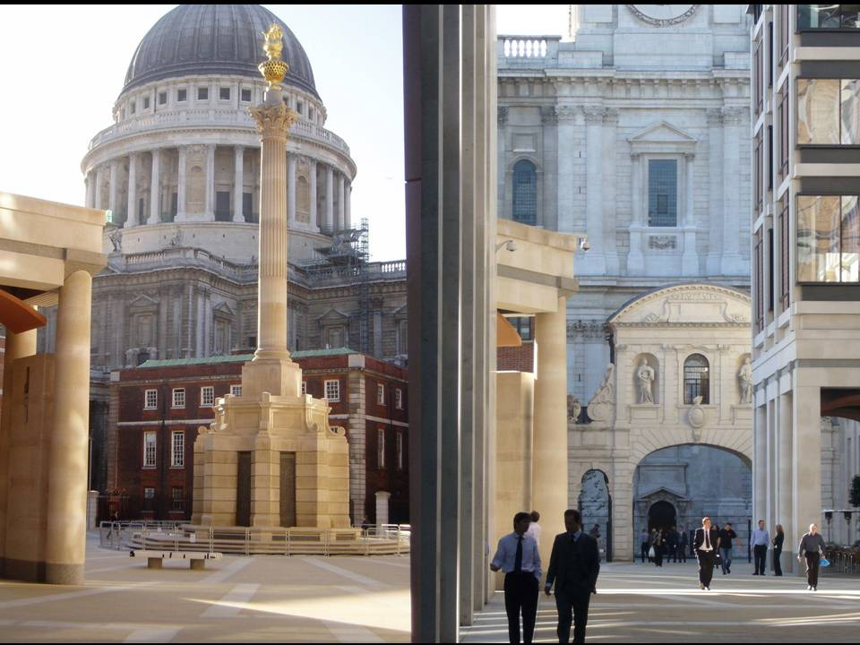

This arrangement does at least allow the Cathedral itself to dominate, and the Chapter House remain an important part of the Square. It has also allowed Temple Bar to be brought back, at last.

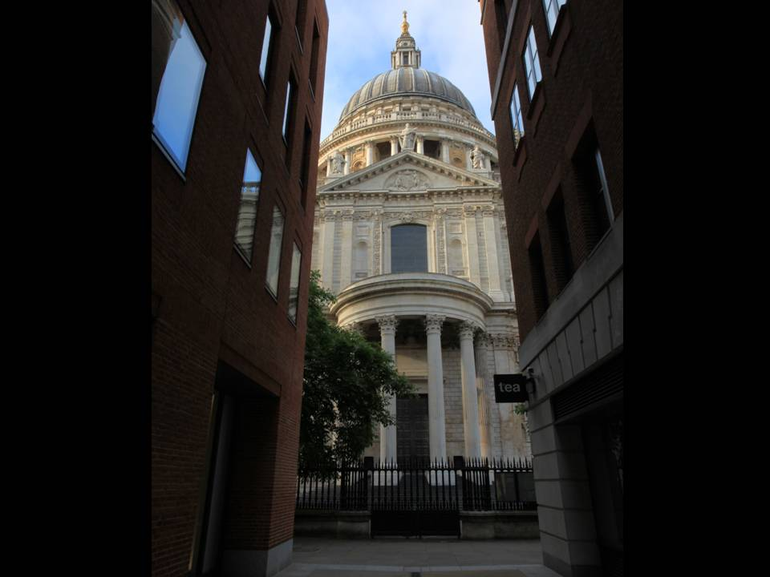

It has also enabled great vistas of the Cathedral to be opened up, which follow street patterns from the original 17th century and indeed earlier, blocked by the Holford scheme. This is a favourite view of mine, down Canon Alley on the north transept.

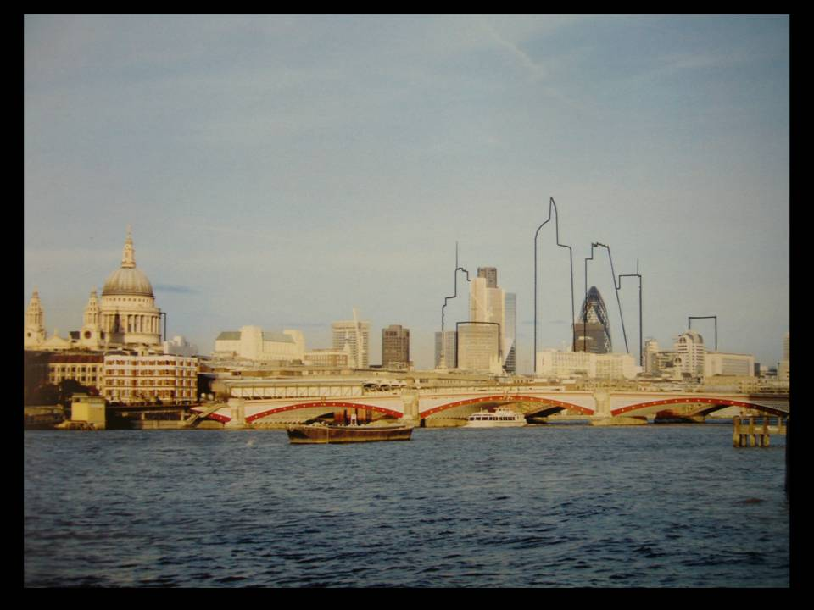

The march of progress of course continues. The planners of the City of London have generally been good friends to the Cathedral and have striven to ensure that the cluster of towers, with which they have been greatly preoccupied over the last twenty years, does not overwhelm the most important views of the Cathedral from the key points. All of those buildings that are shown in the above image have now been given consent and, as you will see, some of them have already been constructed.

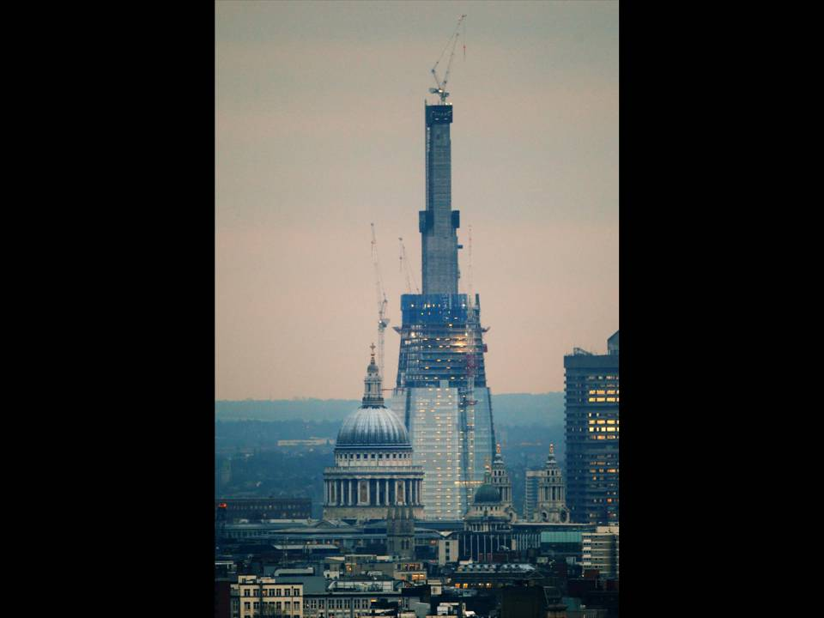

The City, as I say, has been sensitive to the Cathedral and its position on the skyline and sensitive of the need to plan it. Unfortunately, that sensitivity does not quite extend to other boroughs. The Borough of Southwark hardly noticed that this was going to be the impact of the Shard on the Cathedral in important protected views from Parliament Hill Fields.

So the pressures remain. I appeared for the Cathedral at the public inquiry into the Shard to object to it, on the principle of scale, making the point that the Shard would completely dwarf the scale of the Cathedral itself. In the Inspector’s report, he did not use the word “scale” once. That is developers for you…

The real story over the last 20 years is the story of the changes to the building itself, and I admit that they have been fairly radical. It is possible that these changes extend to more parts of the Cathedral, and indeed to more parts of its mission, than those made in any other similar period in its history since the building was completed 300 years ago. My hope is that these new interventions will slip gently and imperceptibly into history, but only time will tell.

Thank you.

© Martin Stancliffe 2011

