Men, Women and Guitars in Romantic England

VI

The Guitar and ‘the Fair Sex

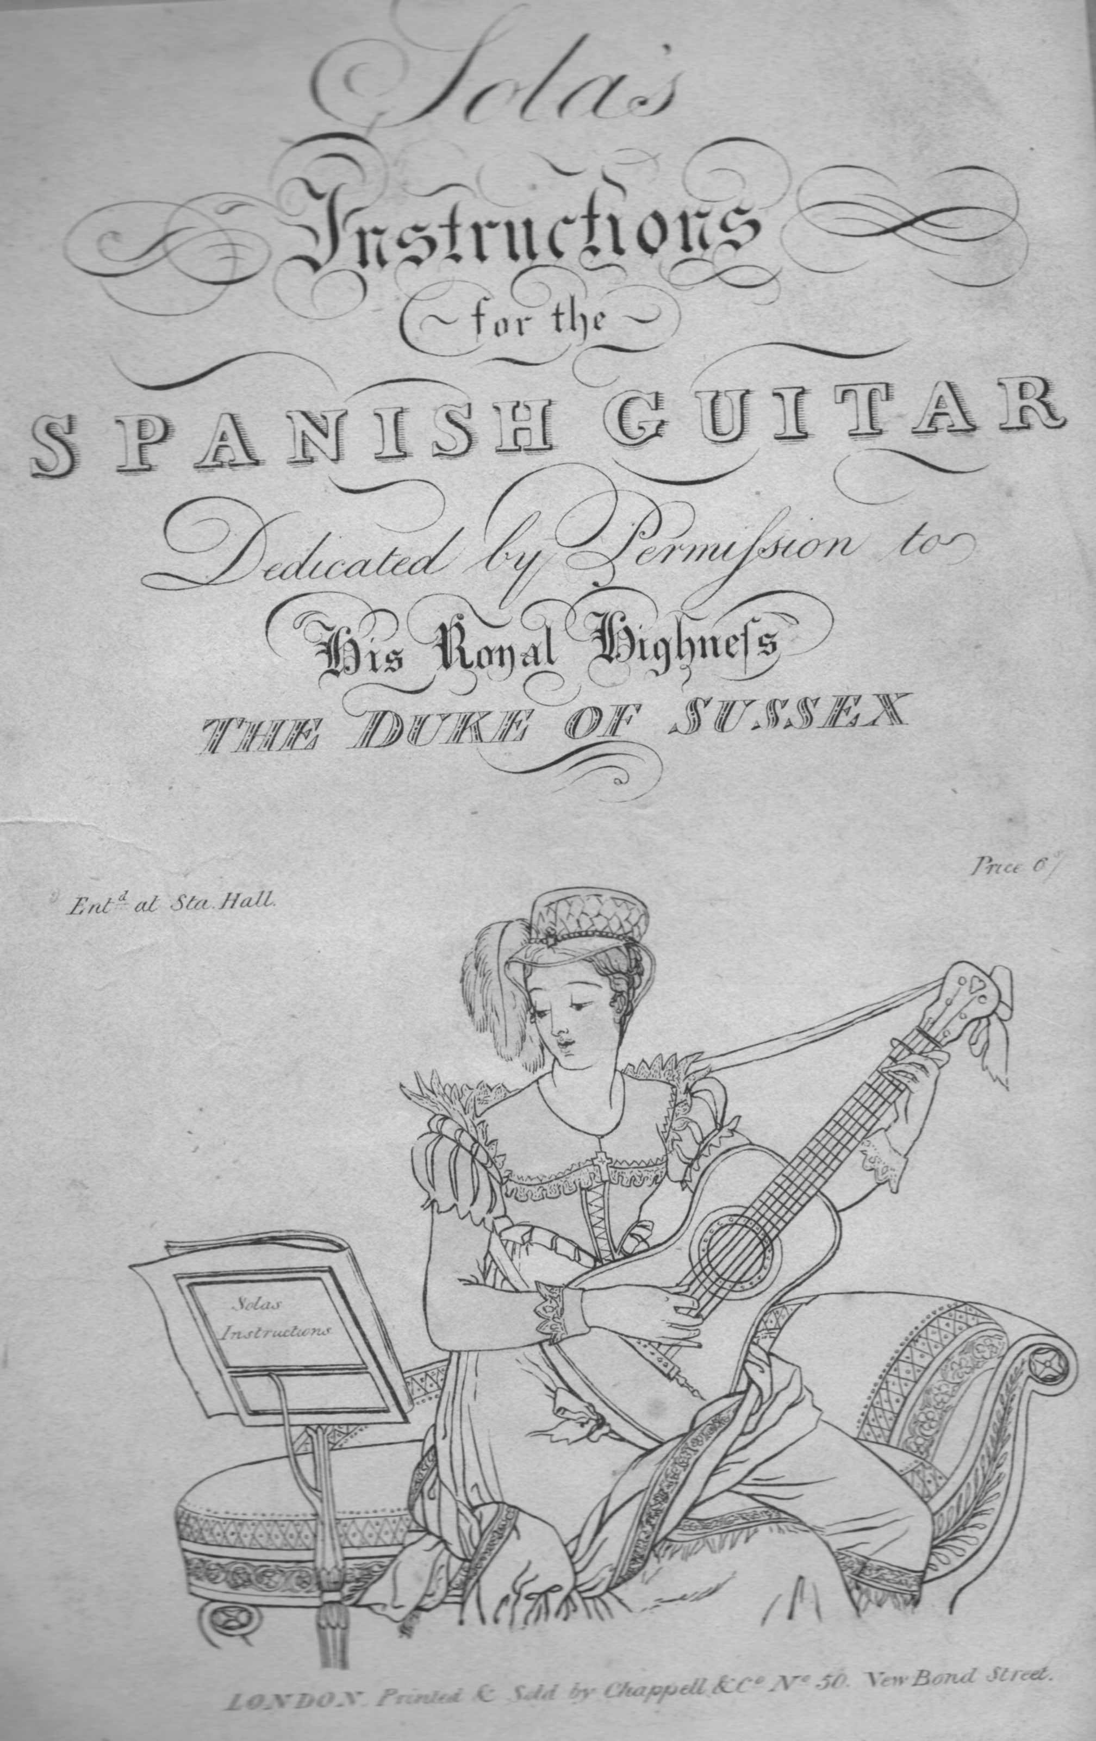

1 The title page of Sola’s Instructions for the Spanish Guitar (1819) Private collection

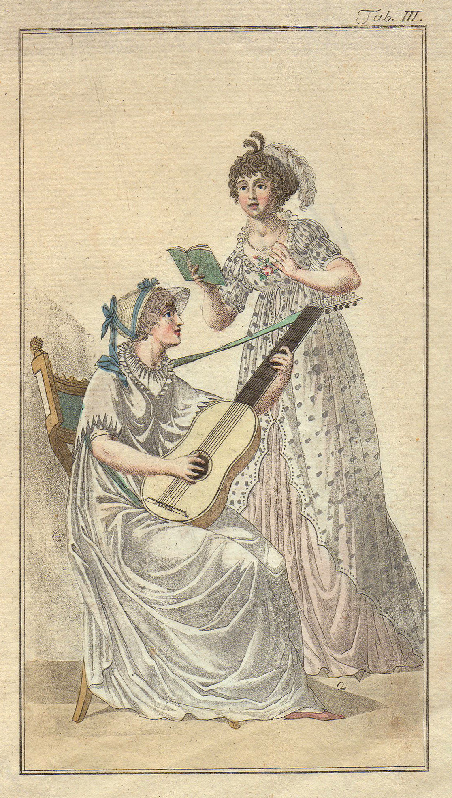

2 Undated fashion plate. Private Collection.

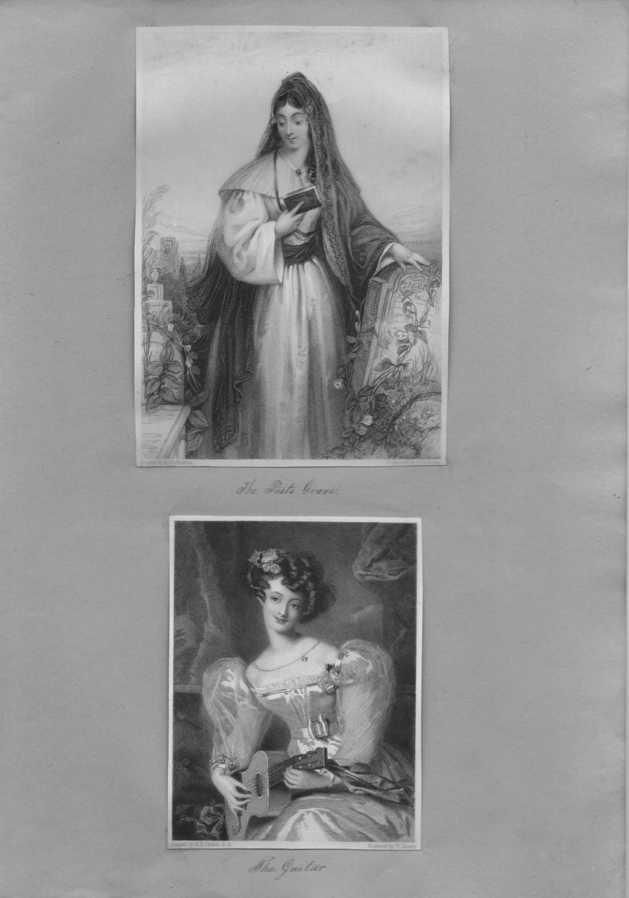

3 ‘The Poet’s Grave’ and ‘The Guitar’ (engraved after Chalon). Scrapbook of c1830. Private collection.

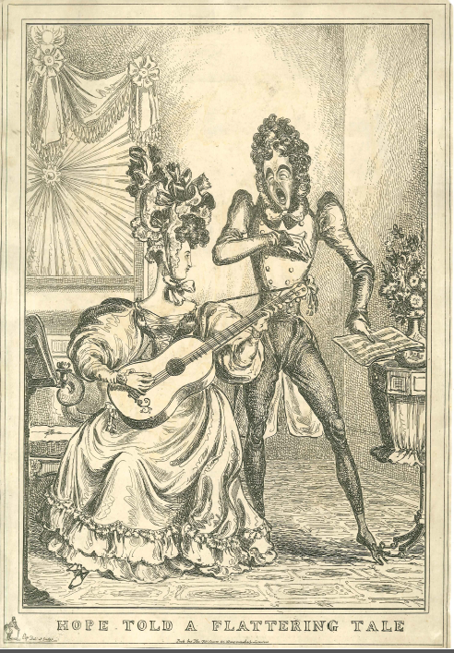

4 ‘Hope told a Flattering Tale’. A caricature by William Heath, published by Thomas McLean, London, c.1828.

