Men Woman and Guitars in Romantic England
IV The Guitar and the Romantic Vision of the Medieval World
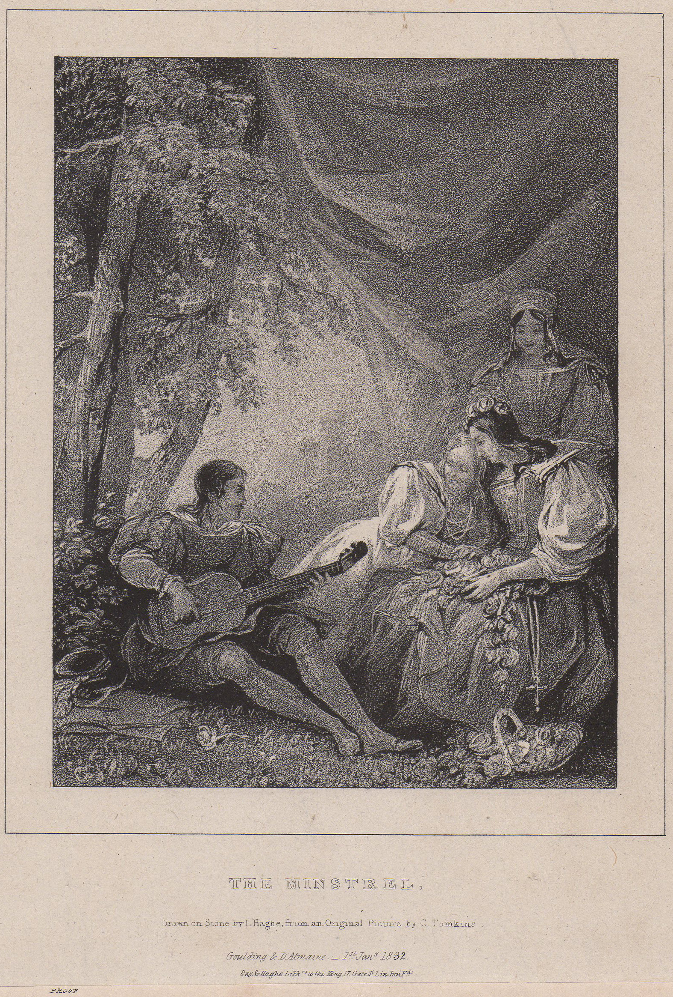

The minstrel. Engraved by L. Haghe from a painting by C. Tomkins. Published by Goulding and d’Almaine, 1 January, 1832. Private Collection.

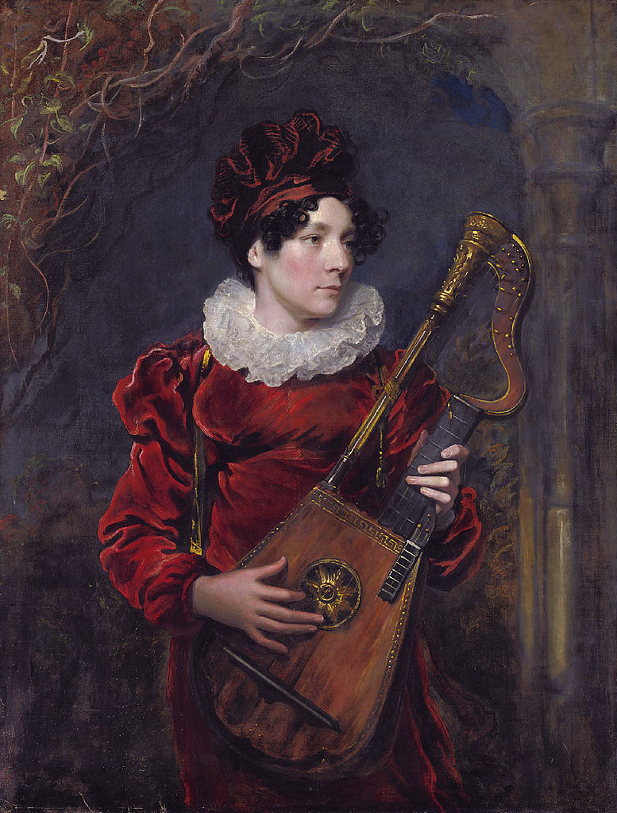

Kitty Stephens, later Countess of Essex (1794 - 1882) playing a harp lute, by George Henry Harlow.

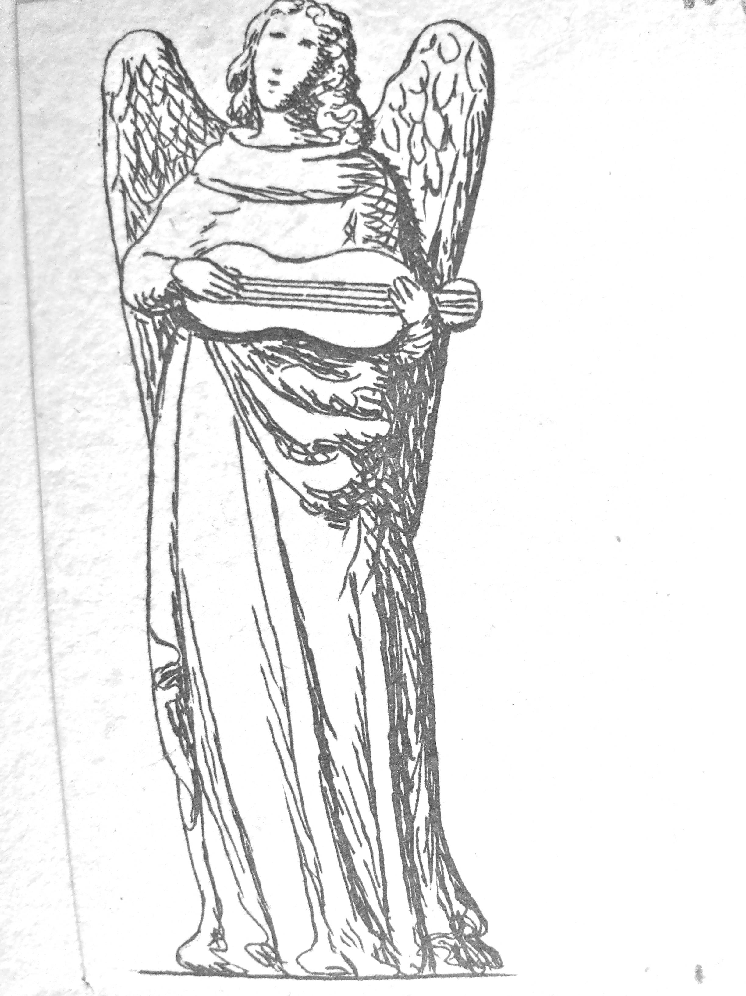

An angel with a gittern. From the sketchbooks of the antiquary Francis Douce (1757-1834).
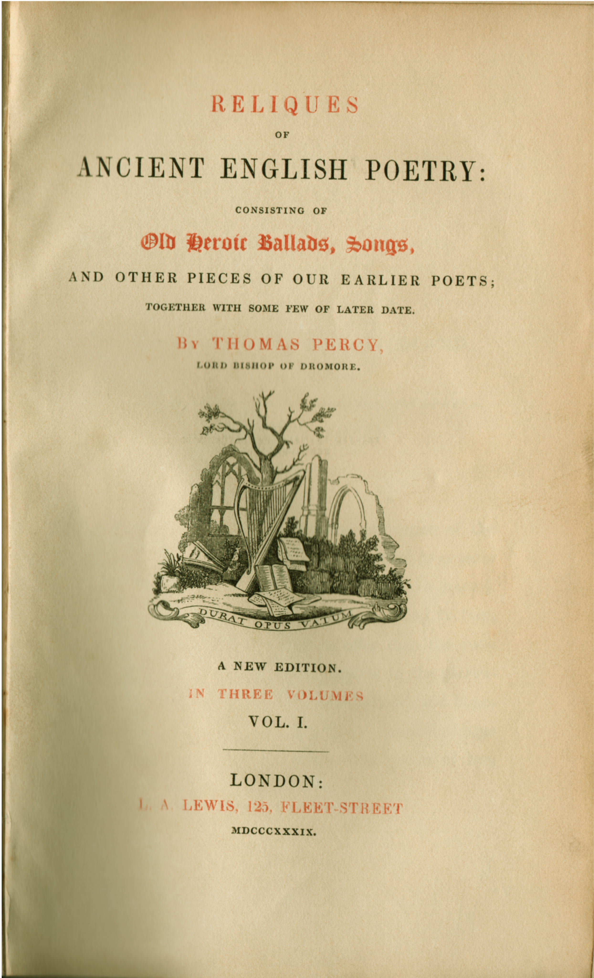

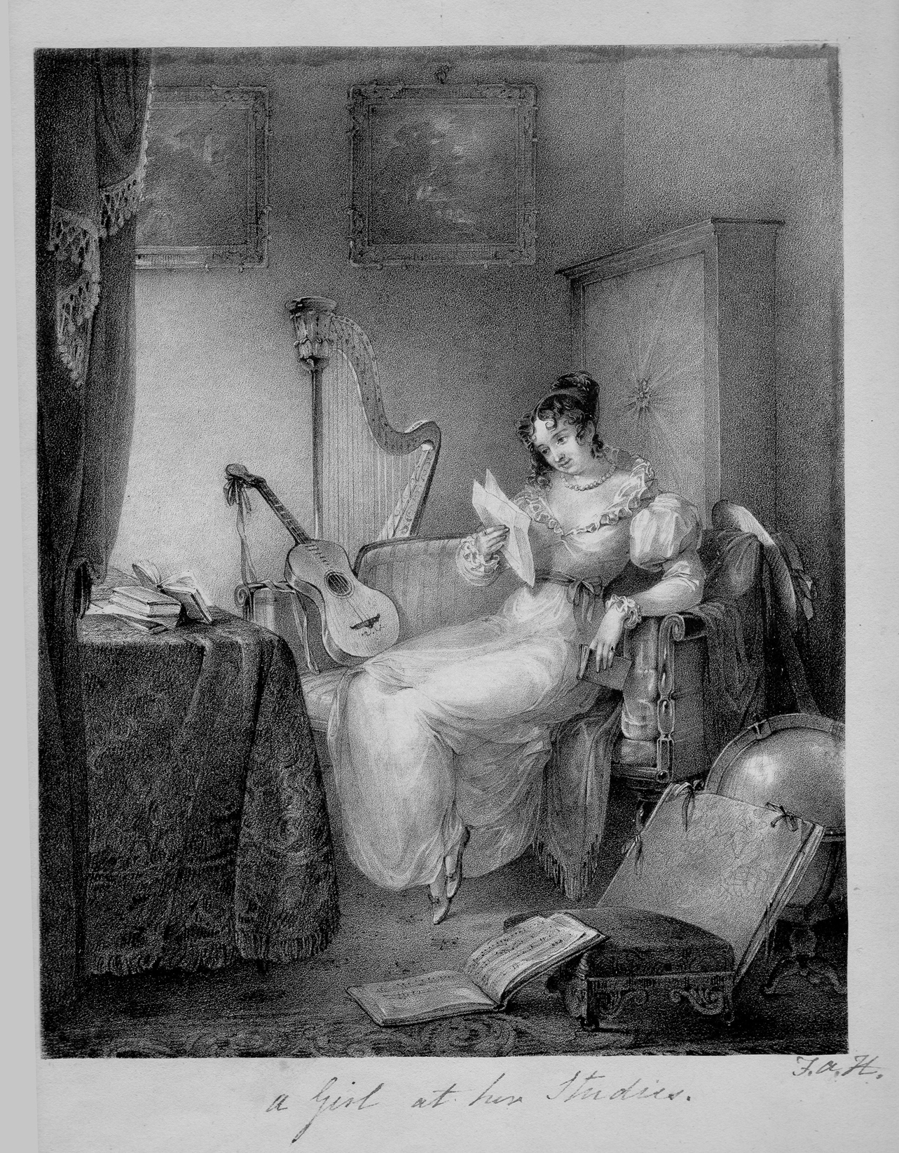

‘A Girl at her studies’. Probably the print of that name advertised by the firm of S. and J. Fuller in The Morning Chronicle for 20 November, 1826. Private collection.

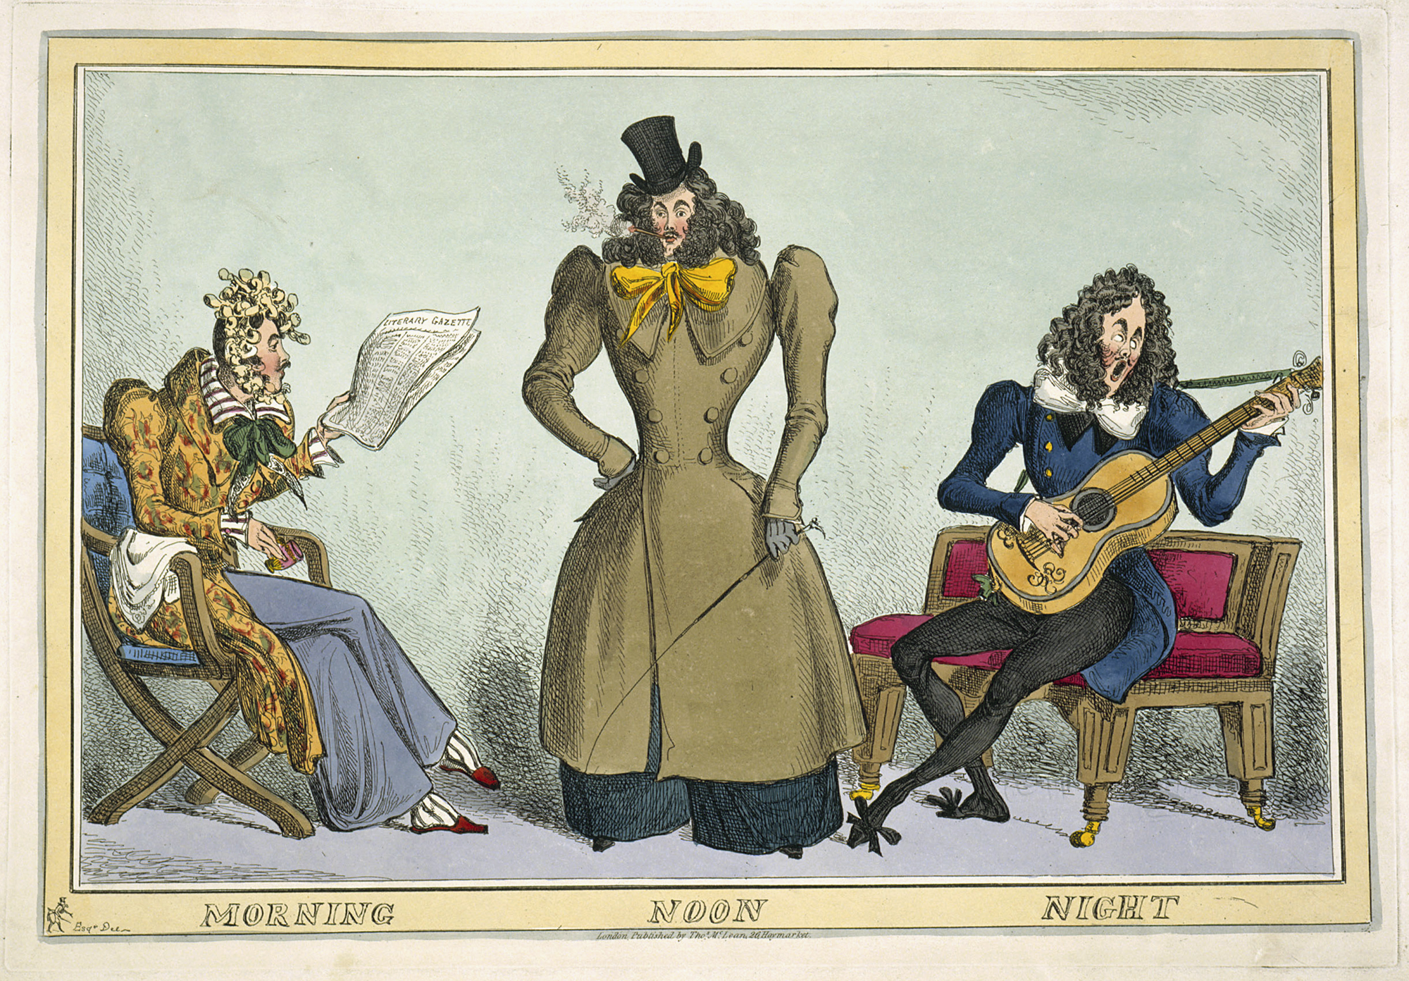

‘Morning, Noon and Night’ (1829). William Heath. Private collection.

