Christopher Page Gresham Professor of Music

Music, imagination and experience in the medieval world

III To sing and dance

A carol. Andrea di Bonaiuto, Spanish chapel of Santa Maria Novella in Florence, painted in 1365.

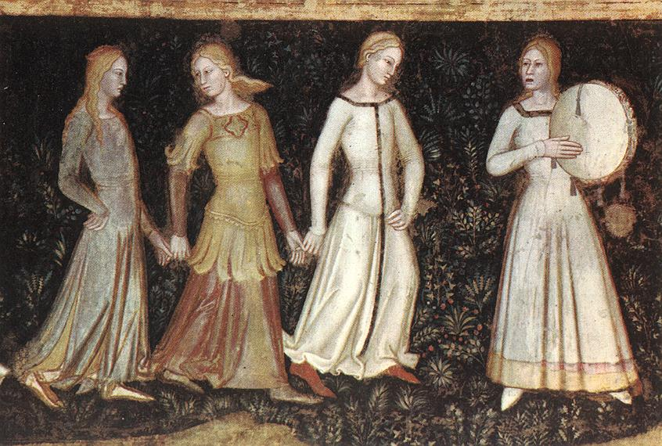

Lullay, lullay, lay, lay lullay
Mid dere moder, sing lullay.

Als I lay on Yoolis night
Alone in my longing,
Me thoughte I saw a well fair sight
A may her child rokking.

The maiden wolde withouten songe
Hir childe o slepe bringge;
The child him thoughte sche ded him wrong
And bad his moder sengge.

‘Sing nou, moder’, seide the child,
‘What sall to me befalle
Hereafter wan I cum to eld; come of age
For so don modres alle’.

‘Sweete sune’, seyde sche,
‘Weroffe suld I singe?
Ne wist I never yet more of the
But Gabriels grettinge’.

‘He grett me goodli on his kne
And seide: Heil Marie,
Heil ful of grace, God is with the,
Thou beren shalt messye’.

‘I wondred michil in my thought,
For man wold I riht none;
Marie, he seyde, drede the nouth,
Lat God of hevene alone’.

‘Ther, als he saide, I the bare
On midwinter night,
In maydenhed, withouten kare,
Be grace of God almiht’.

‘Ther schepperds waked in the wolde
Thei herd a wonder mirthe
Of angles ther, as theim thei tolde
The tiding of thi birthe’.

Serteynly this sight I say,
This song I herde singe,
Als I me lay this Yolis day,
Alone in my longingge’.

