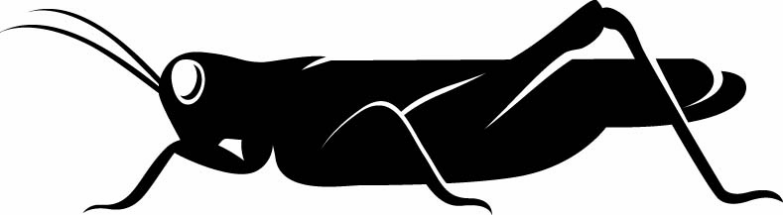
25 January 2016
No Need for Geniuses:
Scientific Revolutions and Revolutionary Scientists
in Paris in the City of Light
Professor Steve Jones

Welcome to the Museum of London. My name is Steve Jones, and I am going to give this talk this evening called “No Need for Geniuses” and it is about science in Paris.

I first went to Paris, I am horrified to look back, in May 1968. I arrived at the Gard du Nord, from Edinburgh, from an icy and still-1950s-like Edinburgh, and I was greatly impressed by the liveliness of the scene, but I was going down to the Pyrenees to collect snails, which is what I have wasted most of my career doing, so I did not have much time in Paris. So I got the Metro down to Gard d’Austrerlitz, and when I was on the Metro, I noticed strange perfume. It was pungent, not unpleasant, but pungent, and I thought, well, what rather strange, odd tastes in perfume these French people have, and not until I got down there and read the paper did I discover there had been a major riot in Paris that day and “perfume” was in fact tear-gas, which had actually soaked down into the Metro.

However, there is still a generation of people of my age in France who are called the Soixante-Huitaires, the 1968ers, who still mentally live in 1968 and they are still looking under the cobblestones for the beach – it is not there! The revolution in 1968 came to nothing of course, but the Revolution of 1789 was quite different – that really was an upheaval which, in some ways, formed modern Europe, and it sprang directly from the Revolution of 1776 in the United States, which really formed the world’s modern political system. The thing which I had not realised until I started getting interested in the subject and reading around it, was the astonishing role that science played in Paris, and France in general, in those years, and even more surprising that scientists played in the Revolution itself. Many scientists were central to the Revolution and got heavily involved in it. Many people who are remembered as revolutionaries were in fact, on the side, scientists. Many scientists paid a heavy price for their involvement. One academician, a fellow of the Royal Society, in four in Paris was guillotined, murdered by the mob, or killed in battle or in prison, and that was a lot, and many of the most figures that we know fell into those categories.

The cover of my book shows scientists standing on top of an enormous podium, where they were showing off, and then suddenly being thrown off, and you see a balloon in the distance, which it was the year of the balloons of course, you see surveying instruments, and it was the year of the survey of France, you see various important books, mathematical instruments, all of which are falling to the ground, where an angry mob awaits them. This is actually a Gillray cartoon, an English cartoonist, who is mocking France, but it actually tells the story in quite a clever way.

So, why is it called “No Need for Geniuses”? Well, it turns on the Revolutionary Tribunal, and you will know the Revolution was in 1789, but in 1793 came the Terror, and the Terror, which was promoted by Robespierre and others, and Marat and others, was really a terror – it was a revolution which went mad of its own accord and sentenced thousands of people, literally thousands of people, to the guillotine, including of course the monarch and his wife. It was almost unheard of for somebody to come before the Revolutionary Tribunal and not be sentenced to death. However, one person was, and that person was a scientist, a chemist, called Lavoisier, and Lavoisier – and we will talk quite a lot about him – was the founder of modern chemistry. He was the first to seek patent in chemistry. He was one of the co-discoverers of oxygen and hydrogen and nitrogen. He founded the understanding of human metabolism, the way that we burn food and use oxygen and breathe out carbon dioxide. So, he was a major figure in science, and he was sentenced to death, for reasons I will explain in a moment, but somebody, very bravely, shouted from the body of the court, “You cannot kill that man, he is a genius!” and the judge sneered and said, “The Revolution has no need for geniuses,” hence the title!

So, why was Lavoisier in front of the Tribunal? Lavoisier is remembered by all chemists, and most modern scientists, as a figure on the same level in chemistry as Newton was in physics or Darwin was in biology. Why was he there? Well, he was there because he had a hobby, and his hobby was collecting taxes and in France, in the pre-Revolutionary era, taxes were paid mainly by the poor. Actually, it sounds rather modern in that context. People paid for the right to buy the right to collect taxes – they were called the tax-farmers, and what the State would do, it would put out a bid for 24 people to pay many millions of francs, hundreds of millions of francs, to the State to collect as many taxes as they could, up to an agreed level, and if they could collect any more, they could keep it. This was enormously repaying to the tax funds. It was extremely hard luck on the poor peasants who had to pay the taxes because they would be flogged or beaten or even hanged if they did not pay the taxes. We have an exact parallel to that today of course with PFIs, Private Finance Initiatives. That is exactly what that is: people are paying the State to borrow some money from it, and the State is paying an enormously inflated sum back to them, £40 to change a light-bulb in a hospital and that kind of stuff. So, that was the tax-farm, and here was Lavoisier being mocked by a French cartoonist, with a starving peasant in front, Lavoisier going out to collect his taxes. Lavoisier made the equivalent of about £50 million in modern money during his career as a tax-farmer.

The tax-farm was very inefficient, as indeed many taxation systems are, and there were various kinds of taxes, one of the most [repellent] of which was called the Octroi, and the Octroi was the tax which people had to pay to bring goods into the big cities, to Paris in particular. If you were to bring any goods, food included, salt, all the essentials of life, into Paris, you had to pay a tax, and there was a wall around the centre of Paris, and the Parisians still say I live “intra-muros”, I live “within the wall”. But it was very leaky and there were all kinds of tricks that people played. It was not really a wall. Many of them were just houses in a terrace, and somebody would buy a house and what they would do is they would bring in goods through the back-door of the house and take it out the front-door of the house and not pay any taxes on it. Another very good scheme, which was used by several people, was to make a wickerwork model of a servant and go out in your carriage and fill the servant with brandy and cigarettes and that kind of stuff, and come back and then unload the servant and you did not pay taxes that way.
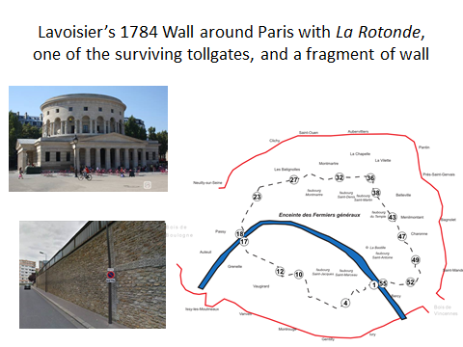
Well, Lavoisier saw that was no good at all, so Lavoisier decided, off his own bat, that the tax-farmers should built a proper wall – and here is the wall, built in 1784, the enceinte de Paris, and there is the track of the wall. The red line is one of the outer defensive walls of Paris. The dotted line is the Enciente des Fermiers Generaux, and it was impermeable. You can see, little fragments are left, in the bottom left there. It is quite a solid wall, very difficult to get over that carrying a bottle of brandy. There were a number of tollgates, only two of which survive, one of which is that one, La Rotonde, which is near the Canal St Martin, and is actually – I have eaten there – it is a very good and very expensive restaurant, ironically enough. But the people were infuriated by this, and five years after it was built, they attacked the wall and burned down many of the tax tollgates. That was on 13th July 1789, one day before the 14th of July 1789, which was when, of course, they burned down the Bastille.

So, the Bastille was burned down, the monarchy fell, there was a revolution, and for a time, a democratic, or semi-democratic government. Napoleon appeared. History happened. There was the events of 1870, there was the revolution of 1848 – it was a busy century, the 19th Century! But a hundred years after the Revolution, in 1889, it was decided to build a monument to the event, and great arguments were made about what they should build. There was a shortlist of six buildings they would make. The one that came second to the top was a 300-metre model of a guillotine – they did not build that, I am glad to say. What they did build was of course the Eiffel Tower.

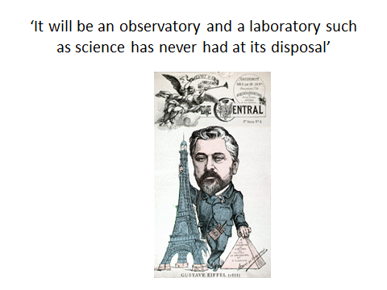

That is the Eiffel Tower, which was, for 40 years, was the tallest building in the world, and it has just welcomed its 250-millionth paying visitor, and it is the most visited commercial monument in the world, and it was built by this chap here, Gustav Eiffel. Eiffel was an engineer, a young, not very well-known engineer, who had already built a number of very daring and radical railway bridges, and he put in a bid to build this thing. Now, he only had a 20-year lease, and he felt that his building, which we all agree is a magnificent thing, although at the time it was not thought, his building should last for much longer than that, so he set out to turn it into a scientific laboratory. As he said, his tower will be “an observatory and a laboratory such as science has never had at its disposal”.

It is a striking building. If you look at it, it is made of wrought iron, which is light and strong. In fact, if you take the mass of the volume of air that is trapped within the Tower, and you weigh the air, and air does in fact have a weight of course, if you were to weigh that volume of air, the air would weigh more than the metal that went to make the Tower. The Tower is 25 metres square at the base, and if you were to take all the metal in the Tower and melt it into the base, how deep do you think it would be? It would be six centimetres deep – that is all. So, it is an extraordinary work of engineering, and even in 100 mile an hour wind, the top only moves by about six centimetres, so clearly, Eiffel had a triumphant piece of engineering that the French have now and of course are very proud of it.

Eiffel set out to make his Tower into a scientific laboratory, and he spoke specifically of memorialising the great scientists of the day, of the Revolution, and he did it in various ways. For example, there is inscribed on the Tower the names of 72 scientists, not that you can read them. Some of them are perhaps more familiar than others, but there is: Cuvier, who was the founder of palaeontology in revolutionary years; Laplace, who was an astronomer and mathematician and really gave us our understanding of the solar system; there was Lavoisier, the founder of chemistry, who we have already talked about; Ampere, the great electrician. That is just a few of them. There are many, many more. There are many more highly familiar names there.

Eiffel set various things up in his Tower. The Eiffel Tower was the site of the world’s first working wind tunnel, amazingly enough. It was in the base of the Eiffel Tower. There is the wind tunnel, with the Tower above it, and it was used in the very earliest tests of wings for aircraft flight.

The Eiffel Tower was also the site of the first real research in aerodynamics, and what Eiffel did was to drop weights down long wires from the top of his Tower and measure how fast they travelled, with a vibrating tuning fork, and what difference the shape and the size of the mass had when it was faced with air resistance. Here he is, on his Tower, on the drop-test experiment.

Various other things were done at that time and then later. Amazingly enough, just five years after it was built, the first cosmic rays were discovered on the Tower. Because Marie Curie had discovered radiation, people became interested in radiation, and people realised really quite soon that if you had a radioactive source here and you went 300 metres away down the road, the amount of radiation you measured would be less than on the source, and soon after the discovery of radiation, somebody had the bright idea to say, “Alright, what happens if you have a radioactive source at the bottom and we climb 300 metres up to the top of the Tower – is it the same effect?” They expected it would be the same effect, but it was not. There was too much radiation at the top of the Tower – it did not decrease as much. What was happening, in fact, was that cosmic rays were coming in from space, originating from the Big Bang in the end, and they were discovered on the Eiffel Tower.

The Eiffel Tower was the site of the world’s first radio broadcast. It had, in 1906, a radio aerial put on its top and messages were sent, and in 1914, the radio aerial was there and it picked up some secret radio messages by the German Army, which was then invading France, that they were planning an attack on Paris immediately, and, famously, the French troops used taxis, Paris taxis – I am sure they tipped the drivers well – to get the Valley of the Marne where they held the Germans back, so the Eiffel Tower saved Paris.

So, it has done many things. It has also become an image, an icon, of Paris, of France itself, and there are various famous pictures of it. This is perhaps one of the more famous. This is the tallest building in the world, the Eiffel Tower, struck by lightning in 1890.

There is an extraordinary series of coincidences that link the issue of lightning to the French Revolution itself and to the downfall of many of the scientists who were involved in it.

So, that is lightning. We all know a lot about lightning, and we all believe, do we not, that Benjamin Franklin actually invented the lightning conductor. Many people had been killed by lightning. Thousands of people were killed by lightning. Paris passed a law forbidding bell-ringers to ring the bells during lightning storms in case it was struck. Some people thought that the bells actually attracted the lightning – they were wrong there. But, literally, thousands of people every year were killed by lightning in Europe. Franklin, famously, is said to have put a kite up in the air, with a key on it, and a wet string which would carry electricity coming down. If that had been struck, he would have been killed instantly, so we know he did not do it because he came back from the experiment. However, he had written a book called “Experiments on Lightning in the City of Philadelphia”, and in the book, he described this experiment, that it would be an interesting thing to do.

Now, Louis XV, the penultimate monarch of Paris, who was a highly intelligent man, as indeed was his son, Louis XVI, read this book and was fascinated by it, and he asked some of his scientists to demonstrate some of the ideas that were there. Well, the people involved, the scientists involved, Buffon, who was a naturalist, and Dalibard, who was a botanist, felt they better practise before they tried it in front of royalty, so they set up the world’s first lightning conductor, in what is now a western suburb of Paris, Marly-la-Ville, in 1752, and there it is. At the bottom, you can see a rather gingerly-looking man in a cloak, with an iron bar, baton, in his hand, and the idea was to wait until the storm clouds passed overhead and to hold this baton some distance away and see if any sparks crossed the gap, and the answer was, yes, they did, whereupon the terrified experimenter, who had been well-paid to do this, ran away screaming, but that was the world’s first lightning conductor. That was the first place where it was actually done.

You can go to the Eiffel Tower and you can look out over the landscape of Paris, the landscape of the Tower itself, and see many other sites where world-firsts took place. I will just mention a couple of them before I get onto the main body of the talk.

The site of the Eiffel Tower was where the world’s first hydrogen balloon was set off. It was set off with hydrogen, and how to make hydrogen had been discovered by Lavoisier, who poured nitric acid onto scrap iron and that generated hydrogen. That was the first hydrogen balloon, from there. If you looked across to the north, you see the Palace of Luxembourg and its beautiful gardens. In revolutionary times, they only had one plant growing in them, and that was – there is the chap, Parmentier, holding the plant – it was the potato.

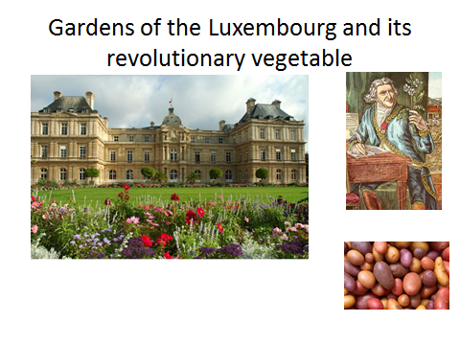

Potato was not eaten in France before the Revolution because people believed it either to be poisonous or suitable only for animal feed. Even in Britain, it was scarcely eaten in the 18th Century. People thought it was either a medicament or even an aphrodisiac. There is a remarkable line in Shakespeare’s “Merry Wives of Windsor” where Falstaff, who believes wrongly of course, that he has persuaded two women to share his bed, looks adoringly upwards as he says, “Let the sky rain potatoes!” Many Shakespeare scholars have been baffled by that, but basically what he is saying is send me some Viagra down from the sky! Well, I have eaten lots of potatoes, and I have to tell you… Potatoes were first planted after the Revolution in the gardens there and they had a clever trick, which is to put guards on the garden during the day, and then remove them at night, so the peasants would come, the local would come and steal the potatoes and plant them in their own plots, and the potato very quickly sped through France, vastly increasing French numbers and French health, so that was very clever.

If you look slightly to the east, you can see the hill of Montmartre, and that was the place where, just after the Revolution, the speed of light was measured for the first time.

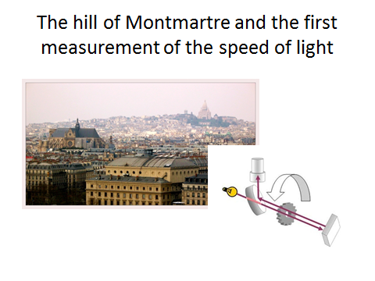
The person involved, Fizeau his name was, passed a powerful beam from his laboratory, just south of the Tower, to the top of the hill of Montmartre, where there was a mirror where it was bounced back, and in front of his detection device in his own laboratory, he had a spinning wheel, with cogs in it, and he speeded it up and speeded it up and speeded it up until, suddenly, the light stopped coming back, and that is because, in the micro-second it took to get to Montmartre and back again, the next cog had come into view and blocked it. From that, he worked out the speed of light, remarkably accurately. So that is something else which perhaps most people do not realise that is actually something that happened in Paris in roughly those days.

More remarkable, of course, as all British people do not know, evolution began in Paris, and if you go to the Jardin des Plantes, which was established, and the Museum of Natural History, which was established in revolutionary times, you see a statue to this chap here, Lamarck, on the left, and if you look at the base of the statue, it says “Fondateur de la Doctrine d’Evolution”, the Founder of the Doctrine of Evolution.

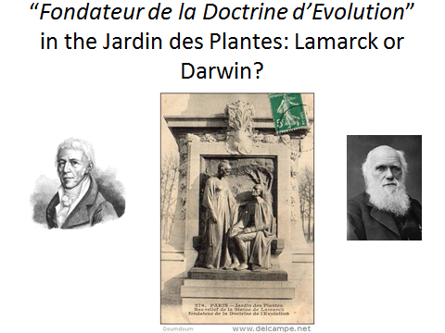

There is Lamarck, and on the other side, I put a rather grumpy picture of Charles Darwin, and we all assume that Darwin was the real founder. Darwin was the real founder, although Lamarck, give him his due, was the first to have the idea that things could actually change.

However, Lamarck, very characteristically, had a very mystical view of how progress happened, and that was characteristic of revolutionary times because many of the scientists involved in the politics felt that they were doing science, that actually it was inevitable, it was programmed, and humans and society would improve according to the laws of nature. Lamarck, for example, spoke of a power in life. De Tracy invented a word called “ideology”, the scientific study of ideas. Ideology is part of zoology. Condorcet, who was a great mathematician and philosopher: “The general laws that direct the universe are necessary and constant – why should this principle be any less true for the development of the intellectual and moral faculties of men?” And then Bailly, who was the man who sparked off the fall of the monarchy when he went into the Jeu de Paume, the tennis court, and they swore the Tennis Court Oath, which was the beginning of the parliament of France. Bailly, who was an astronomer, he is the guy who took the oath, and he wrote that “the universal language of science would bring a golden age”.

Charles Darwin did not agree with any of that. Charles Darwin: “Heaven forfend me from any Lamarck nonsense of a tendency to progress or adaptations from the slow willing of animals.” For him, evolution was a machine which followed simple rules of natural selection. It did not have a direction, a vital force, but the French force certainly did, and indeed, some of them still do if you read French evolutionary biology.

So, there is poor old Bailly, a painting by David, and there is Bailly swearing the Tennis Court Oath.
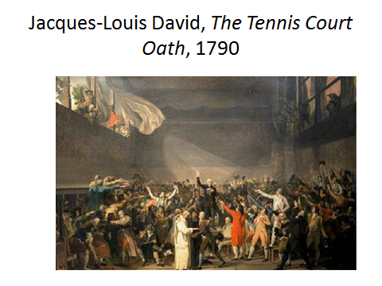

Bailly became the first Mayor of Paris. He did very well, but unfortunately, there was a massacre in Paris on the site of the present Eiffel Tower, where various rioters were shot down by Bailly’s troops. Bailly was grabbed and guillotined. They erected the guillotine on the site of what became the Eiffel Tower and were about to kill him and somebody said, “You are trembling, Bailly,” and this was in February, and he said, “Only through cold,” and they executed him there, and that was the end of poor old Monsieur Bailly.

Of course that execution was the first of many. There is a well-known revolution who wrote from Newcastle-on-Tyne to his colleagues in Paris just before the Revolution proper that “Five or six hundred heads cut off would have assured your repose, freedom and happiness”, and that was referring to a smaller upheaval which had not gone anywhere – it had been quashed. He revised that figure to “50,000 heads cut off would assure your repose”. That was Marat, and Marat certainly was a dangerous activist and political extremist. He wrote, in Newcastle-on-Tyne, a pamphlet, in English, “Chains of Slavery: A Work Wherein the Clandestine and Villainous Attempts of Princes to Ruin Liberty are Pointed Out”, by Jean Paul Marat. But he also wrote some scientific stuff, he wrote two pamphlets: one is called an “Essay on Gleets”, and “gleets” are venereal diseases, non-specific urethritis; and a second “An Enquiry into the Nature and Cure of a Singular Disease of the Eyes”. And he was a doctor and he was quite successful. In fact, his treatment of urethritis was much better than what had gone on before. Instead of using a steel cannula to push it up the penis of the poor man being treated, he used a rubber one which was not nearly as painful, probably just as ineffective. In fact, the University of St Andrews gave him a degree for having done that. Marat is a graduate of the University of St Andrews, but Marat had to pay for that – it was quite a common pastime in those days. Of course, that too has come back… It was quite a common pastime in those days, and Dr Johnson, with his usual weight, said “The University of St Andrews is getting richer by degrees”, and I am kind of tempted to say that myself about University College London and many other such places.

So, he was a scientist, and he was quite an effective scientist. He developed something that he called the solar microscope. He went back to Paris, just three years before the Revolution, and he became interested in Newton’s refraction prism experiments, and he disagreed with Newton. He felt that Newton had got it all wrong and he wrote angry books about Newton, which got him into trouble. He invented this solar microscope in which the sun came into that mirror and then came through the microscope and made images on the wall, and he felt that he had found a caloric fluid, because he found that, if he put flames, in that flame, you could see wobbly stuff coming up from the flame, which we know to be hot air, but he thought that was magic stuff that was called phlogiston which is released by burning objects – that was disproved by Lavoisier actually.

He did more than that: he actually did quite a lot of electrical work, and actually, Marat did experiments which he published, in an obscure place, on electrocuting a frog and making it jump, five years before the famous Italian Galvani did the same thing, and he felt that electric sparks of lightning were in fact the fluid, and that’s a diagram from one of his writings about lightning.

So, he was really quite an effective scientist. He was wrong about lots of things, but he certainly saw himself as a real scientist. He became very embittered because he was never invited to become a Fellow of the Royal Academy of Sciences, and I know lots of my colleagues who secretly are very embittered because they have never been asked to be Fellows of the Royal Society, and I can smugly say, well, I am a Fellow of the Royal Society and it has made no difference whatsoever to me, except having to pay £200 a bloody year for nothing!

He was very able, and in the end of course, he was murdered in his bath. That is a portrait by David of Marat, stabbed by Charlotte Corday, who came in and killed him because her relatives had been executed on his orders. He is painted as a hero and a saint, but he was very far from that.

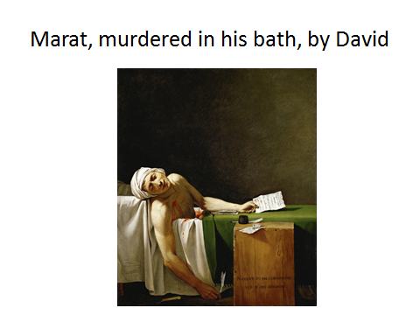

So, that brings Marat into the world of science, and then somebody else, who is also rather surprising, was brought into the world of science. In the 1770s, people began to think about putting lightning conductors on buildings, and this was very, very unpopular because many people argued that the lightning conductors would attract thunder from all over France. In the Americas, they were blamed for earthquakes as well – I think that was even less likely. In St Omer, which is in northern France, somebody called Vissery de Bois-Valé put a complicated lightning conductor on his roof and there were immediate riots and rows, in a very French way, demanding that he take it down, and the citizens of St Omer rioted against the lightning conductor. He refused to do it, and it went to court. The city took him to court to force him to come down, and the discussion went on and on and on and it became kind of a cause celebre in Paris. All the physicists in Paris talked about it. Goethe mentioned it in his writings. It was talked about in the Royal Society of London.

But the case went on and on and on, and the lawyer in charge was very ineffective and he could not explain the science, and he hired a young assistant, who went straight to the centre of the issue and said, “Look, let us not bother ourselves with all this science, all this theory – theory is worthless and useless. All that matters are the observations of sensible men.” Men, of course… “Has anybody ever seen a lightning conductor attract lightning from outside? Has anybody ever been saved or killed by a lightning conductor?” There were only 11 conductors in the whole of France at the time, and they had not, and so he said, “In that case, it is okay, stop making a fuss about it, leave it there,” and he wrote a long judgement, which he sent to Benjamin Franklin, the American living in France, and the name of that individual was Robespierre. That was Robespierre’s first legal case, and he was a young man and it made him famous. He was elected to the Academy of Arras and, from that; he climbed upwards to the highest levels of the French political system. So, he got into it, he got into politics through science.

He was instrumental in the Terror. “Terror is only justice” – sounds a bit like our Home Secretary here – “…consequence of the general principle of democracy, applied to the most pressing wants of the country”. He paid the price, needless to say, because he himself was arrested and threatened with execution. He tried to commit suicide with a pistol, but he only succeeded in blowing his jaw away, and the following day, he was executed. There is the execution of Robespierre and there is his death mask.

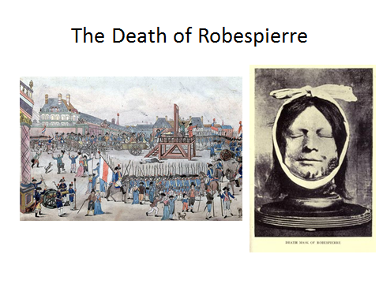

So, that was Robespierre, also involved, and Robespierre was the person behind the prosecution of Lavoisier. People had gone to Robespierre and said, you know, “You cannot kill Lavoisier – I mean, he’s one of the most famous scientists in the world”, and Lavoisier had lost his temper and had threatened to kill the people who came to see him, so that was the end of Lavoisier. So, it is all sort of tied together, and it is tied to another field of human observation, which is Lavoisier’s work not particularly on chemistry but on physiology.

This Lavoisier and his wife in his laboratory, painted again by David, and it is an absolutely wonderful painting.

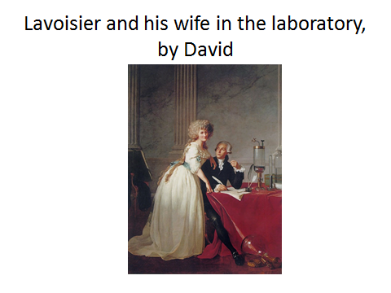

It is said that the painting of those glass vessels is the best painting of glass ever made. It is in the Metropolitan Museum in New York now. There is Lavoisier, with Madame Lavoisier, who he married when she was only 15, and she was his assistant, more than his assistant, and she helped him carry out many of his experiments.

Lavoisier, famously, had done an experiment which caused a sensation. He had erected a burning-glass outside the Louvre on a sunny day, with two powerful lenses and a big complicated apparatus like this, which concentrated the rays of the Sun onto a diamond, and within a few moments, the diamond disappeared. Now, that, of course, was completely baffling, but what of course had happened was the heat of the Sun had caused the carbon in the diamond to combine with oxygen in the air and to blow away, and this of course greatly alarmed the fashionable ladies walking past, who walked a little faster as a result! But that was part of Lavoisier’s demonstration that all substances were made of things that would later be called elements, that could combine and be broken apart in different ways, and that really was the foundation of chemistry.

Lavoisier went further than that because he applied the idea of burning to human metabolism. This is Lavoisier’s respiration experiment, as it is called. Here, we have got Lavoisier, with a bath, into which a young man – his name was Armand Seguin, you see him on the left there.

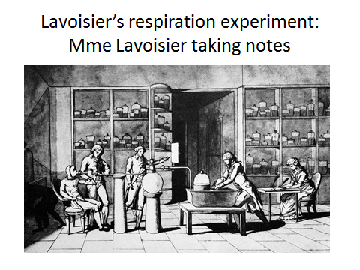

He has got a mask over his face, which is glued onto his face, and he is wearing a rubber suit, and he is breathing in and out, and what Lavoisier is doing is measuring the amount of carbon dioxide he is breathing out, and he is breathing in oxygen and he is simultaneously measuring the amount of oxygen he is breathing in. He did that at rest, he did that after a meal, he did that while pedalling something that looks a bit like a bicycle, with heavy weights being lifted up and down, and what Lavoisier found was that the rate of respiration and the rate of burning increased with exercise. In the background, on the right, you can see Madame Lavoisier taking notes of the experiment.

He went on to do the same thing not just with humans but with guinea pigs. He was the first person to use a guinea pig in experiment. That is where the word “guinea pig” comes from, Lavoisier’s experiment. He and his colleague invented what he called a calorimeter, which is a box filled with ice, they put the guinea pig in there, they measured how much oxygen it breathed in, how much CO2 came out, and how much heat it generated, by measuring the amount of ice-water that dripped out of the bottom of the ice, and Lavoisier summarised his results in his “Elementary Treatise of Chemistry”, published in the very year of the revolution, 1789. “The animal machine is governed by three types of regulators: respiration that consumes hydrogen and carbon and furnishes heat; digestion, which replenishes that which is lost in the lung; and transpiration that increases or diminishes with the necessity to carry away more or less heat” – transpiration being both sweating and breathing out warm air. So, that was Lavoisier’s interpretation of human physiology.

Armand Seguin, the man in the iron mask, went on after the death of Lavoisier to discover opium, to invent a new method of scanning skins for the Napoleonic Armies, and he became extraordinarily rich, but Seguin actually was in at the very beginning of modern pharmacology, with the discovery of opium, of various other chemicals at just that time, including strychnine. All of those, he discovered in Paris.

As you will see in a moment, all these come together in a rather French event, and that French event is Tour de France. The Tour de France has an interesting and uniquely French origin because it began as an anti-Semitic gesture. It was a political gesture, the Tour de France. There was a magazine, the Velo, which was a rather liberal magazine, about bicycles, because bicycles of course were becoming very popular in 1903 when the Tour began, and one of the advertisers in that magazine was a furious anti-Dreyfusard.

Here is Dreyfus, the Dreyfus Affair, and Dreyfus was a Jewish soldier who was accused of treason.

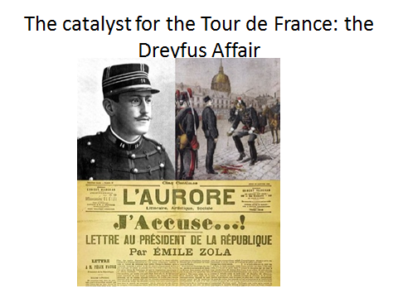

It was a completely false accusation, but he was humbled in public – he was sent to Devil’s Island and his sword was broken and, famously, Emile Zola wrote a furious letter saying this was totally unacceptable, and after some years, Dreyfus came back. But it was at the centre of French politics for many years, and the publisher of this magazine was a liberal, which infuriated one of his richest advertisers, who pulled out all his advertisements from the magazine and started a magazine of his own, which was called L’Auto, and he had a publicity stunt which was to set up a Tour of France, and it happened in 1903, and of course it’s gone on since then ever since.

Since then, of course, it has become deeply involved in cheating in various ways. This is one of the early cheats… He was in the first Tour and he took the train. He almost got away with it, but they found a train ticket in his pocket. He looks like a bit of a rascal.

However, his successor, Lance Armstrong, seemed like a decent all-American boy, but of course he too was a complete cheat.

In fact, at some times, everybody on the Tour was cheating, and they were cheating with drugs, and they were cheating with drugs with the knowledge of physiology which had been worked on in revolutionary times. Many of them used opium, which did not do them any good apart from to make them constipated. Some of them used strychnine because it was thought to be a muscle stimulant, and that does not work either. But they also did things like give themselves blood transfusions to push up their oxygen levels and that kind of stuff. All that has now come out into the open-air and may well, in some ways, mark the end of the sport of athletics unless something drastic is actually done, like cancelling all the present records, which people are now talking about doing.

That too has a tie with Lavoisier, because Lavoisier pointed out that one of the things which was demanded if you were to do intense exercise, like lifting weights up and down, was more oxygen, heavier breathing, and the ability to lose heat. Famously, Tom Simpson, an English rider, on Mount Ventoux, which is a tremendously hot-blasted open place where they ride up the mountains, he had taken drugs the evening before, and he went up there and collapsed of heatstroke, and that is him dying of heatstroke, and his last words were “Put me back on my bike”, and if you go up there now – I have never actually seen this, although I have been to Mount Ventoux – there is a monument to the man who died of heatstroke.

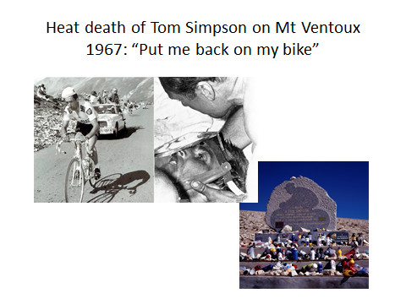

The irony is that now we understand so much about physiology, we understand a great deal of what is happening behind these extreme sports’ events, and in a way, that descends from Lavoisier and his colleagues, and in a way also that descends, as you will see at the end of the talk, from some of the philosophical issues that were raised at the time of the years of the guillotine.

The other great race of course is not the Tour de France, which is new, but the marathon. The marathon is 2000 years old and it, of course, is named after the great run from Marathon to Athens by Pheidippides, who ran there with news of a victory over the Persians on a hot summer’s day and collapsed and died of heat exhaustion, after he had shouted “We have victory!” That is what they say anyway and they are sticking to it.

The Paris Marathon is a big event, the fifth biggest in the world, and they take the same route as the Tour de France at the end, but in the opposite direction, and they go underneath the Eiffel Tower, as they do.

What marathons have done is to show us that, actually, there are differences in individual physiology, individual abilities to deal with oxygen shortage, with heat and the like, which mimic those which you can generate with drugs, and in some ways are more effective than those you can generate with drugs.

That has been known in animals for quite some time. If you climb to the height of Everest, the amount of oxygen in the air drops to a third of what it is at the bottom, and there are almost no animals who can survive on the top of Everest, apart from one, which is this thing called the bar-headed goose. There are some in Green Park, when they are not flying over the top of Everest because it is an Indian bird, and every year, they fly over Tibet at 30,000 feet and more, with absolutely no difficulty. How do they do that? No other bird could do that. They have a shift in haemoglobin. They have got special haemoglobin which can soak up more oxygen than other birds’ haemoglobin, and they also have bigger lungs and they also have more effective muscles, against their muscle fibres. So, these birds have evolved to deal with low oxygen levels, and so have other warm-blooded animals, including the people of Tibet themselves, people of the Andes, and those of the Amhara Mountains in Ethiopia and the Kalenjin Mountains in Kenya.

These are some of these people, and if you test them, it turns out that, in their different ways, these individuals are more able to deal with oxygen-shortage than are people from the lowlands. They do it in a different way. The Tibetans do it by altering the extent to which their blood vessels open, so they can move a lot more blood through the arteries. The Andeans do it with more haemoglobin. The Andeans have not been there as long as the Tibetans, or so it seems, because the Andeans still suffer from mountain sickness, and they suffer from a problem which is, if you have got so much haemoglobin, so many red cells, they can, as it were, get clogged up and cause you real problems. But one of the main winners in this year’s, or the winner of this year’s Tour de France was himself an Andean.

So, there are biological differences between these people, and it is not just in oxygen sensitivity, it is in the ability to withstand pain. This is a colleague of mine who works on pain and it turns out that people of an African background, for reasons we really do not understand, are more able to stand intense pain than people of an Hispanic, European that is, or Asian background, and there are more differences too. The heat thing that really counts – Pheidippides died in 490BC and the Sun in that day published a headline, typical headline, “Maniac killed by 25 mile run – copycats warned over marathon suicide dash”. This was actually the Sun’s attempt to produce an educational book, and it was not really, it is bad.

Here, we have got Pietri in the first Olympic Marathon. The poor guy was so exhausted, so much had heatstroke that he took the wrong turn in the stadium and went the wrong way around, and here, they are helping him to the finishing post, and of course, the medal was taken away from him, rather sadly, but he was heat-exhausted. Heat exhaustion is a major issue when it comes to marathons or any other sport. All the world marathon records have been gained in months outside July and August. The Paris Marathon and the London Marathon are in August, but nobody is going to break the records there. They only break records in May and September, when it is relatively cool. So, even a slight increase in temperature cause a big demand.

There is one group of athletes who now of course dominate the world of the marathon. In 1948, there was only one African in the top 25 marathon runners. Then, as you go on, to 2012, every single one is of African origin, and 21 of those 25 all come from a small part of Kenya, which is Kalenjin – it is 21 of the top-25, and it is a fifth of the top-100. The Kalenjin represent one in 2,000 of the world population, and yet they are one-fifth of top marathon runners, and if you look at them, they have got better heat loss, through body build, they have got low oxygen genes, their basal metabolic rate, the rate at which their body ticks over, is relatively low, they tolerate higher body temperatures because they have got lower pain sensitivity. You can see that all these things have a lot to do with their success, and if you look at them, if you look at any great runner, you will find that they have got long, spindly arms and legs, which gives them more mechanical advantage and also helps them to lose heat. So, these guys are winning, and they go in for it because they get a lot of money. You can get enough to keep your family for a lifetime if you win an international marathon. So these people are highly motivated as well. That is genetic, all these, we know that genes are behind this and we are beginning to find the genes behind heat-sensitivity, behind the ability to deal with oxygen shortage and the like.

But everything has now changed in genetics, in a way of course which you have heard no doubt, because genetics, running of DNA, has in effect become free. This is the cost of reading the human genome from one end to the other – it is 3,000 million DNA letters. There are four letters, A, G, C, and T, and we have all got 3,000 million of those letters in every one of our cells. If any one of you, struck dumb by boredom through this talk, were to rush out into the main street outside here, that dreadful roundabout, and be struck by a speeding bus, or more likely a speeding bicycle I would say, and squashed flat, squashed entirely flat, the DNA in your body would stretch from the damp patch on the pavement that used to be you to the Moon and back 8,000 times. Now, that is a lot of DNA…! That is because there are trillions of cells in your body, each of which has got two metres of DNA in it.

But we can read that now, and I remember when people started talking in the year 2000 about reading off the whole of human DNA, all of us geneticists thought what a load of rubbish, what a waste of money, and of course that is because we were not involved in doing it. The US Government and the Wellcome Trust, not the British Government, the Wellcome Trust, put aside $100 million to do the job, and they basically spent most of their $100 million, but technology of reading the DNA off has expanded at the most astounding, almost unbelievable rate. The solid black line there is what is called Moore’s Law, and what that does, it accepts the fact that the price of computer chips halves and the speed of computer chips doubles, and that has been true consistently for the last 15 or 20 years, and that is pretty impressive. DNA sequencing, in the year 2000, cost $100 million; by 2006, it was down to $10 million; by 2013, it was down to $1000; this year, it is down to $100, and at this rate, it will be down to $10 before 2020. So, you will be able to read DNA, human DNA, for effectively nothing, and people are already going out – there is already a 1000 Genome Project going on in Britain to read 1000 DNA, and that has been done, 1000 seems like nothing, we are going for 10,000 now, and they are going to be taking people, like athletes and the sedentary among us, and asking, on the average, what is the genetic constitution of the athletes versus those of those who are simply sedentary, and they are going to find them.

Here is one they have found, which is an enzyme called Angiotensin Converting Enzyme. This is one of these enzymes that alters the ability to soak in oxygen. It does lots and lots of other things too, but it helps you soak in oxygen. It is important in medicine because, if you have got a feeble version of it and you are having difficulty breathing, you are considerably worse off than you would otherwise be. And, like lots of these enzymes [and] genes, it is present in different flavours in different people. In fact, about a third of the people in this room have got a version of that enzyme, the ACE-gene as it is called, which has inserted into it two copies, insertions it is called, with an extra length of DNA; about another third has got two copies, two lengths of that section of the enzyme with no insertion; and the rest of us have got one copy of the insertion. It turns out that your ability to deal with low oxygen levels, either after an asthma attack or after damaging your chest in a car accident, is strongly related to what your genotype is there.

This was work which began at UCL, a friend of mine called Hugh Montgomery, who himself is a manic, maniacal athlete. He is getting on a bit now – he is in his late-fifties, but in his youth, he was a major athlete. He was a major semi-professional alpine Himalayan climber. He was a free diver who dived down deep into water. He had his own light plane. He writes children’s books that sell hundreds of thousands of copies. In fact, he really annoys me every day but that is a different story! But Hugh’s great desire – he has been up Everest several times, but he has never done it without oxygen. He has never done the bar-headed goose experiment. So, he said up at the base – at the Everest Base Camp, there is a UCL laboratory now, where they test people who have gone up and come down and ask various questions about them, and this is what he found…

If you look at the top here, here is the ACE-gene.

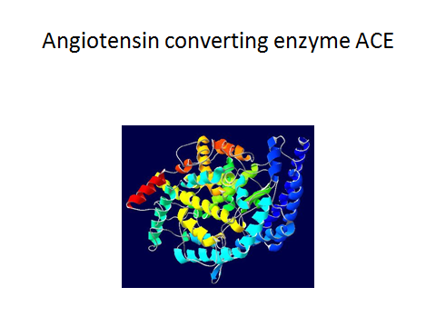

People who have managed to get up to the top of Everest without oxygen on the top in A there are shown in brown as high level oxygen-free climbers, and the others are the general population.

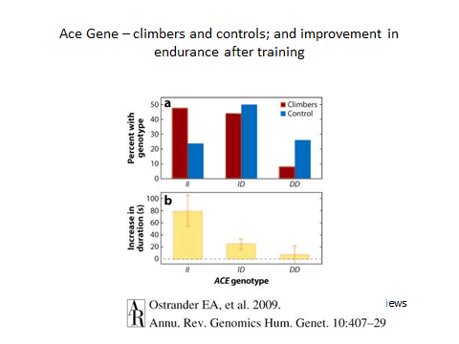

You can see, if you have got two copies of the long version of the gene, the II, the inserted version, that is much more common among the ACE climbers, among those who can deal with low levels of oxygen. It has not yet been done on marathon runners, but I am willing to bet you will find something if you do it. Those, on the other hand, with two copies of the short version are much less liable to be able to deal with low-oxygen at the top of Everest, or for that matter in a marathon. Ironically enough, Hugh Montgomery has discovered that he has two versions of the short form of this enzyme, which means that he, for biological reasons, will never climb Everest without oxygen.

I am not particularly tempted to climb Everest, with or without oxygen. I have been up Snowdon and that is enough for me! But it has got a wider interest than that. The US Army, like all armies, when it hires people to go into the Army, the first thing they do is put them through some intensive training to increase their physical fitness, and that is at (b) below. What this is is a diagram that shows the ability to increase the number of press-ups you can do. Remember press-ups? I think I did my last one in 1961 and I do not intend to do anymore! Press-ups are really pretty hard work – you know, you are pressing up and down… And the question is, if you can do press-ups for a minute, and most people can just about do press-ups, young men, healthy young men, and women, can just about do press-ups for a minute. And then they train them as hard as they can. If you have got two copies of the long version, II, you can increase your time you can do press-ups from by 80 seconds – you can more than double it, but, if you have got two copies of the short version, DD, you can scarcely improve at all. So you could screen soldiers before they join the Army to see whether they’re going to increase fitness or not, for biological reasons.

So, that too is something which I think will come to the world of athletics. What we are going to do about it is much more difficult to know, but you are going to be able to pick out the probable winners with a genetic test. Now, the genetic test is not going to tell you everything. Here is Mo Farah, probably the best athlete in the world.

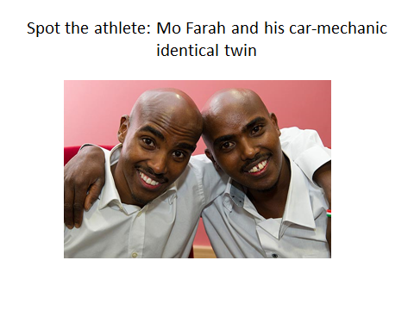
Mo Farah has an identical twin, who shares all his genes. Mo has won short races and long races.He came to Britain from Somalia with his father and went to a state school, which immediately picked up he was an extraordinary athlete and trained. That is his identical twin brother, who is still in Somalia, as a motor mechanic. When they were young, they used to race each other, Mo says, and sometimes he would win, sometimes his twin would win. Now, of course, if they raced each other, Mo would win every time. The genes are the same, but he has trained. So, it is not just genes, but genes are there. When you are at the edge of human abilities, those genes are going to play an important part.

The irony is that in spite of the extraordinary triumph of Africans, with their highly effective genes for athletics in the marathon, there have only been, altogether, five African riders in the Tour de France. This year, there were three of them, in an African team, which came mainly from South Africa – it was a mixture of whites and blacks. They did not do all that well, but that is because the Tour de France demands absolutely top-rate equipment, very expensive and lengthy training and the like which they could not do, but I think, in years to come, it may well be that you are going to end up with African domination of the Tour de France as well.

That releases some very interesting questions. In horse-racing, for example, where exactly this effect is present, if you do particularly well for biological reasons, what happens? You are handicapped. You have to carry little weights to slow you down. Is it going to be the case that Africans are going to have to carry weights in their pockets to slow them down to give Europeans a chance? I do not think so, but it opens up some interesting questions because people who abuse drugs to improve their biological abilities are universally sneered upon and disapproved of, but if people use natural variation, how is that different? In many ways, it is not different. Are you going to match people for their genes before you allow them to race? Does everybody have to be an identical twin in a race? I do not think that is going to happen either.

But actually, Condorcet, who was very active behind the Revolution and was a mathematician and surveyor and philosopher, he stated, in his very extensive writings, that: “The claim that any human group is of its essence less or more blessed with particular abilities than others is an attempt to make Nature herself an accomplice of political inequality.” That is an interesting through, 200 years before its time really, where he had realised that actually there were biological differences, but we must not use them in our decisions about people’s – particularly in politics. He used that as argument that women should have the vote; he did not, on the other hand, use it as an argument that women should be allowed to stand for election – that was going too far. In the end, he was murdered in prison during the course of the Revolution.

So, that really is the essence of my story really, which is that Paris was the world capital of science, in a way that no city before or since ever has been or probably ever will be, that the scientists of Paris were uniquely associated with the Revolution in a way that no scientists anywhere else ever have been, and really, I think we can learn some important lessons from their experiences.

After the Revolution was over, those who survived came back, and many of them made astonishing progress in the world of politics. Arago, who was a geographer who mapped France and did the first survey of Europe, became Prime Minster. Carnot, who was a physicist, was Minister of War. Chaptal, who invented bleach and was a chemist, became Minister of the Interior under Napoleon. And various chemists, explorers, botanists, herpetologists, mathematicians, including Lagrange and Laplace, two major figures, all became Senators in the French Senate. So, really, even after the Revolution, France was a land of scientists. Now, that did not necessarily, of course, mean that France turned into a great political triumph, because it had revolution after revolution. It had the Napoleonic Wars, which it sparked off. It had the Revolution of 1848, which was sparked off by a famine more than anything else. It had the Commune of 1870. So, things can go wrong.

And on this side of the Channel of course, scientists have never played that role. Mrs Thatcher was a scientist, or so she claimed, but I find that hard to believe. Scientists have never played that role at all. She did not finish her PhD so she is not a real scientist. And, actually, you can see that, but here is a man who made an astute summary of that: “Scientists should be on tap and not on top.” Given the events of the century after the French Revolution, before the building of the Eiffel Tower, I think he was probably right.

So, I will stop there – thank you!

© Professor Steve Jones, 2016

Gresham College
Barnard’s Inn Hall
Holborn
London
EC1N 2HH
www.gresham.ac.uk

