20 November 2014

Being a Guitarist in the Time of Byron and Shelley

Professor Christopher Page
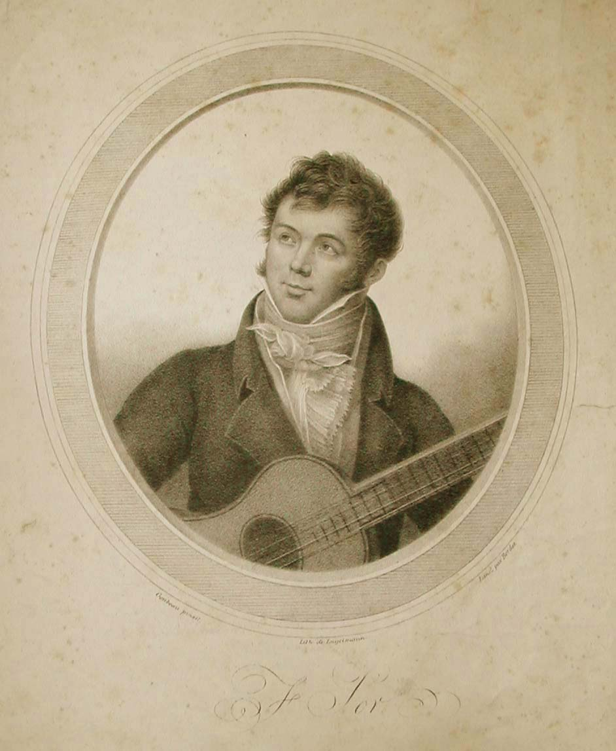

I Lithograph of Fernando Sor (1778-1839) by Engelmann and Bordes, after Goubeau
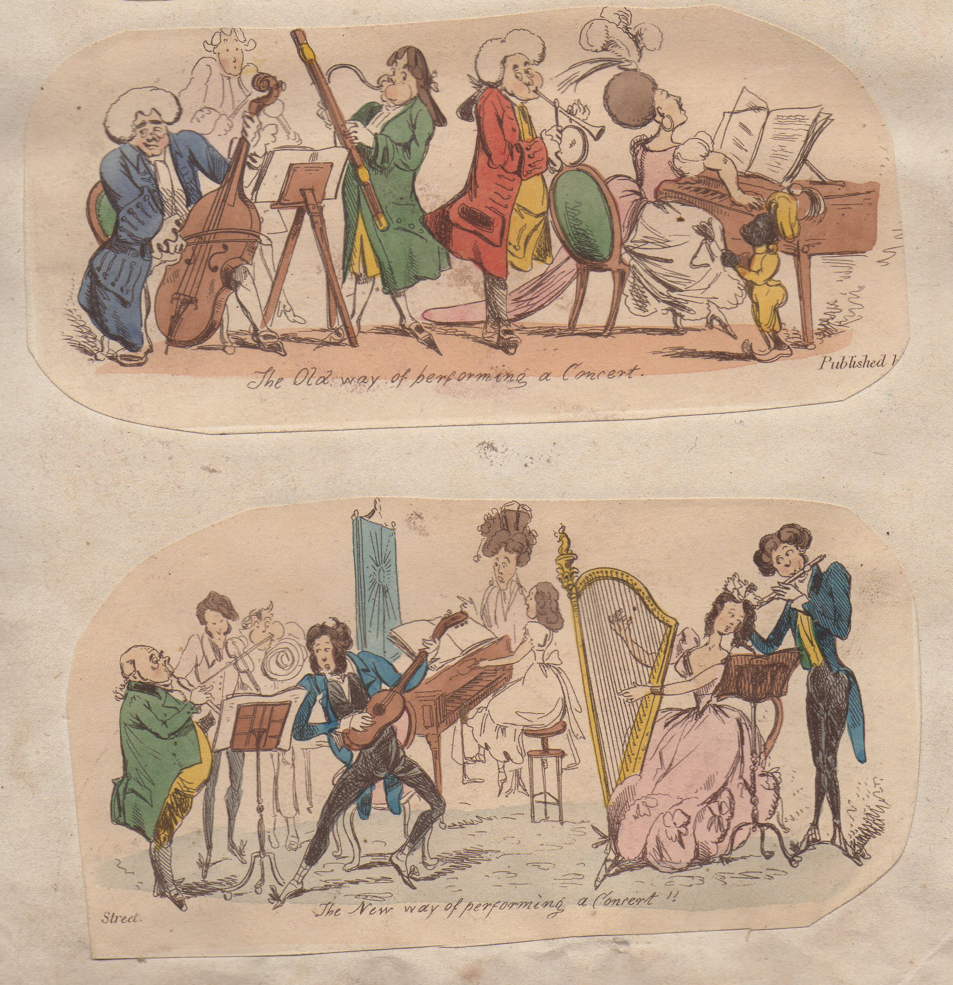
II The old way and new way of performing a concert. From a satirical series entitled Old Ways and New Ways (1829/30)

The Morning Chronicle, January 13, 1830: ‘Comparison of Ancient and Modern Customs and Manners exemplified in Seventy Humorous Groups for Scrap Books, drawn and etched by Heath, printed for Charles Tilt, 86 Fleet Street’.

III Review of a concert from The Sheffield Independent, March 15, 1834.

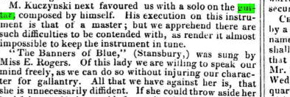

IV Review of a concert from The Preston Chronicle, July 26, 1834.

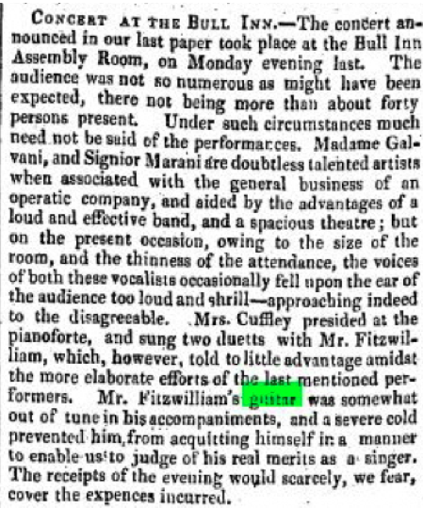

V Review of a concert from The Bristol Mercury, March 24, 1828.

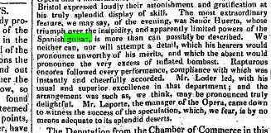

VI Fashion Plate (1801). Private collection

