Christopher Page
Gresham Professor of Music
The Christian Singer, from the Gospels to the Gothic Cathedrals
VI Singers in the Making of Europe

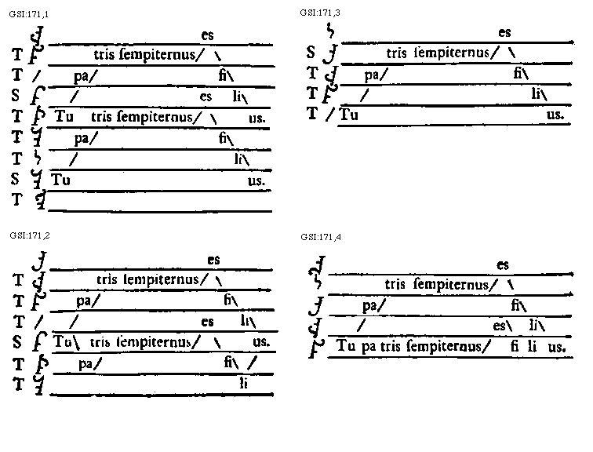

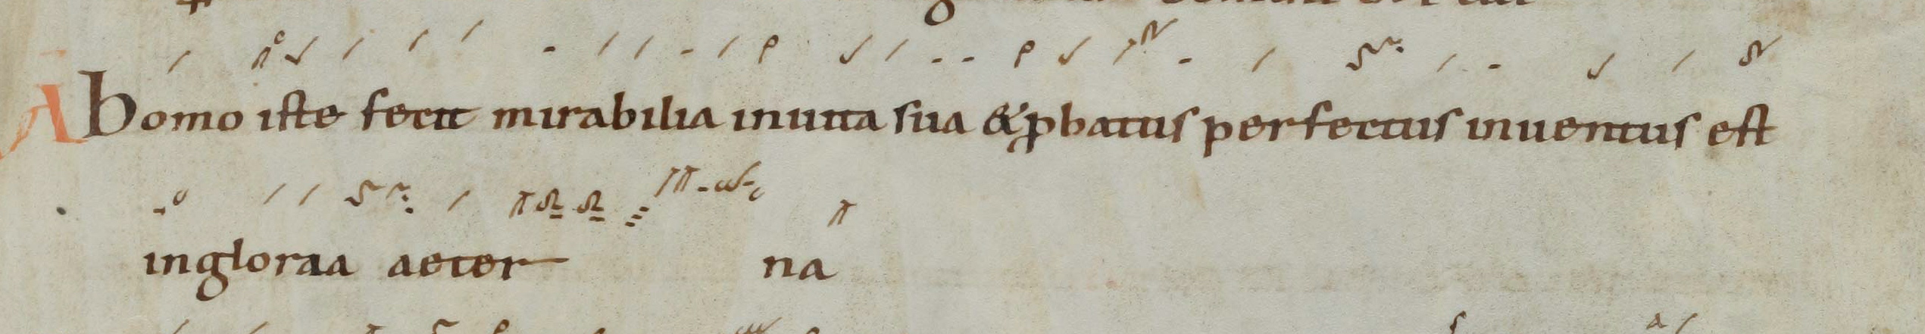

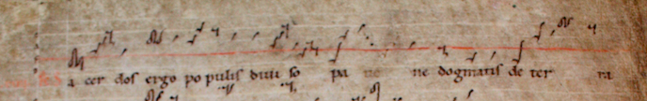

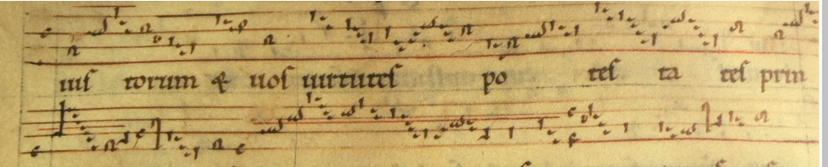

Hildegard of Bingen, Columba aspexit

Columba aspexit
per cancellos fenestre
ubi ante faciem eius
sudando sudavit balsamum
de lucido Maximino.
The dove peered in through the lattices of the windows where, before its face, a balm exuded from incandescent Maximilian.
Calor solis exarsit
et in tenebras resplenduit
unde gemma surrexit
in edificatione templi
purissimi cordis benivoli.

The heat of the sun burned, dazzling into the gloom: whence a jewel sprang forth in the building of the temple of the purest loving heart.

Iste turris excelsa,
de ligno Libani et cipresso facta,
iacincto et sardio ornata est,
urbs precellens artes
aliorum artificum.

He, the high tower, constructed of Lebanon wood and cypress, has been adorned with jacinth and diamonds, a city excelling the crafts of other builders.

Ipse velox cervus cucurrit
ad fontem purissime aque
fluentis de fortissimo lapide
qui dulcia aromata irrigavit.

This swift hart sped to the fountain of clearest water flowing from the most powerful stone which courses with delightful spices.

O pigmentarii
qui estis in suavissima viriditate
hortorum regis,
ascendentes in altum
quando sanctum sacrificium
in arietibus perfecistis.

O Perfume-Makers, you who are in the sweetest greenness of the gardens of the King, ascending on high when you have completed the holy sacrifice with the rams.

Inter vos fulget hic artifex,
paries templi,
qui desideravit alas aquile
osculando nutricem Sapientiam
in gloriosa fecunditate Ecclesie.

This builder shines among you, the wall of the temple, who longed for the wings of an eagle, kissing his nurse Wisdom in the glorious fecundity of the Church.

O Maximine,
mons et vallis es,
et in utroque alta edificatio appares,
ubi capricornus cum elephante exivit,
et Sapientia in deliciis fuit.

O Maximilian, you are the mount and the valley and in both you seem a high building, where the goat went with the elephant and Wisdom was in rapture.

Tu es fortis
et suavis in cerimoniis
et in choruscatione altaris,
ascendens ut fumus aromatum
ad columpnam laudis.

You are strong and beautiful in rites and in the shining of the altar, mounting like the smoke of perfumes to the column of praise.

Ubi intercedis pro populo
qui tendit ad speculum lucis,
cui laus est in altis.

Where you intercede for the people who stretch towards the mirror of light to whom there is praise on high.

Christopher Page

Gresham Professor of Music

Series for 2017-18

For Courtesan, Queen and Gallant: the Guitar in England
from Henry VIII to Samuel Pepys

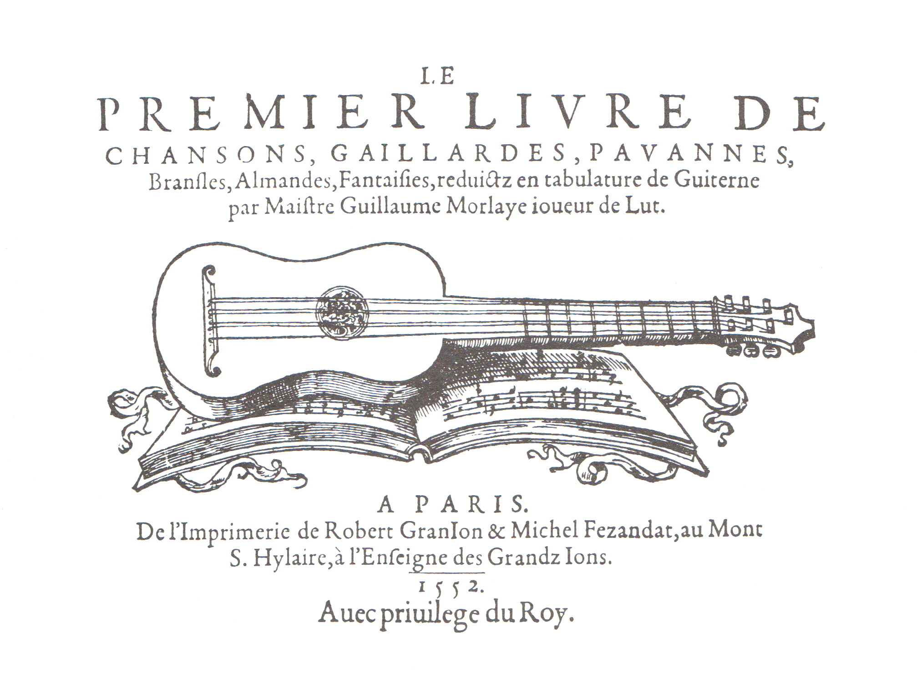

11 October 2017
The Guitar in Tudor London

15 November 2017
Buying, Selling and Owning Guitars in Elizabethan England

17 January 18
The Guitar in the Age of Charles I

14 February 2018
An Englishman (with a Guitar) Abroad

21 March 2018
The Guitar at the Restoration Court

16 May 2018
Samuel Pepys the Guitarist

