14 January 2016
The Creeping Paralysis of Drought
Professor Carolyn Roberts

At face value, there could not be greater irony than lecturing in the UK on the phenomenon of drought, at the moment. Rainstorms of almost unprecedented length and intensity have struck the west coast, thousands of homes and businesses have been flooded in Cumbria, Yorkshire, Lancashire and Scotland in the last fortnight, and we are fortunate only in that loss of life has been so limited. I say fortunate, but this aspect of the situation is in part the result of changes in arrangements for our responses to flooding that have taken place since the £3bn Central England flood disaster of 2007. Inundations also struck in various places in 2012 and 2013, reports were produced (indeed, I participated in the production of some myself), and some political action followed to alter how we respond to such calamities. Whether this action was sufficient, or sufficiently well-funded, is a theme to which I may return later this evening. But the action better to integrate emergency rescue services has clearly paid dividends in terms of saving lives during floods. Now, in my opinion, we need to stop planning to use emergency sand bags, and replace them with better forms of protection and more action on climate change….but that is another story, for another time.
Flooding and drought are intrinsically linked. The climate history of our planet shows that shifts in climate are periodic. In the UK and elsewhere we have previously experienced, historic periods when flooding was a frequent occurrence, followed by decades of droughty years, in some complex cycle. And today, particularly after the agreement at the Climate Change talks in Paris, we should also be conscious of the future implications of climate changes. National attention has recently been on the putative link between climate change and flooding, but there is an equivalent link with drought, to which I will return later.
We can think of the earth’s atmosphere as being like an unstable series of different-sized packages of air, being blasted around a rotating sphere at distinctive heights, driven by radiation coming from the sun, and re-radiated heat coming from the ground and the oceans, and increasingly from our cities. These bubbles are twisted, tossed and torn in rather unpredictable ways, by faster-moving fluctuating jets of air, the patterns sometimes pushing northwards, and sometimes southwards.
On the ground, we experience periods of instability and rainfall when these packages of air cool and release their water vapour, followed by periods of calm, warmth and dryness when they do not, in a way that is very difficult to describe, let alone to forecast. Forecasting and understanding the origins of regional drought is complex, even solely in terms of the earth’s physical parameters. We know that weather trends at the scale of weeks or months (such as droughts) are often associated with planetary-scale perturbations in circulations of the atmosphere, and the oceans. The North Atlantic Oscillation – the jet stream in simple parlance – is implicated in European droughts, but so are a range of other oscillations and teleconnections such as ocean currents and temperatures, and solar activity rates, as the slides show. This listing shows the attempt to predict overall weather patterns for the UK last autumn, based on contradictory evidence. Some suggest warmer, and some milder winters. Sorting out how it all works in detail is not yet possible and consequently forecasting remains, in part, a judgement call. In practice, it is a better than even chance that cold winters, or droughts, will follow similar events the previous year. But not always.
Drought is not only a meteorological phenomenon, a relative concept, but in some definitions has societal origins as well as consequences. We define meteorological, agricultural and water supply droughts which have different characteristics and, we can move from one to another. Water supply droughts perhaps concern us the most. We are all familiar with the major humanitarian catastrophes that can follow exceptionally long periods of dry weather, even where typical rainfall is anyway low. Today in the Free State of South Africa, less than 150 miles from Johannesburg, people will have queued for borehole water for hours in temperatures in excess of 40 degrees Centigrade, having travelled by taxi with a couple of buckets because there is such a local shortage. Their crops and livestock are already dead. This is the current situation widely across much of the centre and south of Africa, where the World Food Programme is predicting that the environmental drought effects of El Nino, the periodic upwelling of warm water in the Pacific Ocean, are expected to last until at least 2017, affecting the food security of 29 million people and their livestock. Dryness and heat usually develop together, with positive feedback between them. The loss of evaporating soil moisture and shade from vegetation exacerbates the air temperature close to the ground, in a cycle that is only broken by a large change in the meteorological drivers. Drought intensity often ratchets upwards until finally it collapses. Water supply drought is now apparently the ‘normal’ situation in some areas where population pressure is high, money is scarce, and technological levels are low. It is often unclear how unusual it is meteorologically, because the rainfall records are so poor.
Drought is not, of course, restricted to the developing world. Parts of both wealthy Australia and California, are also experiencing unusually dry weather and consequent ‘water scarcity’, though people are not yet reduced to collecting water in buckets, and their personal consumption probably remains a hundred times larger than in the Free State. Rainfall in eastern Australia has been low for the last eight months, and very much below average for large areas, for periods of about three years' duration (since the end of the last La Niña ocean event in autumn 2012; La Niña usually follows El Nino in the Pacific Ocean). Long-term rainfall deficiencies have also existed in eastern Australia over the seventeen years since 1998, stimulating bush fires that damage property, and kill. The two maps show how the area defined as being affected by ‘drought’ of different intensity depends not only on the proportional amount of rainfall received, but upon the length of time being considered.

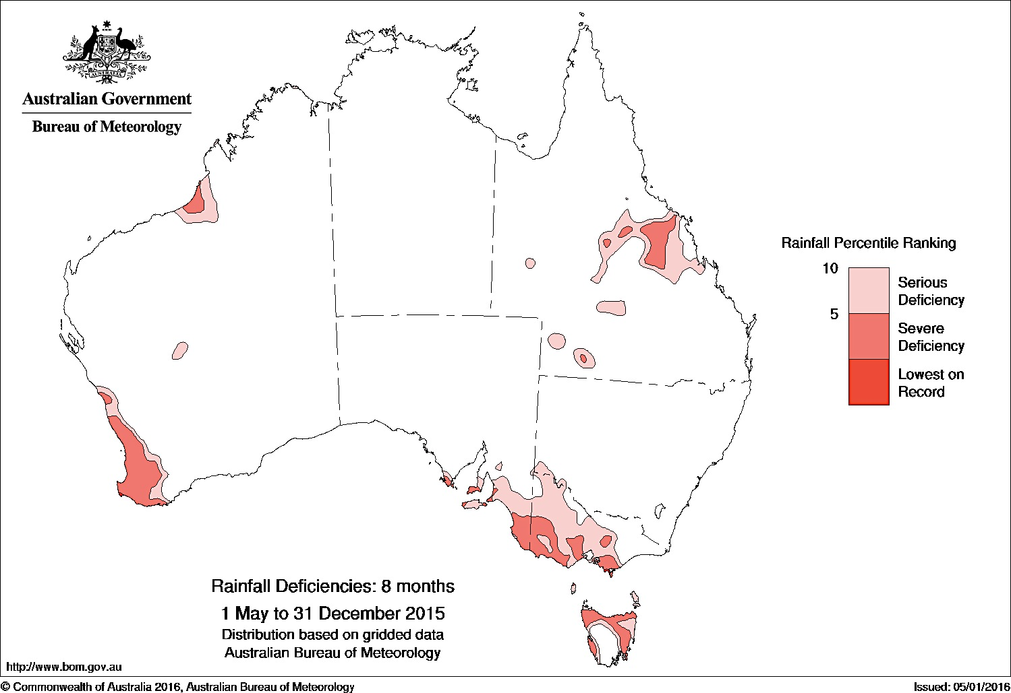
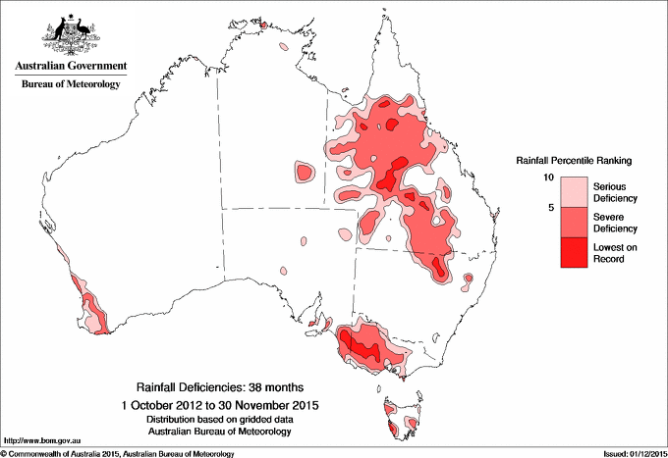

Over the last eight months, total Australian rainfall has been relatively low, in the bottom tenth percentile for each gauge in the areas shaded pink. If we extend the time period being considered to 38 months, the areas that have received less than ten percent of their ‘normal’ rainfall, are much larger. This is a widespread and intense drought, over the multi-year period, but less intense and widespread when considered over the last eight months. Such maps are data hungry, of course.
In California, again there is a longstanding meteorological drought, but with the additional arguments about the extent to which it is self-inflicted by profligate agricultural use. The yellow and brown areas on the map indicate where rainfall has been abnormally low, and the S and L lettering shows whether this is a short or long term drought. Large areas of California and Nevada are experiencing what is classified as an ‘exceptional’ drought, in brown on the map. Water is piped and pumped long distances from the north of the state and beyond, to the south largely for agricultural purposes. A single almond, for instance, requires about five litres of water to produce, although almonds have recently escaped from their ‘drought scapegoat’ role as other fruit trees have been revealed to be almost equally thirsty. This begs the question about longer-term sustainability of agriculture in these areas, naturally, despite the profits to be won even during an exceptional drought. Despite the extreme rainfall deficiency, most Californians say that the drought has had little effect on their day-to-day lives, Residential per capita use is some areas of Southern California exceeds 2500 litres per day; in the UK the average is about 120. At least they are increasingly using artificial turf in gardens, and looking at some water recycling. But this highlights the fact that drought can be partly defined by usage, by cultural norms, as well as by the areal extent, duration and intensity of low rainfall and high temperature figures. The major difference between the developed world and the developing world, of course, is that fewer people die. In the developed world, we use money and technology to overcome at least some of the consequences.
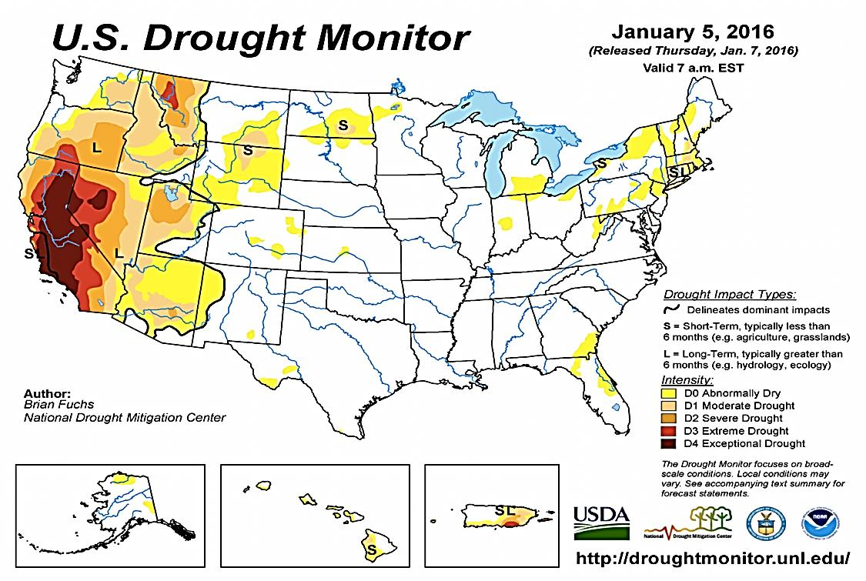
Drought can at times drive people to desperate responses in the face of disruption to their normal economic functions, or worse. Its implications ripple out across the economy, from immediate implications in agriculture, to more insidious effects on such things as power generation, and people’s available time and ability to work. There has been a great deal of debate in the media about water security and its implications for the Syrian war, for instance. Everyone from President Obama, to Prince Charles, through to Charlotte Church has been suggesting that a six year period of low rainfall is responsible for crop failures, mass migration and conflict. Here’s an extract of Ms Church giving her view on drought’s political importance in Syria. American researchers have compiled statistics suggesting that the 2006 to 2010 rainfall deficit appeared to be the worst and longest since reliable scientific recordkeeping began, although that period is relatively short. But although water shortages in Syria, Iraq, and Turkey have certainly killed livestock, driven up food prices, made children ill, and forced 1.5 million villagers into Syria's overcrowded cities just as the country was coping with Iraqui war immigrants, drought is not, in most commentators’ views, the sole catalyser of violence. High unemployment and weak government must also play a role. But it does show the potential human implications of a severe drought, and should cause us to reflect on the crisis responses that can spill out from adverse meteorological circumstances.
Closer to home, I want to take a slightly more detailed look at the anatomy of a drought in Andalucia, Southern Spain in the 1990s. This is an area where the Sierra Nevada mountains often have winter snows, but whose foothills are warm and dry. In summer, hundreds of thousands of tourists flock to the beaches along the coast close to Malaga; in a typical year between eight and nine million thirsty people holiday in Andalucia. The basic rainfall amounts are not very different from large areas of England. The catchment of the River Guadalhorce, typically receives about 500mm of rain per annum across much of the area, although inter-year variability is high. South eastern parts of England normally receive a more reliable 650mm. It is usually hotter in Spain, and rain is more seasonal than in England, but England has more people per square kilometre. So, perhaps not so different overall. Historically, the sharp annual cycle of Andalucian water availability, and the regional disparity, was managed using a combination of aqueducts and small reservoirs, many astonishingly beautiful, and some representing the pinnacle of Arabic, if not Roman, engineering. Many channels still function today, alongside large modern reservoirs and deep boreholes into limestone aquifers. Two out of the three reservoirs in the centre of the Guadalhorce basin area were constructed in the 1970s; the other was primarily a 1920s palliative to quell political discontent amongst impoverished local people. If we consider the period mid-1992 onwards, the pictures show what happened in the reservoirs. Rainfall was low. Water levels fell as the river network feeding into them shrank, killing fish and river bank vegetation, and raising the temperature and the salinity of the remaining water through evaporation. By December 1995, the three reservoirs were almost empty, when suddenly the drought broke, and torrential storms flooded downstream Malaga, caused landsliding and erosion elsewhere, ripped up riverbanks and some settlements and sent a massive plume of sediment out into the Mediterranean Sea.
The time sequence shows the ‘ratcheting up’ effect of drought very well; the histograms show monthly rainfall from 1971 onwards, and the solid line shows the volume of water being stored in the three reservoirs in the wetter uplands of the catchment. The first few years show the reservoirs being filled, slowly for engineering reasons. Then we see a period where storage volume fluctuated generally at low levels. In 1969 heavy winter rainfall was held back in storage, and rainfall stayed relatively abundant. However the period from 1992 onwards to 1995 had low rain, and the water available to supply irrigated agriculture, local residents and tourists finally dropped to almost zero. If you had been the water manager in this area, you would have been extremely concerned; two more weeks without rain would have left your head on the block.

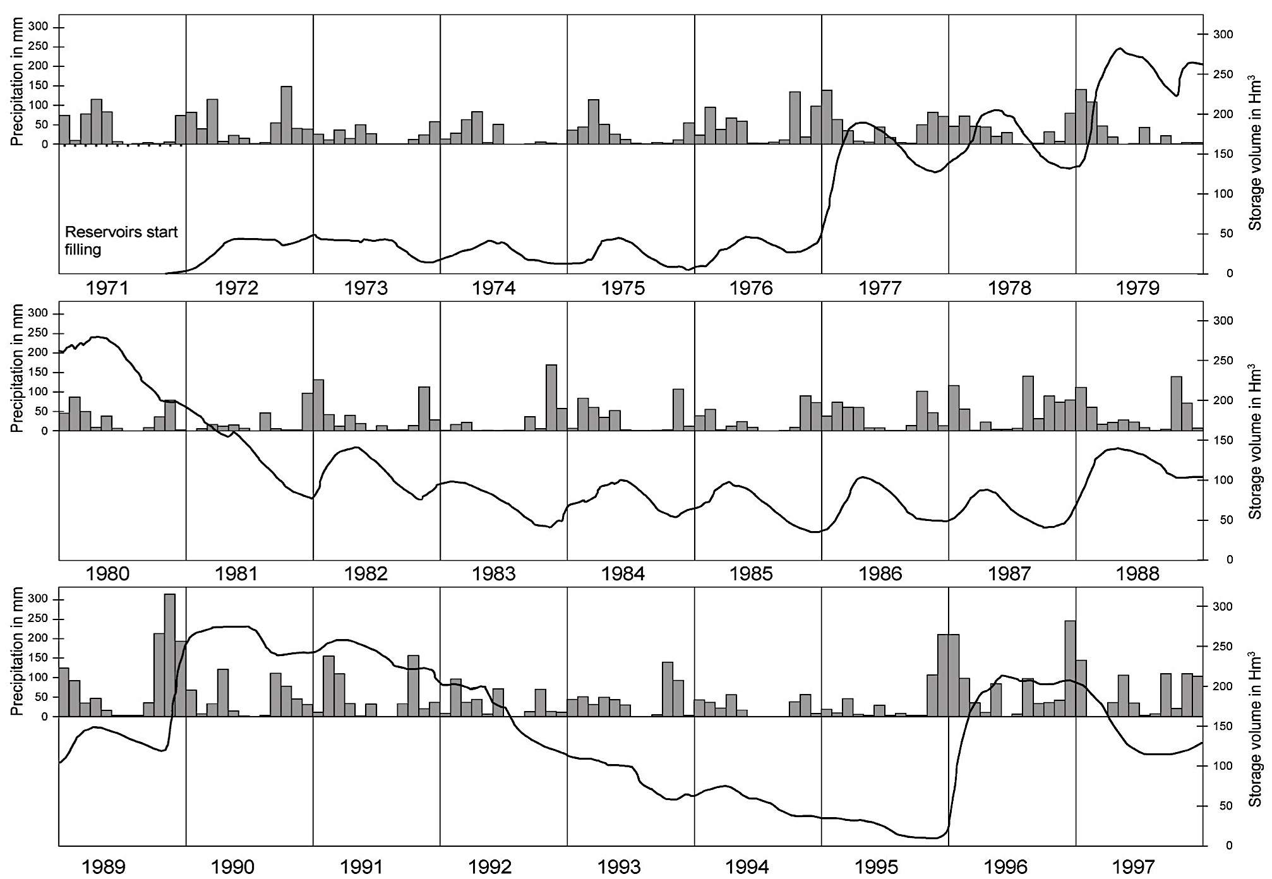

What was done to cope with this situation? Initially local people were asked to reduce their use, and irrigation for agriculture was stopped altogether. This created social tensions, as you may imagine, as livelihoods were lost. Conversely, supplies to golf courses and hotels were protected – no outward sign of a developing problem to disturb visitors. As time went on and with no prospect of an end, an emergency groundwater drilling programme was begun (the colander plan), and restrictions were imposed on houses (but not hotels). Finally a coastal pipeline was initiated to try to bring in water from further east; it was very unpopular with residents there who objected to the annexation of ‘their’ water for residents and tourists in Malaga. The construction was challenged legally, which held it up until after the sudden end of the drought. In the meantime there had been at least one drought- related shooting, many disputes, and attempts to poison urban consumers. I should add that the salinity in the water towards the end of the period was so high that it was rather like drinking seawater.
A statistical analysis shows that the drought was certainly unusual. In terms of the total annual rainfall figures, this simple graphical analysis suggests that the recurrence interval for the 1994-5 rainfall total of about 200 mm was once in about fifty years. For the three year period, it would be more extreme, maybe once in a hundred years. But the local records are very short. Combining a range of data sets including Gibraltar, we can see that there have been other drought episodes in Andalucia that were similar, but longer in duration. The 1870s were very challenging years, but without so many tourists, of course. This sequence raises questions for us about the nature of drought planning, and whether we should plan to accommodate very infrequent events. But unlike the case of flooding, where we might simply decide to do little other than pay people off if they experience damage from exceptional inundations, during exceptional droughts a water supply still needs to come from somewhere. Otherwise, people will die. In Spain they plan in the longer term to move water around the country to cope, although there is great political opposition from potential source areas.
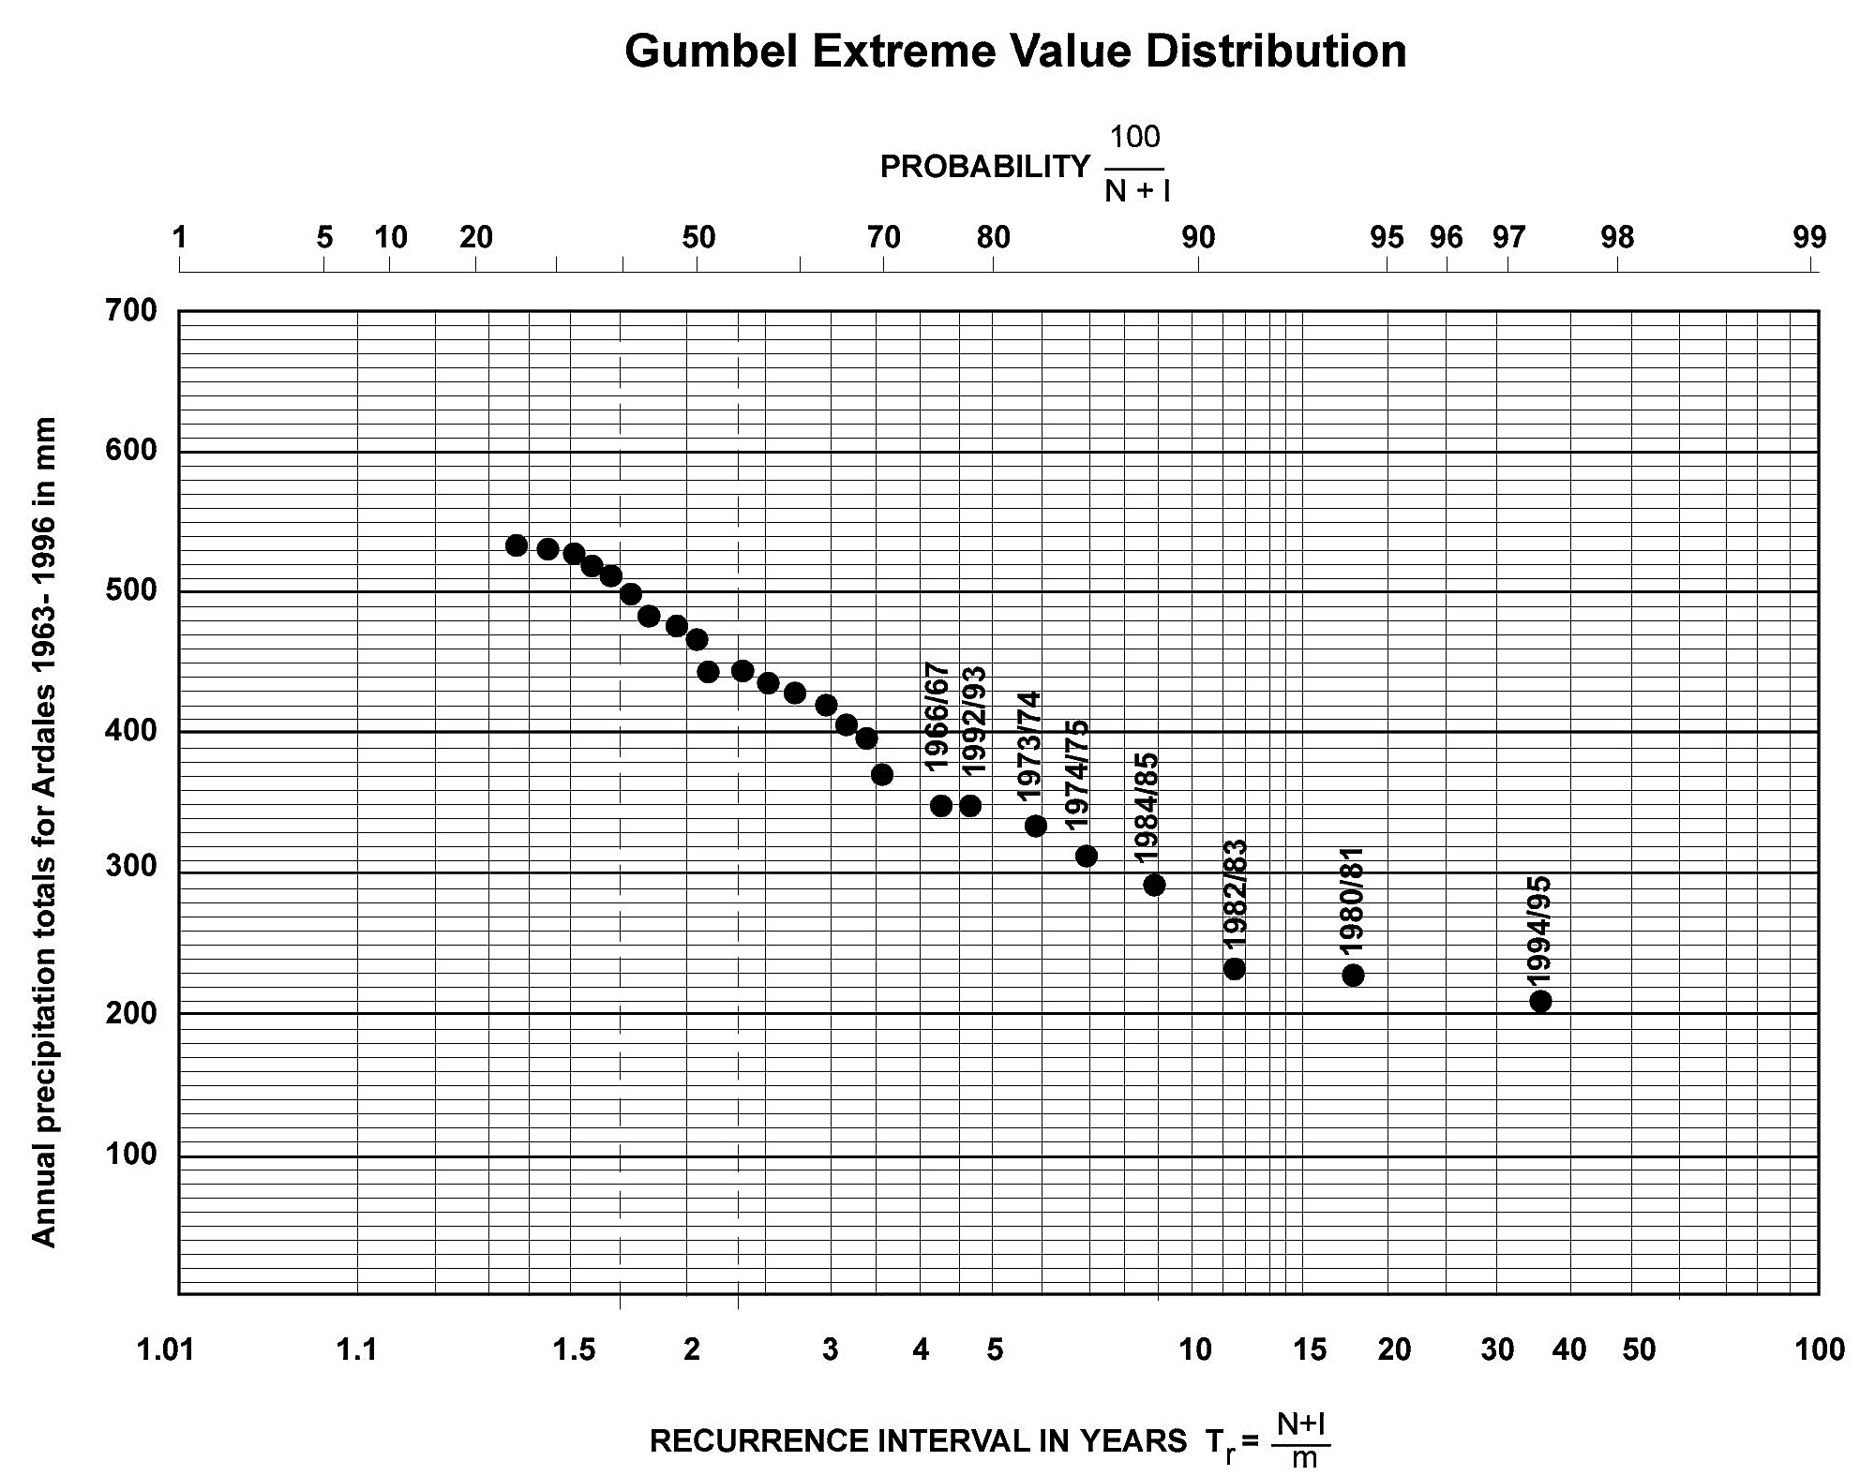

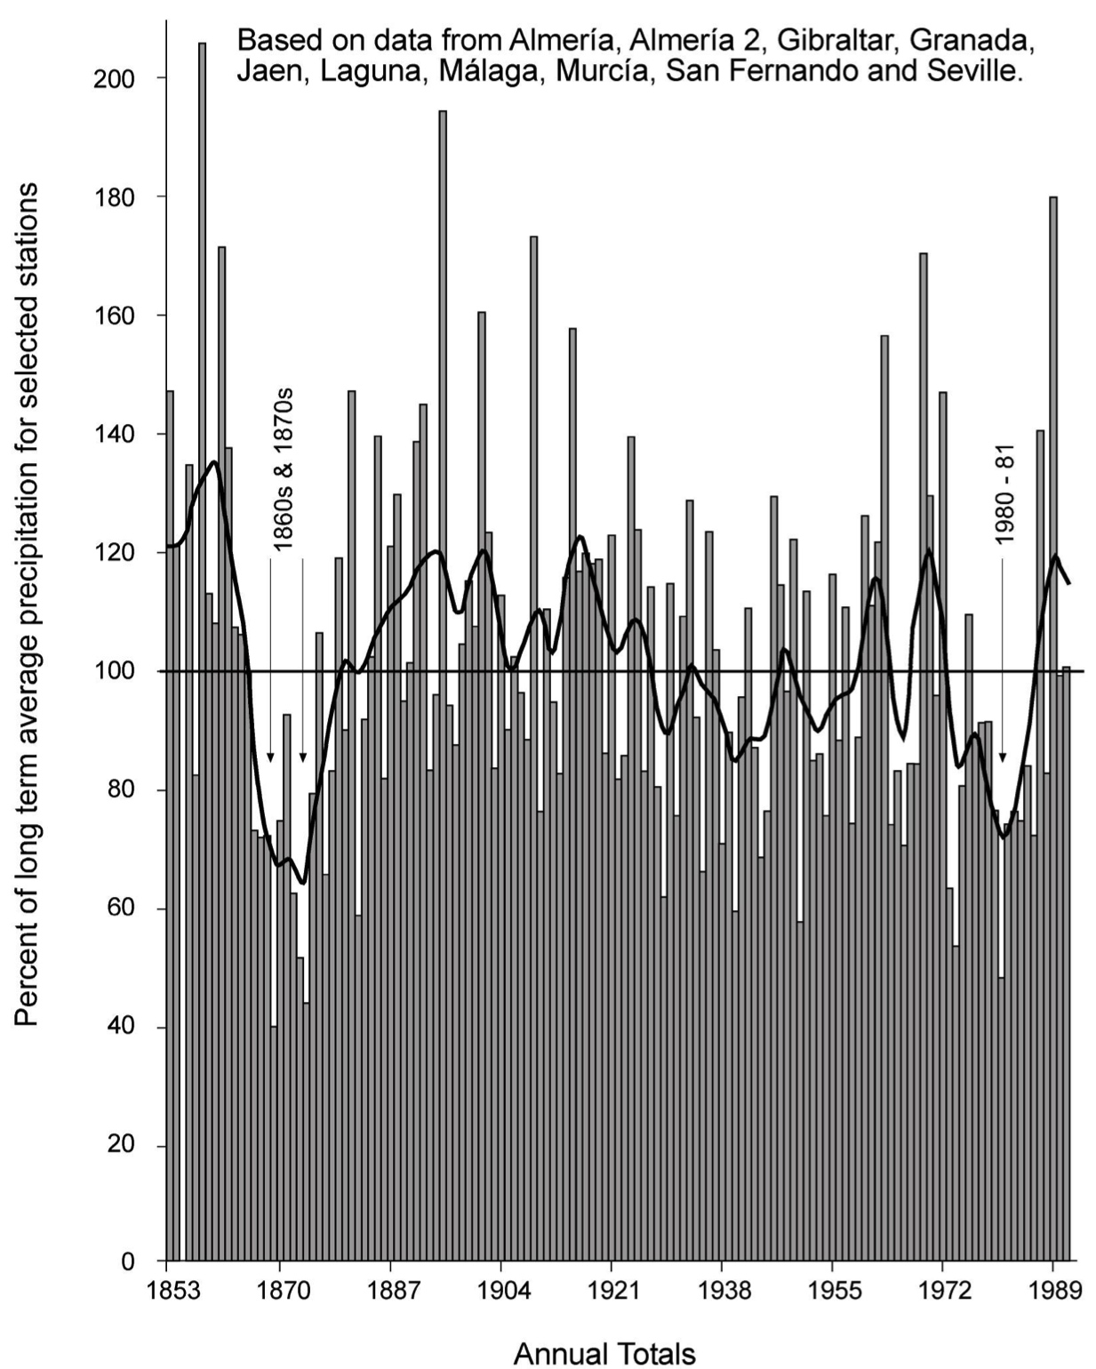
You might suggest, of course, that England (or the UK more widely) does not experience droughts of this extent, duration or severity, and that we have a more resilient economy, so that we are better able to withstand low rainfall periods. We have nevertheless experienced notable droughty phases in the not-too- distant past. 1975-6 was the most severe, with the lowest river flows on record across wide areas of the country, whereas other drought periods in the last forty years had their own distinctive characteristics. The 1995-6 event in the North of England created major economic disruption too, although it much attracted less attention in the London-based media that the earlier ones. More recently, 2010 to 2012 was the driest two year period on record. Further back in our history, there is strong evidence in manorial records of a major southeast England drought in the 1320s and 30s precipitating various types of illnesses (malaria, perhaps, and enteric diarrhoea), widespread starvation, and a massive death toll.
The imagery of the 1976 drought may provoke personal memories amongst some of the Gresham audience, even if the 1920s and the 1880s are lost to us in the mists of time. The diagram shows the rainfall trend, and the fact that this event was most severe over a 16 month period. During the drought, all hydrological parameters were affected. Moreover, crops withered and died, houses experienced substrate shrinkage and structural damage, wildlife and woodland were devastated, and millions of fish were killed by heat. River pollution reached unprecedented levels as a result of lack of dilution of domestic and agricultural effluent. Again, drought ended suddenly with intense rainstorms in September 1976 following the appointment of a drought Minister, Dennis Howells, whose arrival on local fact finding missions was deemed responsible for the subsequent flooding.
Several ‘coping’ strategies are worthy of note. Tourists were advised by local residents to turn back from the southwest of England, which was the area that proved to have the weakest infrastructure, even though this was not the area of most extreme drought meteorologically speaking. People were advised to ‘bath with a friend’, as the cartoon shows! Ice cubes disappeared from pubs, and trains stopped being washed. But more significantly, major policy decisions were taken by central government, who were the responsible authorities at the time.
Did this extreme event under any statistical scenario represent a failure of socio-economic management systems? Firstly under Margaret Thatcher’s leadership, industry was protected at the expense of domestic consumers. Householders in Devon and South Wales were put onto street standpipes, a deeply unpopular tactic, particularly affecting women and disabled people. If you ask me whether this would have happened in Chelsea, I would have to point out that Devon is a long way from Westminster, in the same way that flooded Cumbria is equally remote. Secondly, farmers were largely unrestricted in their use of river and local borehole water, and continued to use it. Yields were nevertheless somewhat lower than usual in areas reliant on direct rainfall alone. A decade later, the management strategy had almost reversed, and in fact the whole water sector had been shifted in line with Conservative thinking from being a public service (with regional Water Authorities), to being a private (although tightly regulated) industry. During the 1995 meteorological drought in the north of England, manufacturing industry was sacrificed to maintain water supplies to households. A memorable interview with the head of Yorkshire Water was broadcast in which he advised Yorkshire-based companies to move south, angering those who had been laid off work by the industry restrictions and company closures. It was subsequently revealed in the press that he was having baths at his mother’s house; outside the region for which he was responsible, which I fear did not help his reputation.
Much more recently, we have been in drought again, though our memories may be drowned out by the floods of recent weeks. We had an intense and growing drought across much of England during 2010-12, a creeping paralysis that developed from areas around the Wash, to embrace most of the south, centre and west of England. River and borehole water levels dropped alarmingly, as did the contents of reservoirs. I will use the diagram of water storage in Rutland Water, to demonstrate the water manager’s dilemma. We see the level dropping. We know the typical behaviour, the usual ranges, but we cannot accurately forecast when the drought will end, and we do not know how firmly to act – when to move to rotational cuts in supplies to houses, or cessation of services to some consumers in order to husband the remaining resource. In previous years, it was usual to make an assumption when operating a reservoir that rain would inevitably fall by October 15th, so if the projection of the line showing the fall in level did not reach zero (or close) by then, all would be well. But as before, in 2012 we were only a few weeks away from a potential catastrophe when the flooding arrived unexpectedly. Lucky.
2010-2012 Drought in Rutland Water
Summarising, we actually know surprisingly little about the quantification of drought in the UK, let alone the social dimensions of drought. How might this type of meteorological situation change in future? Most of you are probably running ahead of me in realizing that climate change is likely to make things worse in future. The south and east of England already has water stress comparable to that experienced in Spain and Italy, the result of a combination of low rainfall, relatively high evaporation and heavy domestic demand for water. Establishing exactly how climate change will affect the future situation in areas already under stress is difficult. Most models suggest increasing overall variability in the UK climate: wetter winters, and warmer drier summers. We actually require a series of models moving from various carbon emissions scenarios, to global scale models showing future temperatures and the less certain figures for rainfall, to regional scale observations and models based on limited data and understanding. You see here the Central England Temperature Anomaly figures from 1772-2015, and even if there is an ‘urban climate’ effect relating to the position of met stations, the concentration of high temperatures in recent years is highly unlikely now to be entirely driven by natural variability. We have moved, as other commentators have observed, into the ‘Anthropocene Age’.

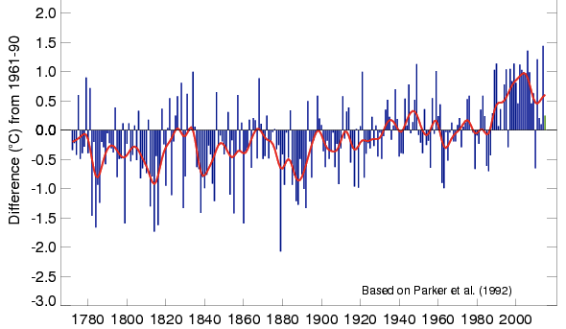

Generalising, drought is obviously more likely to be associated with those areas of the world where both total average rainfall either reduces or becomes more variable year-to-year or seasonally, and where summer temperatures increase (most areas, in fact). It is currently thought, with medium confidence that meteorological droughts will intensify in the 21st Century but this will not be homogenous: rather it will happen particularly in some areas and some seasons in southern and central Europe, centre North America, Central America and Mexico, Northeast Brazil and southern Africa. By 2080, some long term climate projections forecast only half as much English rainfall in summer (nothing like fully offset by the 30% more rainfall in winter) in the southeast. Research in the UK and elsewhere is in progress to improve the forecasting, for example in the MARIUS research programme based in Oxford.
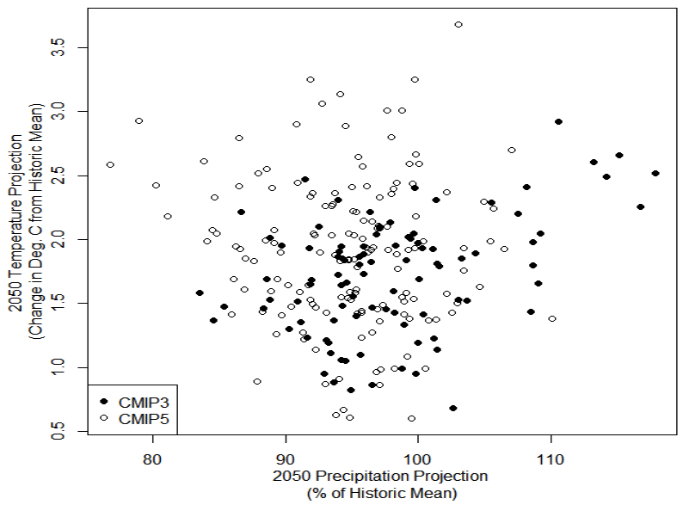

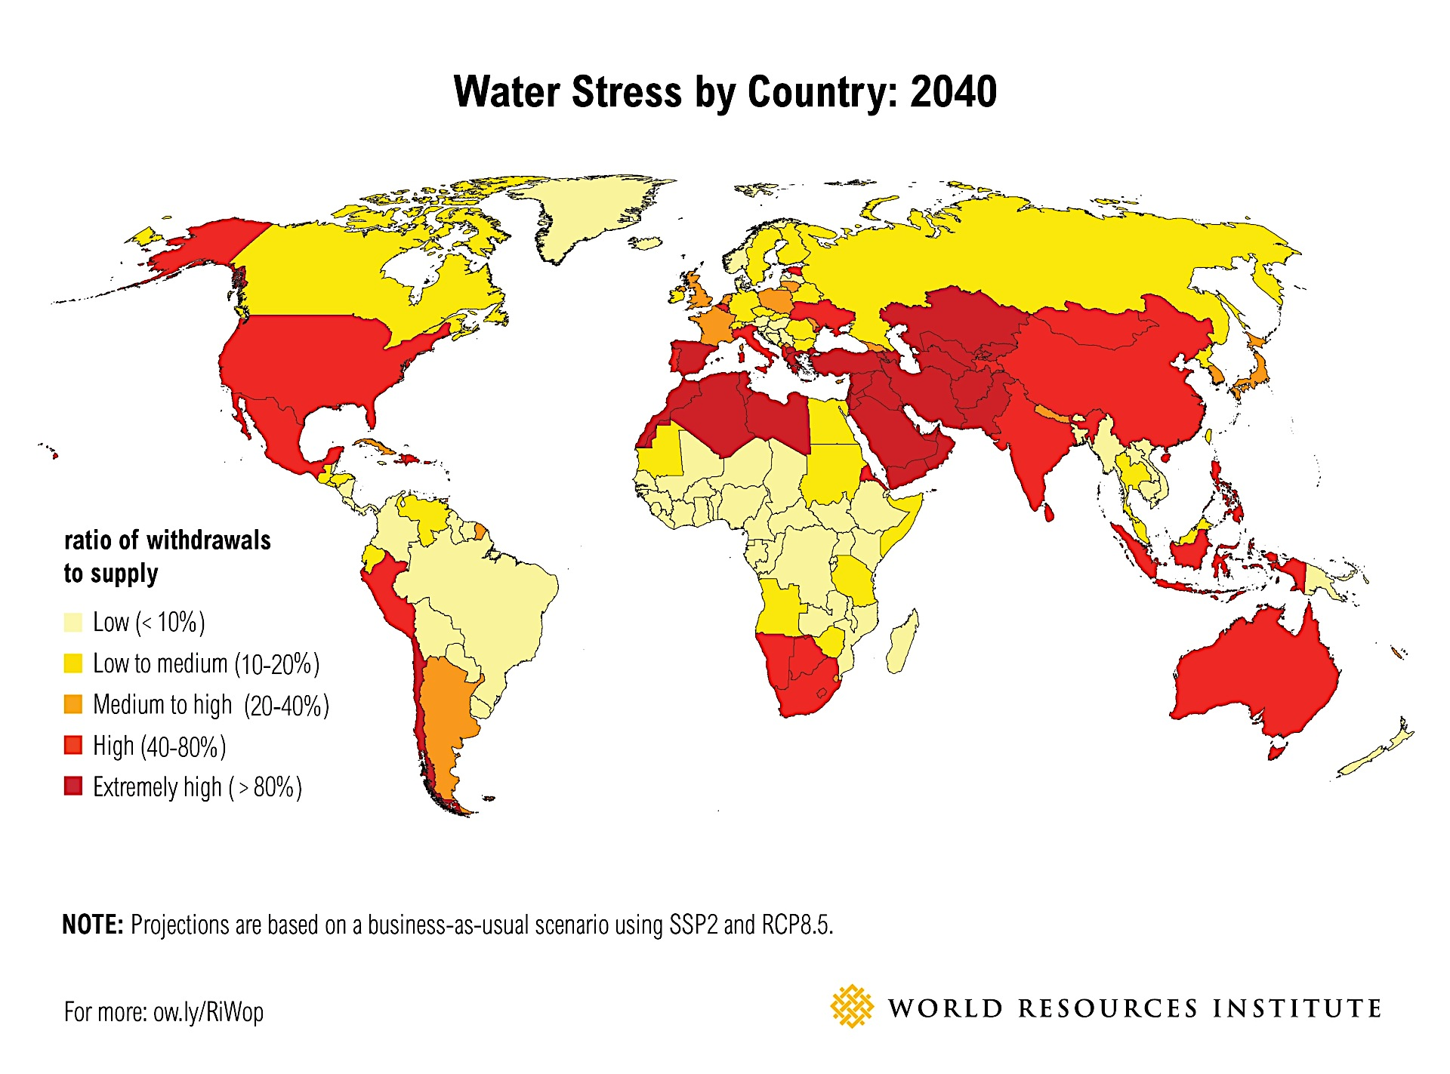
The graph here shows how regional-scale climate model outcomes, each calculated for a particular river basin, can be used to identify those areas likely to be at particular risk. Superimposed onto that we have likely population growth, and allowances for increased urbanization and the associated shifts in developing world residents’ aspirations for showers and green lawns. We end up with a global map that flags up, in red, the areas of concern, of which the UK is one at medium to high risk of water stress. The map does not show actual droughts, merely the forecast stress; prediction of the locations, spread, intensity and evolution of specific events is, as we have seen, still well beyond our current capabilities. By definition, extreme events are rare, so it is very difficult even to quantify their probability. They are at one end of a spectrum, and their duration makes them even more difficult to predict ahead of time, than for floods. But Some people have argued that we are generally on the path to ‘peak water’. It is certainly bothering global businesses. By 2040 the gap between the global demand for freshwater and its supply is likely to reach 50 per cent, intensifying the competition for global water resources in a way that will impact businesses across a range of sectors. Water-intensive industries, such as coal mining, textile production, paper production and chemicals production, will be hit hardest, as they tend to be based in countries set to experience high water stress. For example, 88 per cent of coal mines and 80 per cent of textile production is located in the 29 countries ranked as "high to extremely high" for water stress risk by the World Resources Institute. That is uncomfortable.
Let’s turn now to how we might respond to these potential calamities – these ‘wicked’ problems (to quote Rittel and Webber) - where human and environmental systems are intertwined in such a complex way. We can learn something from looking, in the way I did previously, at specific droughts of particular intensities and durations, to see how they played out in a cultural, social, economic, and political context. We can ask people to tell their stories (preferably soon after the event), and we can observe institutional shifts. The overarching influence on our ability to tolerate meteorological drought, and to prevent it turning into a water supply drought, is as Professor Jim Hall points out ‘the Three I’s’: institutions, infrastructure and information. Their order of importance is debateable, but his diagram shows on the x-axis, the variability of monthly rainfall, and on the vertical axis a composite indicator of the local storage capacity for water. Plotted on top we see points representing regions of different income (as per capita GDP). The increasingly red shading indicates the total drought risk arising from rainfall variability, water security investments, and wealth. No doubt the Thames Basin would be somewhere in the greenish-yellow area, but you can see here why Australians (point 10) and even West Coast Americans (around point 2) are not too bothered. Conversely, the African states should be anxious if they are not already. And they have less data, too. But we are not immune either. More than half the water on which the UK depends arrives in the country not in the atmosphere, but as ‘virtual water’, embedded in the goods we purchase from overseas, including from areas in the red zones. No cause to be smug.

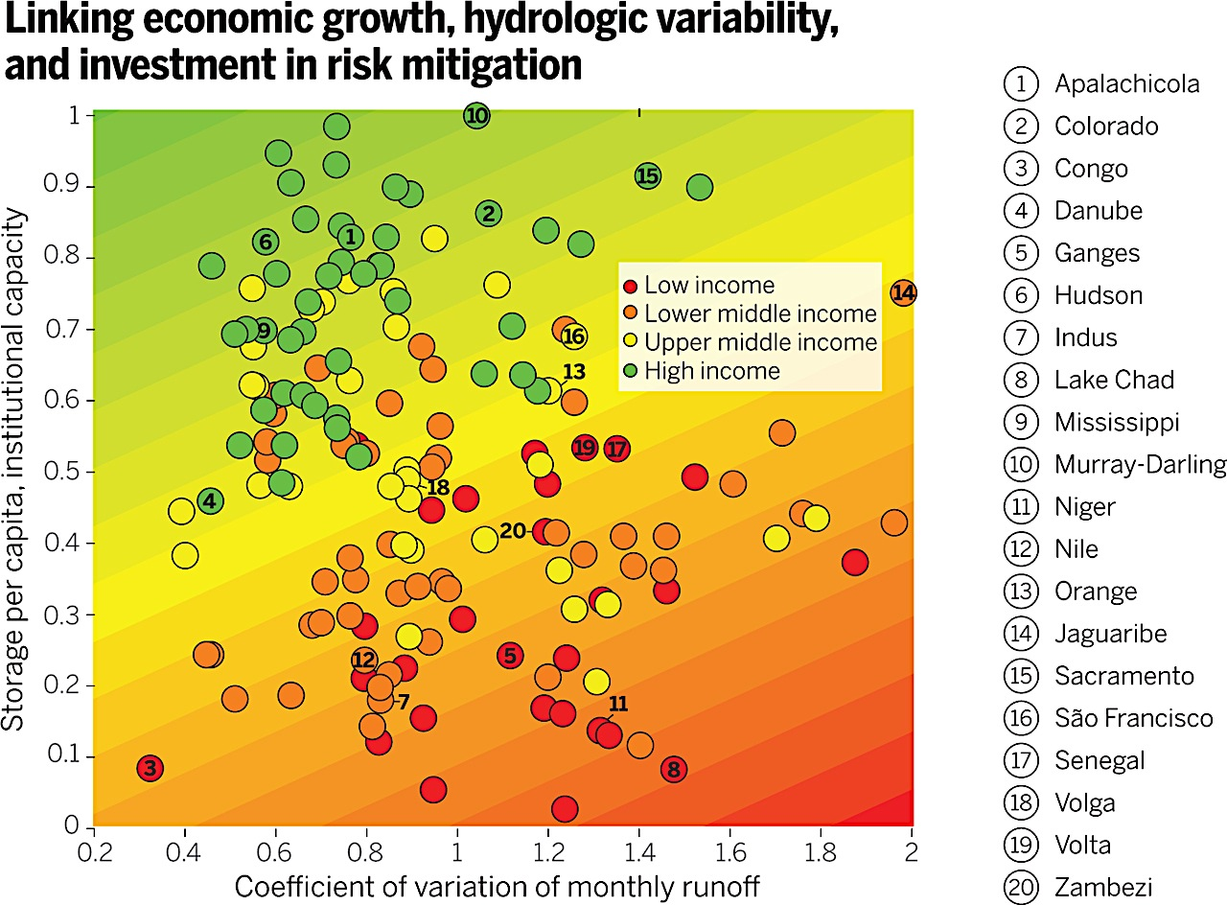

Now, finally, we need plans to cope with, or adapt to, variability in supplies and uncertain but actual droughts. Joe Louis pointed out that ‘everyone has a plan until they have been hit’, and our plans have to ensure that we are resilient to meteorological drought. We in the West, and specifically in the UK, turn on the tap and we expect to get drinkable water delivered immediately into our kitchen sink. So what if in a drought, that did not happen? Like air, water is a basic human right, like air (if not food) – right? What if, in a privatised system, one region, one company, had very little water left – what would happen?
Californian drought plans, being played out now, include some unusual sights – here we see millions of plastic balls being poured into a reservoir to reduce evaporation from the surface. I don’t know what will happen to them over the years, but it’s not something I would really want to see in the UK. In our heretical view it would be perhaps better for Californians to try to address levels of domestic and agricultural water consumption by adaptation. Reduce shower flow – stop watering lawns - grow different crops. What we are trying to do in sociological terms is to absorb the shock to human systems, whilst retaining their basic functions and structures. We do not want societies to descend into the chaos of rioting, shootings, poisonings, and mass migration that have occurred elsewhere during droughts.
Our ‘Plan’ ideally needs to protect, as we have seen from the examples, a whole variety of human activities, and the natural environment – from wholesome and sufficient public water supplies, through food and agriculture, waterborne traffic, to infrastructure such as power supplies (HEP, but also cooling water for power stations – wind turbines do not require that, of course), and industry more widely. Manufacturing a half litre bottle of Coca Cola takes about 15 litres of water, for instance. And to protect ecosystems. I am not going to trawl through all the options for long term adaptation – the two strategies that need to be undertaken in parallel, involve a balance between an engineering-led increase in the supplies of water and decreasing the demand. But in an era of limited financial resources, absolute choices and choices about this balance have to be made. Do decision makers like the idea of restricting water use, for example? After all, water companies make money by selling us water, so the balance might be tipped in favour of the former. ‘Future Water, the Government’s Water Strategy for England (2008 to 2030)’ proposes various ways of reducing demand and increasing supply (for example by expanding reservoirs) although this latter is challenging in relation to environmental impact. Some things look politically, economically or environmentally risky –long distance water transfers, for instance, although networks are growing slowly, is expensive, ecologically damaging, and could in future be threatened by devolution. Our attention is now on public and private investment against floods, not drought, but I wonder how much a cubic metre of Welsh Water might cost a Londoner to buy in a dry period if things became tight? Water is no longer, in the UK, essentially a public service, but is a profitmaking (albeit regulated) industry. We have already seen this commercial philosophy in action, where operational targets for leakage reduction, for instance, are not defined by the amount of water being lost but by whether in the short term it is ‘economic’ to repair pipes; often it is ‘cheaper’ simply to push more water into the top of a leaky network, or to build another reservoir. In my personal view this is the economics of Alice in Wonderland, and probably does not reflect what wider society would wish to see. But I wonder if you think you have ever been consulted about this?
Water management in the UK is organisationally highly complex, with many agencies and many functions, so I am simplifying. During a drought emergency, things can get very desperate, but again there are published ‘plans’. Each privatised water company in England and Wales has a plan that they are required to communicate to local authorities in their region. Water Companies are encouraged by the Environment Agency and Defra to ‘take the right steps’ to avoid emergency action. The definition of an ‘emergency’ is rather vague and I do wonder whether the economics of the current arrangements predisposes companies to work to very tight margins in terms of ‘resilience’. When do emergencies become acute – when the Thames runs completely dry, perhaps? Would it be fine for Thames Water’s Chief Executive to suggest that companies to migrate northwards, whilst he travels to take a shower in the Midlands? Of course, even in a privatised situation, some central government control is maintained – COBR, the Cabinet Office Briefing Room could be activated at different levels, bringing in the Prime Minister if the need arose. The Environment Agency would ‘inform’ ministers about the risks and the prospects. But it is ultimately companies that will decide what is done.
Finally, I leave you with a question. What is the role of the environmental scientist in this? Roger Pielke’s book entitled ‘The Honest Broker, raises some interesting discourse about the role that scientists should play in establishing public policy and subsequent action. He captures four potential roles: The ‘Pure Scientist’, the ‘Science Arbiter’, the ‘Issue Advocate’ and the ‘Honest Broker’. My diagram illustrates the different role by using his analogy of choosing a restaurant. We might offer a set of guidelines about what would be good for us. We could say ‘we know about droughts, so ask us anything you like’. We could offer specific views, as I did earlier – ‘don’t spend money on sandbags’, or in the case of drought, ‘let’s not rely on floating plastic balls’ and ‘leakage control is not being addressed properly’. Or we could attempt to present full analyses of drought implications, and guidance on what each of the choices implies. Pielke’s view is that as scientists we might aspire to the last, leaving others to actually decide, although it is clear that things are not that simple in reality. But my final question to you concerns not just the appropriate role, but the audience for scientists? Who is actually in charge?
© Professor Carolyn Roberts, 2016

Gresham College
Barnard’s Inn Hall
Holborn
London
EC1N 2HH
www.gresham.ac.uk

