11 May 2016
The Five Catastrophes That Made London
Professor Simon Thurley

Good evening, ladies and gentlemen. My lecture starts this evening with a premise, and it is a premise that I think many of you who have been to my previous lectures will have heard me talk about before, which is that London’s history is unique. The way London has developed is very different from other European cities, and its history has created a place that has been exceptionally successful over an extremely long time. It is a city which has a unique visual identity. I want to, tonight, reflect on these two points: the fact that the city has been incredibly successful; and that it looks different from other cities. The way I am going to do it is through five moments in our history, five moments of catastrophe, and each of these catastrophes produced extraordinarily positive developments that fundamentally shaped London’s future and gave it, I think, a unique advantage.

I want you now silently in your head to think what my five catastrophes are. I suspect you will get two of them – two of them are very obvious. A third one I think is probably a bit obvious. The fourth one is a bit harder to get, and if you get five then you are doing very well. So, just check them off in your mind and we will see at the end if you got them all right. There is not a prize; there is just the satisfaction of knowing.

For hundreds of years, London was just another European city, rather a small one in fact, much smaller than Paris. It was not particularly notable and it was not particularly economically successful, but suddenly, around 1650, London’s economy took off, and within a century, London became Europe’s largest city, and a hundred years after that, London was the richest city in the world, and I think probably the undisputed global capital. The tipping point in this extraordinary process, the moment that London changed from being a city to being the city came about between 1530 and 1630, and that is where I want to start this evening.

Some of you who have heard me talking about the big sweep of English history will remember this graph because, in the 1530s, the population of England started to grow again. So, this is the Middle Ages, here is the Black Death, population crashes, stagnates for hundreds of years, and in the 1530s, the population starts going up, and this is important because, while the national population expanded, the population of London grew twice as fast, and what you see here is a very good graph that shows all the sort of major cities in Europe.
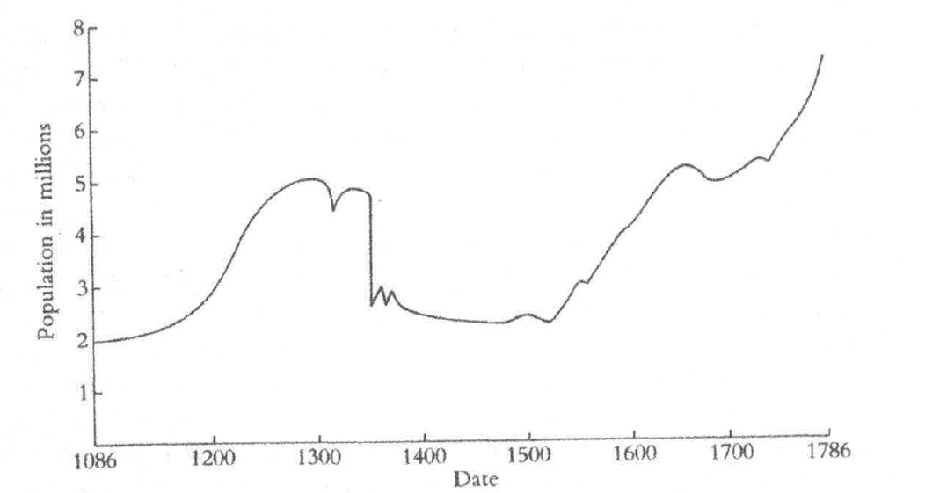
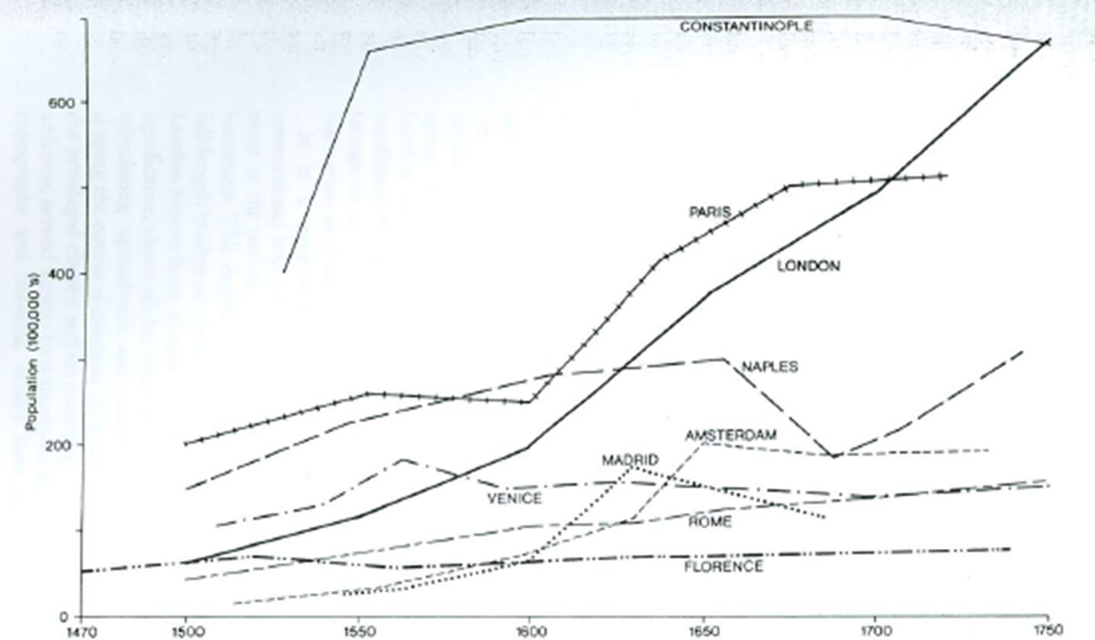

You have got Constantinople, the largest city in Europe, Paris, Naples, Amsterdam, Madrid, etc. and here you have London, this extraordinary, rapid growth in its population, again, from the early Tudor period up here to about 1750. London’s exceptional growth was not due to increased fertility but due to migration because, from the 1650s, around 10,000 people a year were coming into London to make it their home. Historians argue, sometimes vociferously, as to whether this migration was push, in other words, whether people were pushed out of the countryside into London, or whether people were attracted to come to London to make their fortune.

Well, as always with these historical conundrums, it was a bit of both, but as today, London was a honeypot because of its wealth and, in the 17th Century, that wealth was based on the export of woollen cloth. When Henry VIII came to the throne, London was exporting about 43% of England’s finished cloth; by his death in 1547, London was exporting 86% of the country’s cloth production, and the tax-take from this export was as large as the tax-take from all the other towns in England combined. In the 15th Century, the main trading place for London merchants was in Lombard Street and it was out in the open.

In 1531, Antwerp rebuilt its Bourse, demonstrating the enormous benefits of a purpose-built indoor trading centre. Although Henry VIII wanted to follow suit, wanted to build a Bourse in London, it was not in fact until 1564 when the great Sir Thomas Gresham, founder of this College and London’s wealthiest merchant, offered to build one at his own expense. I am sure that Gresham wanted this to be called the Gresham Exchange, but unfortunately, at the opening, Queen Elizabeth offered, very generously, to give it her royal title, and obviously Gresham could not really refuse. So, this building, the Royal Exchange, contained a pantheon of the kings and queens in England – here they were, statues of them sitting in these niches, and this Royal Exchange was, in every way, a royal structure, symbol of the joint interest that the Corporation of London, the merchants, and the Crown had in London’s rapidly rising prosperity. The profits of trade were huge and coincided with the first of the five massive historic changes to the physical structure of London that I want to mention tonight.

The first change was the suppression of the monasteries, and here you see Anthonis van den Wijngaerde’s panorama from the Thames, and you can just see a few of the monasteries dotted around in the city.

Now, it really is impossible today to understand how cataclysmic and how traumatic the suppression of the monasteries was. Obviously, this was the complete erosion of a belief system, the erosion of a way of life, a world picture, but it was also physically devastating for the city. Twenty-three major royal houses were suppressed and sold. Most were simply demolished for their building materials and the value of land on which they stood. The whole topography of the City of London was transformed in a period of less than five years.

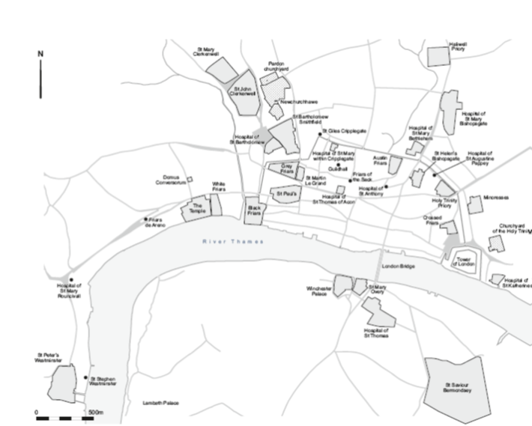

This map that I am showing you here shows you the locations of the principal religious houses in 1530, and you can see what an extraordinary amount of the city but also the immediate environs of the city was made up of monastic land, but this map tells a very partial story because the true picture has to take into account, as well as the monastic precincts, the religious houses, the huge amount of secular property that was owned by the monasteries. Over 100 monasteries owned buildings and land in the city, and, for example, St Mary Spital and St Mary Clerkenwell, both up here, owned property in 60 parishes in the City of London. In fact, I think on the eve of the Reformation, around 60% of the City of London, of the area inside the walls, was owned by religious institutions – 60%. This of course coloured the whole London property market, for the Church was not an aggressive nor was it a progressive landlord, and when all the Church landholdings came onto the market at one time, this meant a change in landlord for thousands and thousands of tenants in the City.

Many of the big monastic sites were bought by aristocrats and many of them converted them into their own houses. Some of the urban rental properties were bought by rich merchants, who ploughed the profits of their wool trade into real estate, and these merchants who bought houses, in today’s parlance, for buy-to-let, took a much more commercial attitude than the Church ever had, investing in their new properties and rebuilding them to push up yields by raising rents, and here, you see some very typical property just round the corner from here, commercially built by merchants to make money out of their investments.

So what was the effect of all of this in the long term? Well, the Dissolution came at just the point when London’s population was growing fast. The expansion and diversification of the property market increased capacity for residential, for commercial and for industrial development, and a really important aspect of this was the ability of the aristocracy to buy into the London property market. From around 30 aristocrats living in London at the start of Elizabeth’s reign, there were around 90 living there by the Civil War. Along the Strand developed a whole string of huge aristocratic mansions, the former residences of bishops and abbots. Here is John Norden’s map of London: City of London is over here, Westminster is over here, here is the Strand, and along here, these words you can’t see are the words identifying the great aristocratic townhouses, chock-a-block along the Strand. The largest and most magnificent of these of course was Northumberland House which you see here, on the corner of what is now Northumberland Avenue.

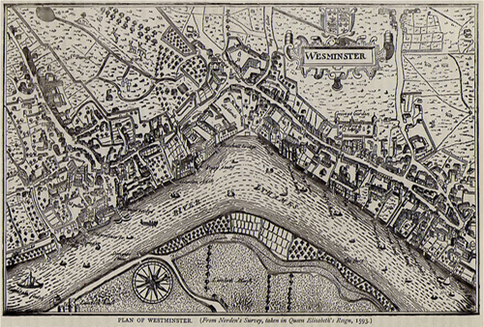

The reason why so many aristocrats came to London, almost all of them occupying former church property, was because of the rejuvenated Royal Court under the Tudors. No longer were aristocrats fighting each other, and some of the time fighting the Crown, with their private armies, as they had been doing during the Wars of the Roses. They wanted to be in London, close to the Court, which was the route to power and advancement, so the availability of Church land made it much easier for the nobility to establish themselves in the City, and the effect of these 90 aristocratic families on London’s economy was absolutely enormous. These people, and in particular their wives and their families, wanted to go shopping, and from the late-Elizabethan period, shopping became the underpinning dynamic producer of wealth in the capital.

Here is the Royal Exchange. We saw it a few moments ago. This included two floors of kiosks above the arcades, selling luxury goods, shoes, watches, silks, gloves, ribbons and many more things too. These little kiosks measured only five foot by seven and a half feet, but each one could generate enormous profits for their tenants.

In 1609, Robert Cecil, Earl of Salisbury, Queen Elizabeth’s chief minister, her prime minister if you like, commissioned a rival emporium on the Strand, amidst the houses of the aristocracy. Like the Royal Exchange, it had a street-side arcade and above it, there were a hundred shops, on two levels. These buildings, the Royal Exchange and this one, which was called the Great British Exchange, were a whole new concept in shopping. Elite customers were not forced to walk on the dirty streets, but could browse in comfort and relative privacy. The upper floors of the new exchange recreated a long gallery, and fashionable shoppers could now parade up and down as they bought their hats, shoes, fans and goodness knows what else.

So, the Royal Court, the wool trade, shopping, immigration, and the sale of Church assets, re-drew the economic and physical map of London after 1530, and the combination of these factors was unique to London. In no other city in Christendom was political power and commerce so centralised in one city.

Well, it was this city; it was this shopping mecca that was, in 1666, destroyed by the second great physical change to hit London. 488 acres of the inside of the city, 373 of them destroyed by the Great Fire – that’s 83% of the ground area. An extra 63 acres, here, were destroyed in the western suburbs.
Well, this apparent catastrophe was not - some of you will have heard me say this before, in reality, one of the best things that ever happened to London, because, like the dissolution of the monasteries, it allowed the city to completely re-invent itself for a second time.

The most important, really long-term effect of the Great Fire was to de-populate the Square Mile. In 1550, most Londoners lived in the Square Mile; by 1700, most Londoners lived outside it. Of the 13,500 houses burnt in the Great Fire, only around 4,000 were rebuilt. Just think of that for a moment…13,500 destroyed, 4,000 rebuilt…a vast, vast difference. And many of the ones that were rebuilt, the speculative developers found very hard to let because, even after the Fire, the city was crowded and polluted. Living there was expensive and vexatious and downright hard work, as a disproportionate number of people had to serve on the top-heavy governance of 26 wards, 242 precincts, and over 100 parishes – an incredibly cumbersome, top-heavy governance.

Well, in 1667, Charles II had specified that new houses had to be built of brick, and he specified the height and type of building that could be built in any specific location. Here is King’s Bench Walk, which shows very nicely what were described in 1667 as “houses of a larger sort”.

This was the first comprehensive government intervention in the planning of London. There had been many others before, but this was a completely comprehensive scheme for the rebuilding of the city, stimulated entirely by the effects of the Fire, and a scheme that had a huge impact on the appearance not only of the capital but, in due course, on the whole country at large. The new houses constructed after 1666 were not an invention of the 1660s. They had in fact been being built since the 1630s, but the huge demand for building after the Fire meant that they became the ubiquitous face of the city.

Some historians have argued that this was somehow the birth of classical architecture in London, but I do not see this myself. This was a native, home-grown solution to modernising the sort of houses that were lived in by thousands of people before the Fire. Most of the early terraces were in fact timber-framed, and the neat brick exteriors that you see in an illustration like that were a non-structural, decorative skin over a structural timber frame. These houses were built by a generation of get-rich-quick, speculative builders, who built as quickly as they could, using a kit of prefabricated materials. The houses were stylistically minimalist because they could be built cheaply and sold cheaply. This was the birth of the quintessential English terrace, a housing type that went to go on and dominate our towns and cities well into the 20th Century.

Gower Street in Bloomsbury, a very typical sight throughout England, and you can see how incredibly minimalist this style is, and it is really plain, just the windows, the simplest door-cases, simplest cornice – you know, 20th Century minimalism has got nothing on what was invented in terms of the terrace.

So, the Great Fire enabled a new start, a new type of mass housing, and handsome paved streets, populated with modern churches and public buildings. There was a new Royal Exchange, a new cathedral, a rebuilt guildhall. London now was cleaner, more modern, more uniform than any city in Europe, than Paris for instance, and it remained so until the mid-19th Century, when the great rebuilding of 19th Century cities took place. It is very easy when you go to Paris now to think that it is a much more regular city than London, but of course, in the 17th Century, it was the opposite way round.

But most importantly, London’s suburban growth from the Great Fire until after the First World War was absolutely continuous. Now we have to remember that in 1931, London was still five times larger than Calcutta, which was then the largest city in the British Empire. London was absolutely enormous. Speculators developed parts of London with terraced houses, in exactly the same way as they had done in the 1660s, and unlike Continental cities, there were no blocks of flats. After 1900, there were some blocks of flats, but basically it was a city of terraces, and latterly some detached houses. There were no great state-sponsored rebuilding schemes, just continuous, relentless commercial development, spreading London further and further out, and as London outgrew the walls of the City, and elegant streets and squares spread out west, and workers’ housing spread out east, became the problem of connectivity, one that was not solved by the barge or the horse but by steam-power. The construction of the railways did more to alter the cityscape and change the lives of the inhabitants of London than either of my first two catastrophes – the suppression of the monasteries or the Great Fire.

In September 1830, the world’s first intercity passenger railway opened for business, running between Manchester and Liverpool. It already possessed the characteristics of most of the railways system that was to come afterwards: the capacity to move high volumes of people and goods long distances on fixed routes at speed. Speed of course was a phenomenon that terrified the early users. Many believed that they would be brain-damaged or unborn babies would be deformed by going at 30 miles an hour. Of course, they were not. But what speed did was annihilate distance. By 1852, no town of any size in England was more than a day’s journey from the capital. During the 40 years that followed 1830, the core of Britain’s railway network was built and by 1871, it covered 15,736 miles. About 66% of what British Rail was operating a century later had already been built by 1871. Investment came in waves, 1830 to 1840, 1845 to 1847, 1862 to 1865, but by 1870, the railway companies in Britain had invested £530 million in land, track, buildings and rolling stocks, and they operated an entirely new business model. They were not the traditional family firm that still characterised most enterprises, but these were public joint stock companies with a limited liability and dispersed ownership and a separate managerial structure, what we would recognise as a plc today. Like the canals before them, they relied on individual Acts of Parliament to authorise land purchase and construction.

At the height of railway mania, when investors were deluging money into the railway companies and engineers were working round the clock on bigger and more ambitious proposals, the effects on Central London were drastic, to say the least. At one point, in 1840, new fewer than 19 lines were proposed to terminate in Central London with their termini. Here you can see Central London, the Inns of Court, and here you see these huge railway stations that were proposed to penetrate right into the heart of the West End and the City. These proposals would have sliced London up into small pieces of land, with islands of old building stranded by massive new viaducts and cuttings.

It was decided, in the face of these draconian proposals, that the normal Select Committee procedure that would have scrutinised each separate railway proposal had to be replaced by something that looked at London in a more strategic sense, and so a Royal Commission was set-up that would consider the merits and the demerits of what these railway companies were proposing. The dilemma of this Royal Commission was this: if the railways were allowed to do what they wanted to do, the destruction would be colossal. Hundreds of thousands of poor people would be displaced, and they thought that rather than these poor people being moved out to the suburbs, which actually would have been too expensive for them to buy houses in, they would simply re-occupy the remaining buildings in the centre of the city, increasing overcrowding and intensifying the slums. But on the other hand, if the railways were not allowed into the centre and were to be stuck on the periphery, as the companies claimed, the streets of London would soon be gridlocked by people moving goods around.

Well, this Royal Commission, which reported in 1846, in the end, banned stations being built south of the Euston Road or north of the river, and thereby keeping the termini outside the central districts. The Euston Road in the north is a barrier, and the river in the south – no termini in Central London. This is why London, amongst European cities, was extremely unusual, because in almost every other European city in there is one main railway station, usually called terminus or termini or something. But in London, when Marylebone Station opened in 1899, it was the fifteenth London terminus to be built. Only Paris was unusual too, with eight. Almost every other European city went for a single station.

Well, the eventual solution to a very unsatisfactory situation which the Royal Commission had created, whereby, if you wanted to travel from the north to the south, you had to get off south of the river, you had to cross the river, you had to cross London on a cab, and then get onto a railway and go north, was to try and link these peripheral termini by underground railways. So, the Metropolitan Railway, from Paddington to Farringdon, which opened in 1863, started a transformation in urban travel. Though at first it stole custom from road-carriers, it managed actually to expand the market, and it was soon carrying nine million passengers.

So, up to 1859, the only railway terminus in the City of London was at Fenchurch Street. All the others stopped south of the river or outside the Square Mile. But, between 1859 and 1867, the railways penetrated into the heart of residential and commercial London. The reason that Parliament dropped its opposition to this was the massive success of the Metropolitan Railway. So, four new termini came over the river, two into the City at Ludgate Hill and Cannon Street, while from the north came Broad Street. The Corporation of London petitioned Parliament to stop the development because it was literally tearing the City apart, but despite this, approval was given for two more bridges and a station at Blackfriars, linking North and South London, and finally, a really massive new commuter terminus at Liverpool Street.

Now, I do not have a precise figure for the extent of the destruction caused by railway construction in the Square Mile, but we should have no doubt that it was colossal, perhaps affecting as much as 25% of the City. Underground railways in the 19th Century were cut and cover, and the Metropolitan line, and later the modern Circle line, took a trench 100 feet wide to build, so you can imagine these great swathes of destruction cut through the City. Many other lines, such as Broad Street, were built up on viaducts to cross roads and to provide commercial storage space below. Many of you will remember, as I do, the viaduct that went across Ludgate Circus and blocked out the view of St Paul’s Cathedral, which you see there.

The cost of all this was of course huge, so big that no one really could afford to buy land in the richest residential areas of the West End, and it was only with the deep-tunnelled Central Line that the tube finally reached Mayfair. But quite apart from the public and commercial buildings that were destroyed, railway construction displaced at least 120,000 people – their homes were demolished and replaced by railway lines.

Well, of course, the railways transformed London, and doubled, tripled or quadrupled land values wherever they went. The nature of land use at the termini changed. They attracted warehouses and offices, they displaced houses and shops, and in their hinterland, they bought sidings, coalyards and gasworks.

You see, you have got to remember that, before the arrival of passengers, railways had basically been designed to transport coal, and the first railways, such as the Stockton and Darlington Railway of 1825, were built to solve the problem of moving coal around. Here, you see the Stockton and Darlington Railway. These are the coal-trucks, and here are people sort of hitching a lift in coal-trucks. I mean, this was why they were built. So, the real prize for the commercial railway operators was to bring coal into London. In the 1840s, three million tons of coal were brought into London docks by coastal shipping. The railways took the docks head-on, and by 1856, the railways were supplying nearly 30% of the capital’s coal, and by 1867, they were supplying more half, and most of this came in through the great north Northern Railway into the Kings Cross goods’ yard. Here, you see this wonderful great aerial picture showing Kings Cross and St Pancras and the vast area here to the north which was covered by goods’ yards to mainly deal with the coal - 59 acres, in fact, one of the largest railway goods’ yards in Britain, and when it opened in 1852, the most impressive facility of its kind in the world.

At all the main goods’ yards, there was huge provision for stabling horses because of course, when the trains disgorged their goods, there was no other way for distributing the goods other than by horsepower, whether the goods were going to go on a cart or were going to go on a canal, and so these railway goods’ yards had vast stables, industrial stables. In 1893, the London railway companies alone had stables for 28,000 horses.

These are the wonderful Mint Stables in Paddington, which are still partially there. These were double-decker stables to make the most of the land value. They were designed for 600 horses.

So, the railways re-shaped the City and its surroundings like nothing before it. By 1870, the railways were delivering 200,000 people into the heart of the City every day, men and women who stuffed the merchants’ offices, the banks, the insurance companies, that generated the City’s wealth. Between the 1840s and the 1870s, these institutions transformed the City with a firework display of architectural virtuosity. But this incredibly destructive development led to the fundamental changes in creating the commerce of the City. Before the railways, the Square Mile had been largely made-up of residential scale Georgian buildings. It was now transformed, and because of the coming of the railways, 80% of the buildings standing in the City in 1855 were demolished and replaced by 1900. So, in 50 years, because of the massive commercial development enabled by all these people coming into the City, 80% of the City was completely replaced. The population of London, as a consequence, fell from 129,000 in 1850 to only 26,000 in 1900.

The charge for new buildings was led by the insurance companies, eager to use their offices to infuse their businesses with a sense of confidence, solidity and endurance. The earliest in the City is the Atlas Insurance office, just round the corner from here, still standing, in Cheapside, built in 1838, a smooth essay in classicism.

But by the 1860s, the insurance companies looked to their headquarters to convey very different messages. This is a message about solidity, about tradition, about reassurance. By the 1860s, the architecture of these insurance offices was basically an extension of their advertising budget.

Here is the Royal Insurance Company headquarters, a company started in Liverpool, constructing a huge, flamboyant building in Lombard Street in 1857.

Banks also started to move from sober and domestic premises to Italianate offices similar to those occupied by the insurance companies. So, here you have got the headquarters of the National Provincial Bank, which of course eventually morphed into the NatWest Bank, on Bishopsgate. This is the best of the 19th Century banks, built in 1864-5 to replace an 18th Century mansion built in 1750, from which the bank was conducting its business up until that point. This new building proclaimed the bank as a national rather than just as a provincial success, and you can see that, in many ways, its architecture was aping the architecture of the Bank of England itself, with these huge, giant Corinthian plasters on its front.

It was very much this Victorian and Edwardian commercial city that was subjected to the fourth of my destructive forces, the Blitz. During the War, it was possible for a city like Sheffield to deceive the German bombers and to divert their deadly payload away from the city centre, but London, still the largest city on the planet, was an unmissable 12-mile-wide target. Between September 1940 and May 1941, it was subjected to the most devastating aerial bombardment. During the first three months, every night, on average, 160 bombers dropped 200 tons of high-explosive and 182 canisters of incendiaries on the City. On October 15th, there were 410 raiders, dropping 538 tons of explosive. In the first six weeks of bombing, a quarter of a million were made homeless, and on 29th December 1940, there was the second Great Fire of London. In one night, 64,000 incendiary bombs rained down on London, igniting a massive swathe of building from St Paul’s to Islington. In the City of London, 164 out of 460 acres of building were destroyed, that is to say 36% of the area. The Blitz, like its destructive predecessors, the suppression, the Great Fire, the railways, re-drew the economic and architectural rules of the City. More than half its industrial and warehouse buildings were destroyed, and by 1947, 40% of its industrial workers had left, and more to follow over the following decade. Industry had, in fact, been leaving the City before the War, but the Blitz resulted in a massive shift in the City’s economy, away from industry to trade and commerce.

The context of post-War rebuilding was, like that of 1666, state intervention and control, which at first held back reconstruction but, in the early 1950s, after the Conservatives had liberalised the property market, a property boom was unleashed across London, which resulted in the construction of 24 million square feet of office space in just eight years. By 1962, there was 114 million square feet of office space in London, twice what there had been in 1938. Just as the London of the 1660s and 1670s had been built by speculators, building cheap, fast and minimally, so was the office estate of the 1950s – history repeated itself almost exactly.

So, what was the attitude of the Corporation of London to this massive building boom? Their consultants for the City restoration were the architect, Charles Holden, and the planner, William Holford. They said, and I quote: “It would not be wise to adopt a new aesthetic and a new scale for building in the City of London until the old one has been definitively lost or outmoded. The 17th Century scale should be preserved and St Paul’s Cathedral, the noblest in the country, should remain architecturally, as in other ways, the chief building.” Well, this was a fine ambition, but in practice, it was impossible to achieve.

In the first years after the War, until around 1955, most office buildings in the City were built of Portland stone, with stripped-back classical details, very much in the vein of the 1930s. This was the initial ambition, to take up the historical roots of the City as the foundation for reconstruction.

Bracken House is a very good example of this generation of buildings.

But everyone here will probably be familiar with the recently-demolished Number One New Change, much more typical of the quality, if not the scale, of office buildings built in the ‘50s.

However, in 1953 to 1958, Bucklersbury House was constructed, the first building in the City in a modernist style. Bucklersbury House demonstrated that buildings with an exposed frame and glass and precast panels could be built much more cheaply, and much faster, and therefore much more profitably than those like this that were built in a classical style.

So, in 1955, at Fountain House in Fenchurch Street, the developers switched styles and introduced the first American-style tower and podium and the first block with an all-glass curtain wall. So, here, you see the podium, and here you see the block on top, and you see these curtain walls here, all made of glass. These sorts of blocks went on to dominate the City during the 1960s and the 1970s.

The Corporation of London was also a major developer in this vein. Determined not to make the same mistake as they thought was made in 1667, the Corporation spent £13 million buying up 115 acres of bombsites round St Paul’s Cathedral, the Barbican and Fetter Lane. The Corporation’s commercial buildings included six almost identical 18-storey tower blocks in London Wall, as the commercial zone of the Barbican development. Of course, we are sitting underneath the only surviving one of those, Bastion House. When you go out there, you will see that one, but it was originally, as you can see from this view down London Wall, just one of a number. I said the Corporation spent £13 million buying up the land. They actually spent £31 million buying up the land, just for the record.

The problem with City office building in this period is that it was, at best, of middling quality and it was not built to last. Only Bracken House has been listed, out of the scores of new City office buildings erected between 1945 and 1980 in the City of London. In the West End, a small number of buildings from the same period have been listed – Centre Point, which is currently being converted into residential accommodation; the Economist Group building, the Millbank Tower; New Zealand House, just off Trafalgar Square.

But this is not to say that the Corporation did not make a contribution to post-War architecture because of course it commissioned the Barbican Centre, one of the largest and most spectacular pieces of state-sponsored architectural patronage in English history.

But, essentially, I think there was a failure of design in the City in the post-War period, a failure that partially explains my next image… This map, ladies and gentlemen, was given to me by the recently-retired City planning officer, Peter Rees, and it shows, in red and in orange, the area of the City of London redeveloped between 1985 and 2005. Every one of those blobs there is a redeveloped site in the 1980s and 1990s.

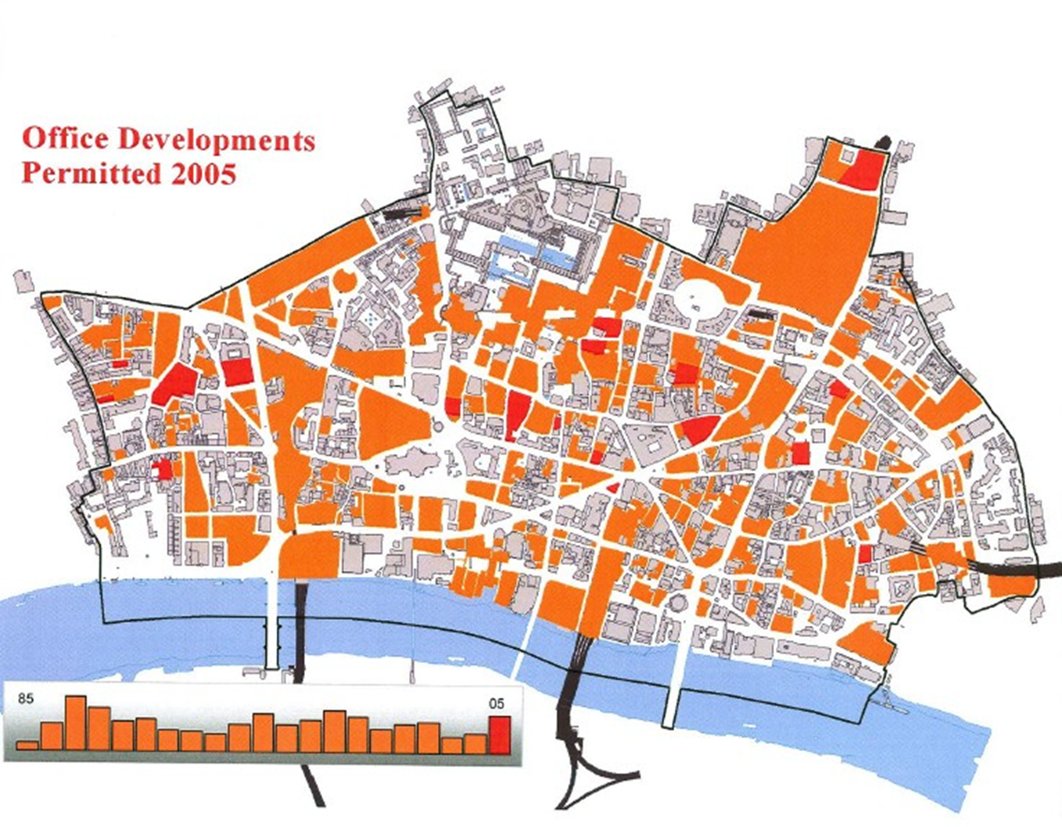

If you compare this with the map showing redevelopment between 1945 and 1985, you will see that barely a single corner of the City of London remains undeveloped twice since the Second World War.

Well, Leon Trotsky said that war was the locomotive of history, and there is a huge truth in this. War, catastrophe, revolutions, push societies, push economies, push cultures on. Five years of the suppression of the monasteries, four days of the Great Fire of London, eight years of railway construction, and 57 days of the Blitz, accelerated changes in London that had been inherent and had allowed the City to reinvent itself afterwards. Never let anyone tell you that history has held this city back. You only need to look at that development map again to see that the city has been almost entirely reinvented over the last 25 years. This city has been driven by cataclysm, by sharp, destructive, physical change, but change that has allowed it to renew itself and change that has given it a crucial economic advantage. At each turn, out of disaster, the money, inventiveness, and creativeness of the city has thrown up buildings of interest, and sometimes of great distinction, and this is a very important point because the quality of the city’s build environment is a bellwether. It symbolises the cultural health and vibrancy of the metropolis.

Great civilisations build great architecture and create great art. It is no coincidence that Elizabethan London, in its great period of expansion, was home to Shakespeare and the Southbank theatres, buildings unique in Europe, showing plays recognised the world round as amongst the greatest ever written.

Out of the Great Fire of course came Wren and Hooke and his companions, who created the greatest single corpus of religious buildings and the incredible skyline of London, invented in the 20 or 30 years after the Great Fire.

I could go on, but I am not going to. My point is a very simple one, that the quality of our built environment depends on cultural confidence, which in itself is generated by economic success. Economic success is reliant on attracting people to live and work in centres of economic activity, and we know that people are attracted to places where the environment is beautiful, so there is a virtuous circle.

But hold on…he said five catastrophes! I have only spoken about four. Now, who, honestly, got all five? Who got four? Who got three? Yeah, quite a few people got three – that’s good.

Well, ladies and gentlemen, I have got some bad news for you this evening because we are now living through the fifth catastrophe. This is a catastrophic housing crisis, a crisis that means, today, 40,000 households are homeless or in temporary accommodation, and a further 220,000 living in overcrowded conditions, a crisis that will see the minimum deposit to buy a house rise in London to £100,000 by 2020 - here you see a graph showing the rise in house prices over the last few years - a crisis that could mean that by 2040, the only people who could afford to buy a house in London is a banker. Did you know that, if the price of food had risen at exactly the same rate as house prices over the last 30 years, your supermarket chicken would cost you £47, your jar of coffee would cost you £20… Private rents in London rose by an average of £750 a year in 2012 alone, and on top of this, population growth is expected to add a further 850,000 houses in the capital by 2031.

The causes of this ongoing catastrophe are very complicated, and we have got absolutely no time tonight to go into it all, even if I were qualified to talk about it, but a basic fact is that, before the Second World War, private developers were regularly building 300,000 houses a year. In the 1950s and in the 1960s, we were still building more than 300,000 houses a year - nearly half of them were being built by local authorities, by the councils. But in the last few years, we have been building fewer than 100,000 a year. In London, we need to build 33,000 new houses a year, but only 25,000 were completed in 2011, and this is not enough to keep up with new demand let alone to deal with the backlog. So, we have a problem, and we have a problem that has huge, absolutely huge architectural consequences, which no one really has got to grips with yet. Where are we going to put hundreds and hundreds and hundreds of thousands of new homes and what are they going to look like?

You may have read that over 320 tower blocks, taller than 20 storeys, are currently being planned for London. Seventy of them, which you see on this map here, are currently under construction.

Let me introduce you to Stratosphere in Stratford – get it? And to 1 The Elephant in Elephant & Castle… And, almost up now, 199 Westminster Bridge Road… These, ladies and gentlemen, are the face of London in the future.

So, each time, through history, a huge crisis has led to changes that have made London stronger, better and more successful. From the pain has genuinely, history shows us, come gain. But what of this housing crisis, the catastrophe in waiting for the 21st Century, one that will probably make it impossible for my 7-year-old twins to buy a house in London in 20 years’ time? Is the response to this carefully thought-out? Will the radical, fundamental change to the appearance and character of London be for the better or for the worse? Will we emerge stronger in the global economy or will we emerge weaker?
Well, of course, we do not yet know, but you probably will all have your opinions. So, what I suggest is that we reconvene in 2026 and see what’s happened!

Thank you very much.

© Professor Simon Thurley, 2016

