03 February 2015
The Shape of Things to Come:
How our Changing Demographic Structure will Shape Future Society and Health
Professor Christopher Whitty

It is appropriate that this lecture is being delivered at Gresham College as one of the founders of demography was William Petty. Physician, astronomer, economist and MP, he was Gresham Professor of Music and also helped lay the foundation of modern census techniques.

The world is currently going through some of the most rapid demographic shifts in history, which have never occurred before and for reasons that will be explored later are very unlikely to occur again. This will shape our choices and is going to throw up some serious policy challenges. Two parts of this shift tend to dominate public debate; the global increase in the general population, and the ageing population in richer countries. This lecture, whilst touching on this will look in more detail at the shape of the demographic profile of different countries, how this is changing and what the possible effects of this will be on society including on health. The lecture will first consider drivers of demographic changes, and in particular the phenomenon of the demographic transition. It will go on to look at some of the really marked shifts in demographic structure and dependency ratios between several key countries and within them over the next 4 decades and consider the possible implications. Finally it will turn to the UK and some of the possible implications of demographic changes for UK policy especially for the very old. Of children born in 2015 1 in 3 born in the UK will reach 100 years of age; most will reach over 90. Demography is not destiny, but it is one of the things about the future which can be predicted with reasonable certainty, and provides major opportunities and constraints on what a society can do, as we will explore.

Drivers of demographic change.

Multiple things drive changes in the shape of the demographic profile of countries. The key ones are the numbers of children being born (fertility), their survival through childhood, the age of which they die, and migration patterns. The starting point for this series of lectures was outlined in the initial lecture in this series looking at health in the very young and very old. Two major changes are happening throughout the world; a significant reduction in childhood mortality everywhere, meaning that the chance that a child surviving the first 28 days will survive through to late adulthood is now high almost everywhere, and a gradual upward shifting of the age at which adults die.

As countries get richer, child mortality drops, female education increases and contraception becomes widely available, and then after a time lag the number of children per mother has historically tended significantly to decline. The drivers of this change in family size choice are complex, but this appears at least on historical basis to be a one-way phenomenon; it is very rare for any generation of mothers to have more children on average than their predecessors. In many parts of the world, including most of Europe and large parts of Asia and Latin America there are now 2 or fewer children born to every mother- so fertility is below replacement levels (Fig 1). Populations are still growing (population momentum), but this is because adults are living longer not because more children are being born every generation. Data presented comes either from the United Nations and its bodies, or the UK Office for National Statistics.

Fertility rates in Europe: most are below the 2.1 child per mother that is roughly the replacement rate.
1.5
2

This process of dropping childhood mortality followed after a lag period by dropping fertility of mothers leads to the demographic transition (Fig 2).

Schematic of the demographic transition.

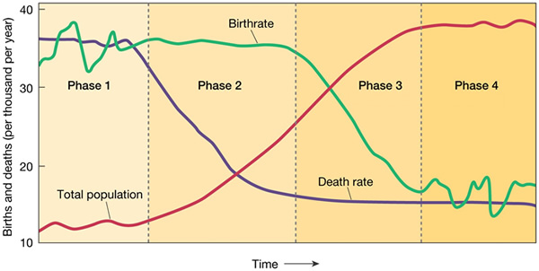

It starts with a steady state with large numbers of children per mother, a high proportion of which die so the population is stable, and eventually ends up with a much smaller number of children where very few of them die and the population is stable. The period between the two is the one that leads to a dramatic shift in the shape of the population pyramid, and also to an explosion in numbers in a country. In the initial lecture of this series I explored some of the reasons that children are dying at a much lower rate everywhere in the world, but particularly in the developing world (most recently and most rapidly in Africa). These include better nutrition, water and sanitation, preventative medicines such as vaccination, improved housing stock and curative medical services. At the same time in richer industrialised countries mortality, especially due to cardiovascular disease has also dropped rapidly partly due to societal changes (such as reduced smoking) and partly due to improved preventive and curative medicine. In future lectures I will consider why this reduction in cardiovascular disease has been so marked and what it means for the very old.

The reason women have fewer children is clearly complex and depends on many factors including their age at marriage (which is increasing), their education (also increasing) and the availability of a mixture of contraceptive methods that are socially acceptable locally as well as child survival. All of these have some way to go in many countries before they reach steady state but it is clear that women with reasonable life choices and free availability of contraception do not choose to have multiple children on the whole. There are now very few high fertility countries (those with over 3 children per woman) where fertility rates are not dropping, in some cases very rapidly.

There are a large number of possible demographic pyramid shapes which we will go through with examples of current country structures and where they are likely to go in the next thirty years. But to understand the basics here below are three current population pyramids. The first, illustrated by Nigeria (Fig 3, L), shows a high fertility population only starting to go through the demographic transition. The second is when child mortality has reduced but after a lag fertility has reduced and the population gradually (or rapidly) expands as these surviving children become adults. An example in Bangladesh (Fig 4, middle). The third is an ageing population, illustrated by Japan in 2030 (Fig 5, Right). Each of these present significant challenges to the society and to policy makers within it but rapid shifts between them can require a wrenching change in society and economies.

Population pyramids for Nigeria (2010), Bangladesh (2010) and Japan (2030)

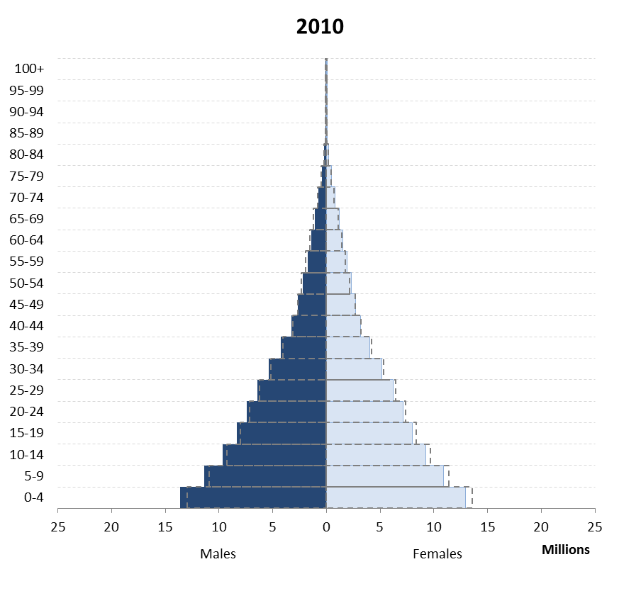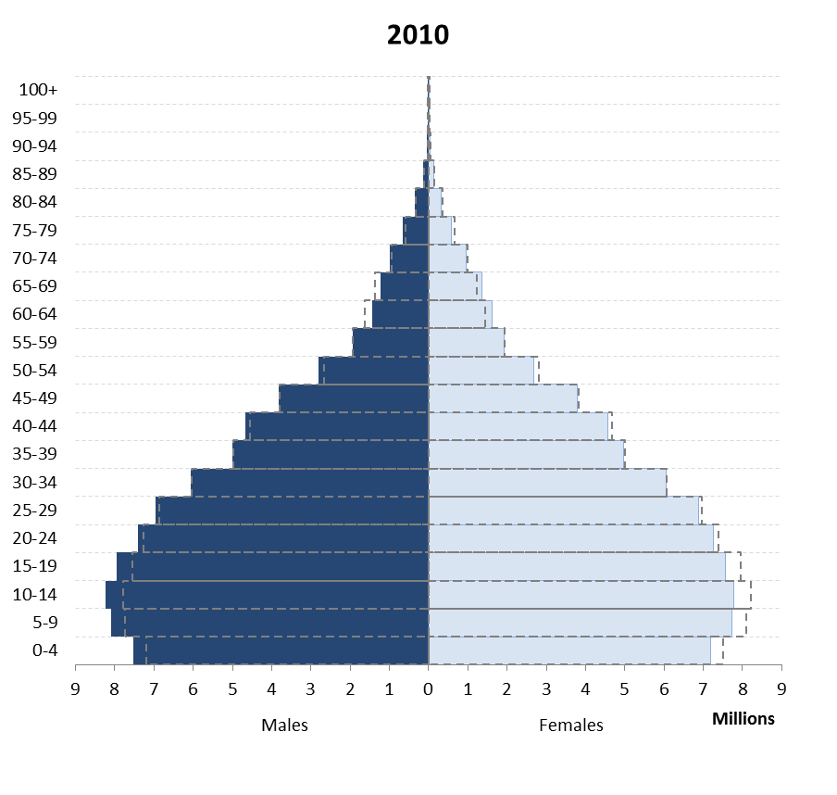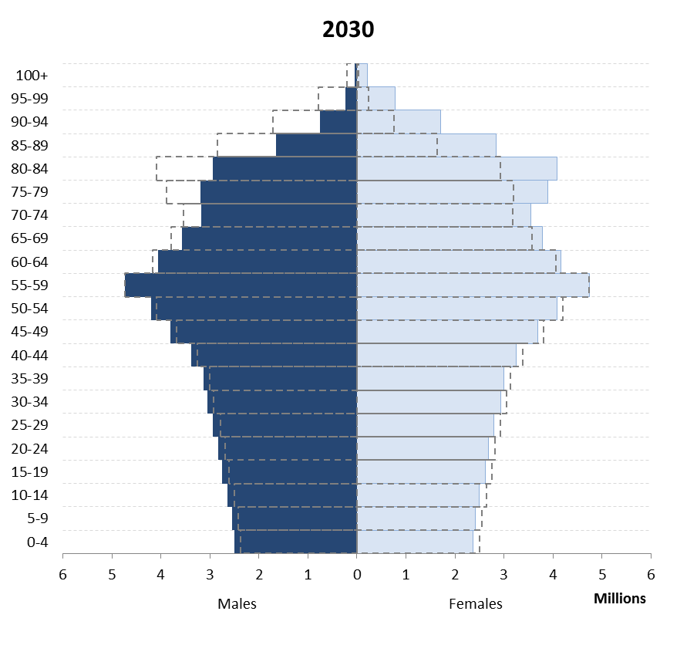

The demographic dividend.

Whist the demographic change can create major problems, it also creates opportunities. The most well known is the demographic dividend. For a generation or two countries move from a position with a high dependency ratio to a very low one. The dependency ratio is the number of working-age adults compared to the combination of children+dependent elderly. Initially his is high due to large number of children compared to adults (Africa at present (Fig 6, Left), but moves to one where the number of elderly retired is high compared to working age adults (Europe, Fig 7, Right). In the period between those points there is a time when the dependency ratio is very low: this is the demographic dividend. Some countries such as China have used this period of demographic dividend rapidly to expand their economies. There is noting automatic about this however; if unemployment is high it just leads to large numbers of unemployed young adults. Greece for example currently has a very favourable demographic profile in terms of dependency ratio but this has not translated automatically into a rapidly growing economy.

Dependency ratios for Africa (L) and Europe (R) 1980-2050. Low is good from an economic point of view.

Implications for the balance of populations between countries.

Looking at the world as a whole there is going to be over the next fifty years a marked shift in where the majority of the global population lives. At the point where some of the audience was born Europe had around 20% of the world population and was significantly more populous than Africa. By the time most of us die Africa will make up around a third of the world population, Asia more than 40% of the reminder and Europe will around 7% with the USA even smaller. This has significant implications in terms of economics which are obvious. For those who are worried about a Malthusian end to the human race with massive overpopulation leading to extreme scarcity remember that the demographic transition is a temporary phenomenon, with a short (but intense) period of population growth between mortality going down and fertility going down. What is the ‘optimum’ human population is subjective and has been the subject of violent debate over centuries, with environmental, economic and philosophical dimensions, which it is not the aim of this lecture to cover. As an objective fact however population growth has already slowed in Europe, is slowing rapidly in Latin America and Asia and in all probability will do so by the end of the century in Africa. At that point the population of the world is likely to remain fairly stable (or even shrink) but of a completely different population structure to that which we entered the 19th Century with.

The shape of some important population pyramids.

In this section of the lecture I will go through a number of countries with important population pyramids that change over the next few years because of either rapid transition or particular factors. To understand them it is easiest to see all the pyramids and how they progress over time, and there inevitably quite a lot of them so I recommend looking at the slides (or better still watching the lecture online). The data for all of these comes either from the UN Population Division or the UK Office for National Statistics, all freely available.

To illustrate the kinds of issues demographic projections help with an example of a country about to go through a major change that may have international implications is Iran. In Iran at the moment there is a very major bulge of population in young adults (including young men of fighting age) (Figure 9a). There was a significant decision by the Government to encourage a smaller family size, and allow families the means (contraception) to achieve it which once achieved is not reversed, means that looking thirty years into the future Iran will look very different (Figure 9b).

Population pyramid in Iran, 2010 and 2050.

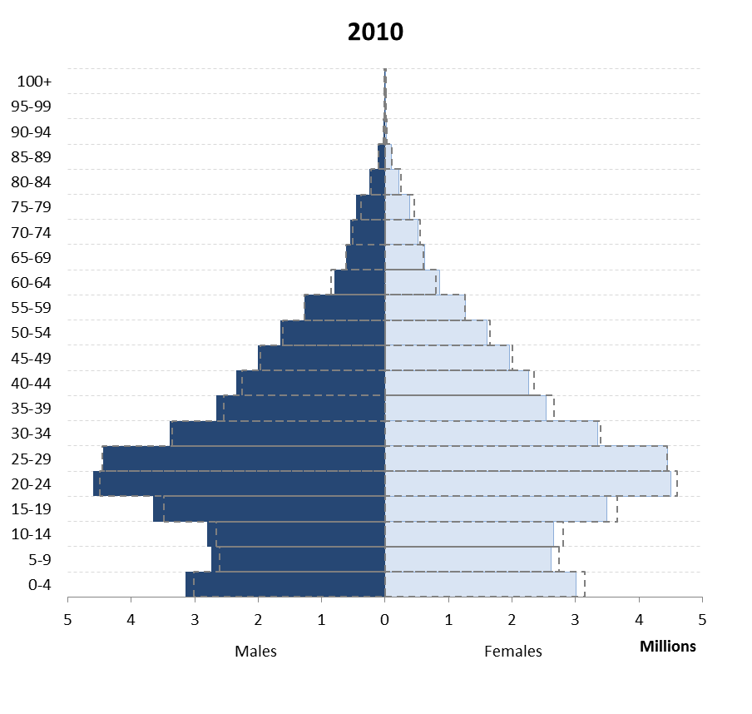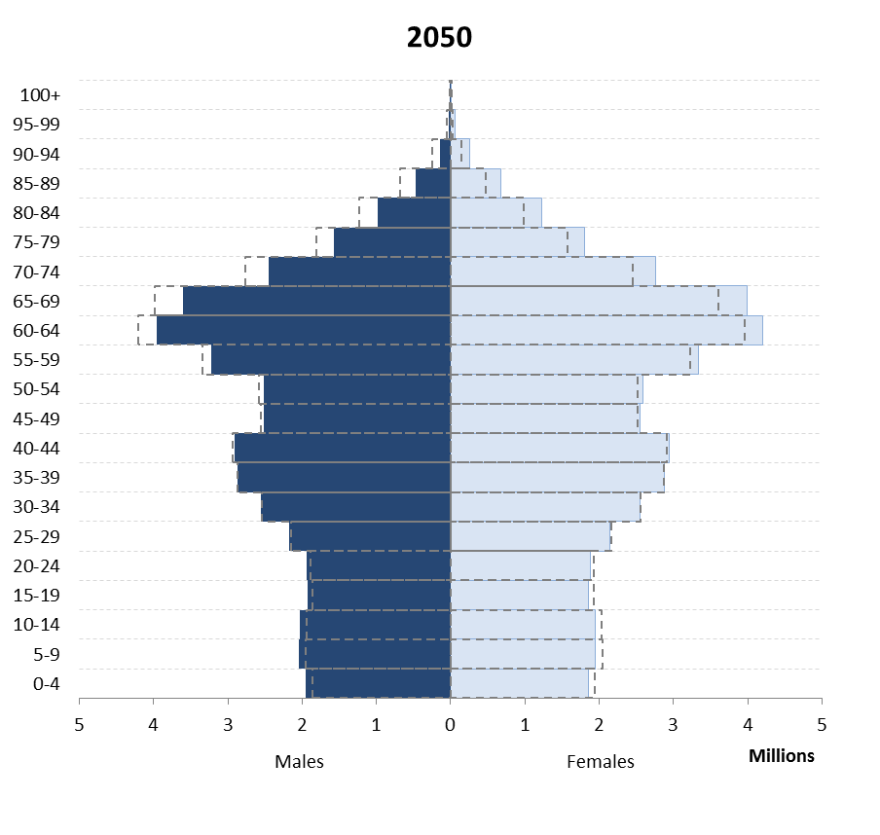

A similar policy decision was taken in China and here an equally striking change occurs (Figures 10a L and 10b). China’s dependency ratio, once dominated by children, is now very low- but will increase again soon due to elderly adults (Figure 10c, R). Certain countries illustrate some very major events in their history which have had a significant impact on demography.

The change in China's population pyramid and dependency ratio 2010-2050.

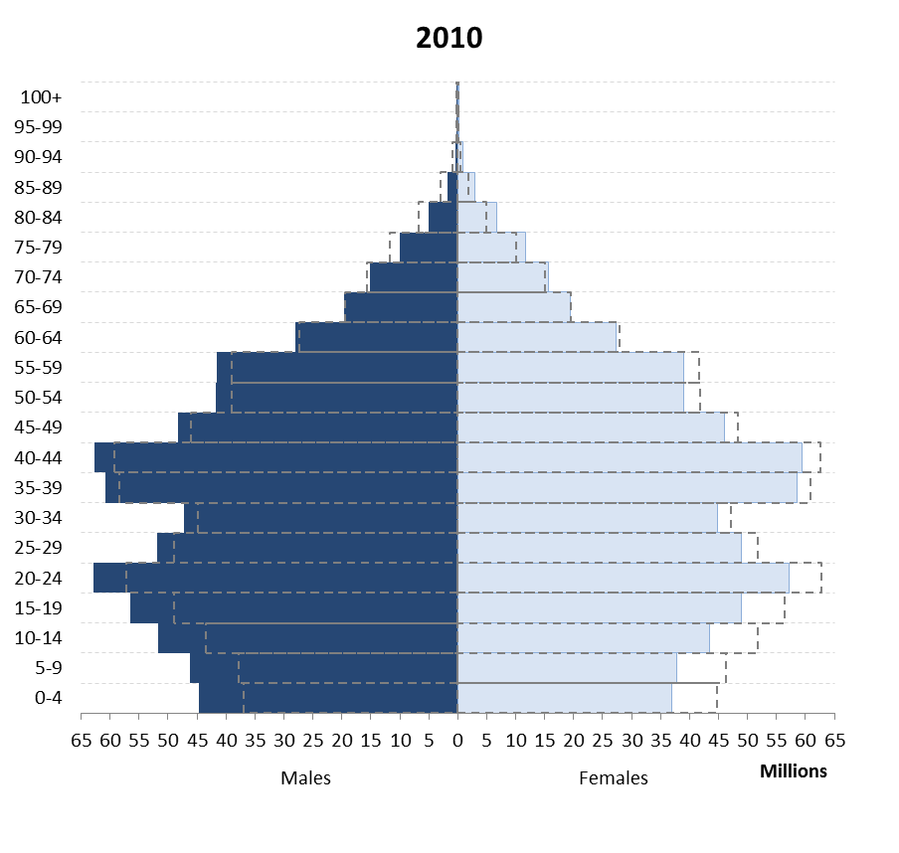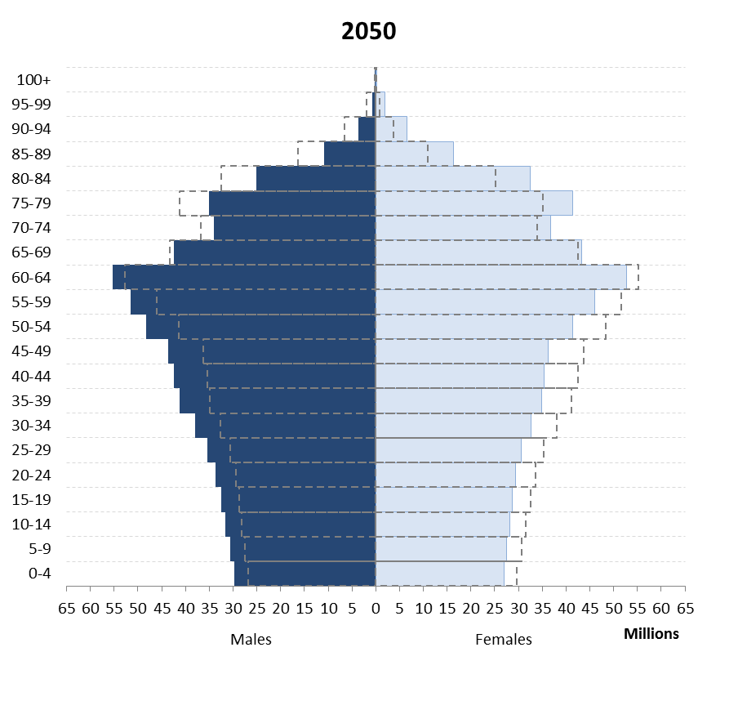

In southern Africa the impact of HIV on population structures has been substantial, illustrated here by Zimbabwe (Figure 11), and the effects of this will be felt for a long time.

Population pyramid for Zimbabwe, 2010-30 with a major shoulder due to HIV.

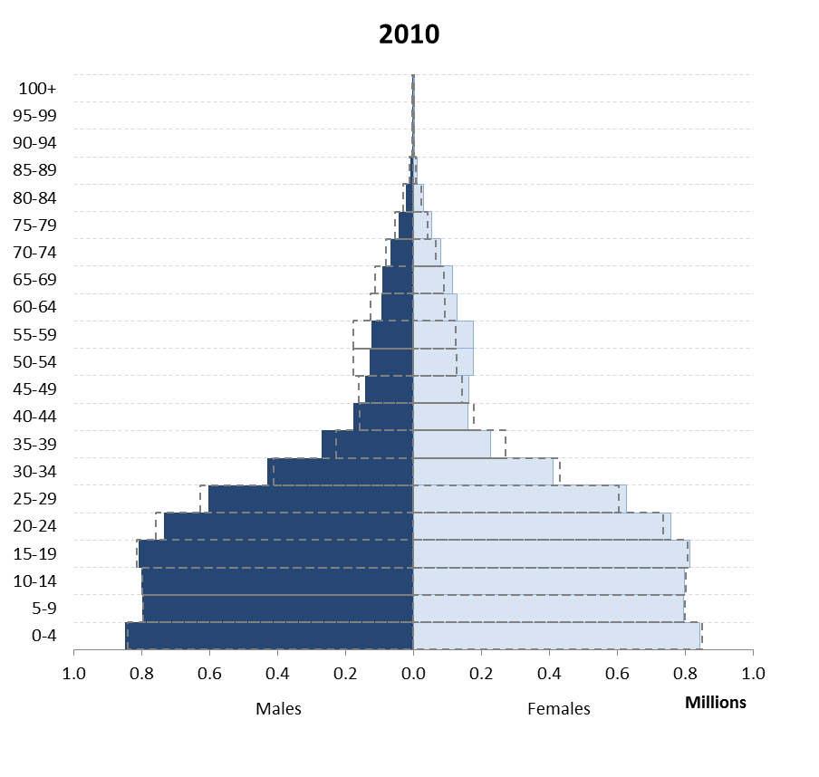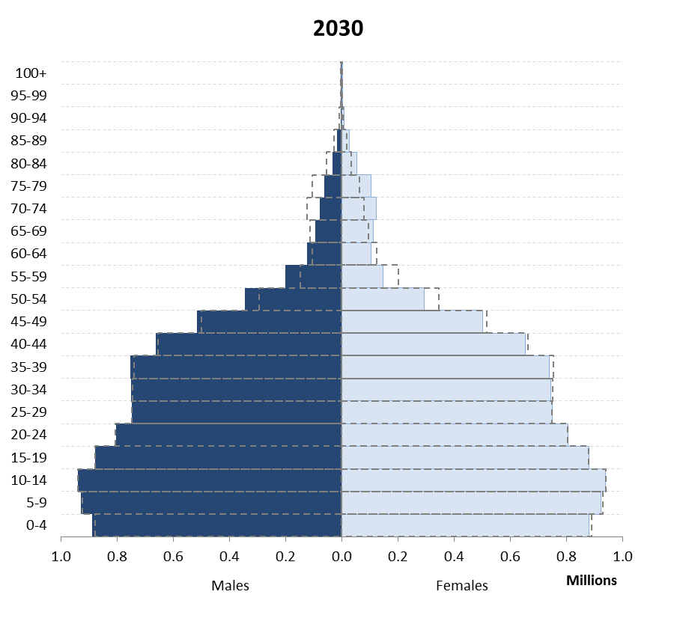
The impact of the world wars and the 1918-20 flu pandemic can be seen in many countries including the UK (Figure 12).

The UK 1921 and 2011. It is easy to see the gap due to children not being conceived during WW1, and the missing men who died. This is followed by a baby boom. The post WW" baby boom is only now reaching retirement.

Turning to the UK, it is instructive to compare the UK population pyramid now and in thirty years’ time with that of Germany, the USA and France. In all countries dependency ratios as currently defined are going to worsen although much more gradually in the UK than for example Germany. Part of the explanation for this is migration patterns which are not considered extensively in this lecture as they are not a medical issue. Demographic profiles are not however just an issue for a country as a whole; major effects can be very local. Large urban centres such as London are likely to remain relatively young if current trends continue because there is continual process of in migration of younger people from elsewhere in the UK (and overseas) and an out migration of older people either when they start having families and need to commute, or once they retire. The result is that inner London looks forever young (Figure 13)- but many other areas of the country are therefore going to age more rapidly than average figures would suggest because age is exported to them from the cities.

Inner London (L), Chichester (R), with UK average superimposed.

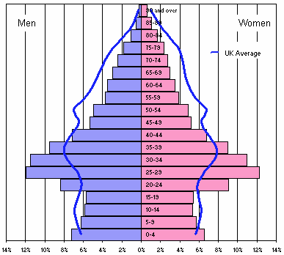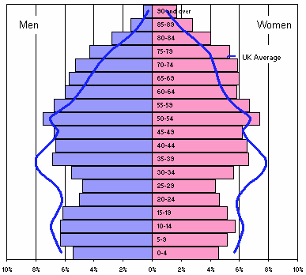

Where the elderly live is already concentrated and will become more so over the next 20 years. The demographic profile therefore of central London and other major cities on the one hand, and of a south east country town or rural areas will look even more different in 30 years than it does now with significant implications for policy. How to deliver health and other care when such a high proportion of many areas is elderly is going to require a significant rethink of our current models. As most of Europe is aging faster than the UK this is going to be a problem for the whole continent.

Distribution of people aged 85 or over in 2033. Southwark highlighted for comparison- as UK ages, Southwark does not. ONS.

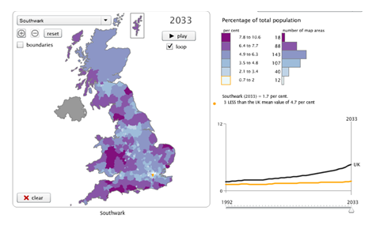

It is extremely unlikely that any future generation will go through as profound a shift in population structure as the current one. The UK has took great advantages from its demographic transition and the demographic dividend that followed, and will have to be equally imaginative in responding to the shifts that will be coming in the next 20-30 years as the population ages. Arguably too little policy time has been spent on an issue which is predictable, profound, and permanent. Globally by the end of this century, barring unforeseen circumstances, the period of extraordinary change in demographic profile which we have seen in the last century and we will continue to for this one will gradually come to an end and we will be left with a stable population with a relatively stable age structure (still ageing in Africa). Demographic profile changes and demographic transitions do not either lead automatically to good or to bad outcomes but they are predictable major drivers of how society will look and how economies will operate and we need to take account of them in the way that we plan and respond both internationally and domestically.

© Professor Christopher Whitty, 2015

